**DevOps**

DevOps (Development and Operations) is a set of practices that aim to automate and improve the process of software development and IT operations. It involves collaboration between developers and IT professionals to deliver software and services more efficiently. Below is a general outline for a DevOps tutorial. Keep in mind that the tools and technologies mentioned may evolve, so it's essential to check for the latest information.

**1. Introduction to DevOps:**

* Understand the principles of DevOps.
* Explore the benefits of adopting a DevOps culture.
* Learn about the key practices and concepts, such as Continuous Integration (CI) and Continuous Deployment (CD).

**2. Version Control:**

* Introduction to version control systems like Git.
* Learn branching strategies and best practices.
* Understand how version control fits into the DevOps workflow.

**3. Continuous Integration (CI):**

* Set up a CI/CD pipeline using popular CI tools like Jenkins, GitLab CI, or Travis CI.
* Configure automated builds and tests.
* Understand the importance of automated testing in the CI process.

**4. Infrastructure as Code (IaC):**

* Introduction to Infrastructure as Code concepts.
* Learn a tool like Terraform or Ansible for provisioning and managing infrastructure.
* Create and manage infrastructure using code.

**5. Containerization:**

* Introduction to containerization with Docker.
* Understand the Docker ecosystem and basic commands.
* Dockerizing applications and services.

**6. Orchestration:**

* Overview of container orchestration tools like Kubernetes.
* Deploy and manage containerized applications with Kubernetes.
* Understand concepts like pods, services, and deployments.

**7. Continuous Deployment (CD):**

* Implement CD pipelines for deploying applications.
* Explore blue-green deployments and canary releases.
* Monitor and log deployments for troubleshooting.

**8. Monitoring and Logging:**

* Introduction to monitoring tools like Prometheus, Grafana, or ELK stack.
* Set up monitoring for infrastructure and applications.
* Configure logging for better visibility into application behavior.

**9. Collaboration and Communication:**

* Use collaboration tools like Slack, Microsoft Teams, or others for team communication.
* Implement ChatOps for better collaboration between development and operations teams.

**10. Security in DevOps:**

* Implement security best practices throughout the DevOps lifecycle.
* Learn about static code analysis, vulnerability scanning, and security testing.

**11. DevOps Culture and Best Practices:**

* Foster a DevOps culture within your organization.
* Explore case studies and success stories.
* Continuous improvement and feedback loops.

**Additional Tips:**

* Stay updated with the latest tools and practices in the DevOps space.
* Participate in forums, conferences, and online communities to learn from others.
* Consider certifications like AWS Certified DevOps Engineer, Docker Certified Associate, or Kubernetes certifications.

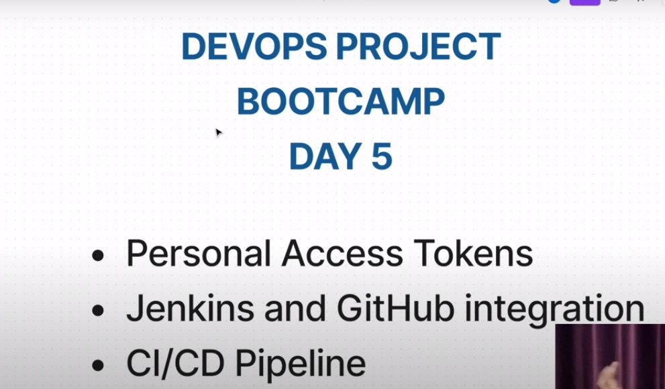

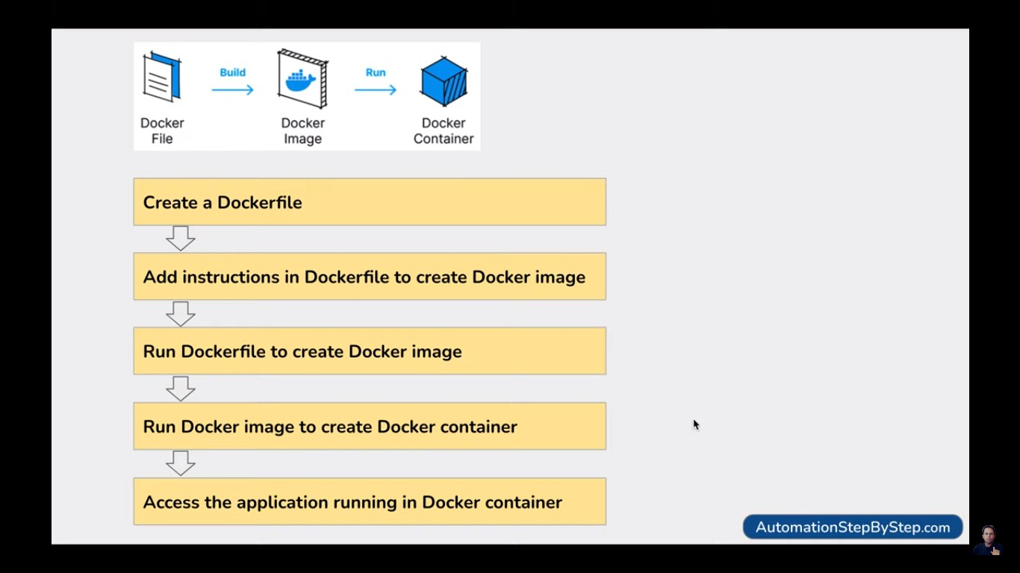

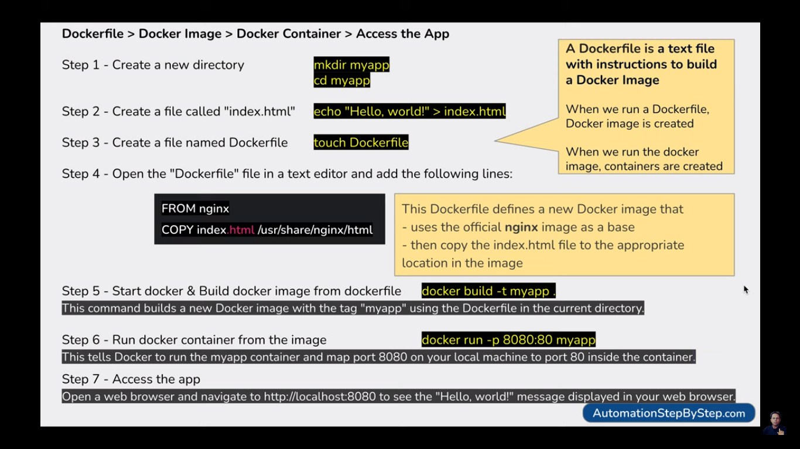

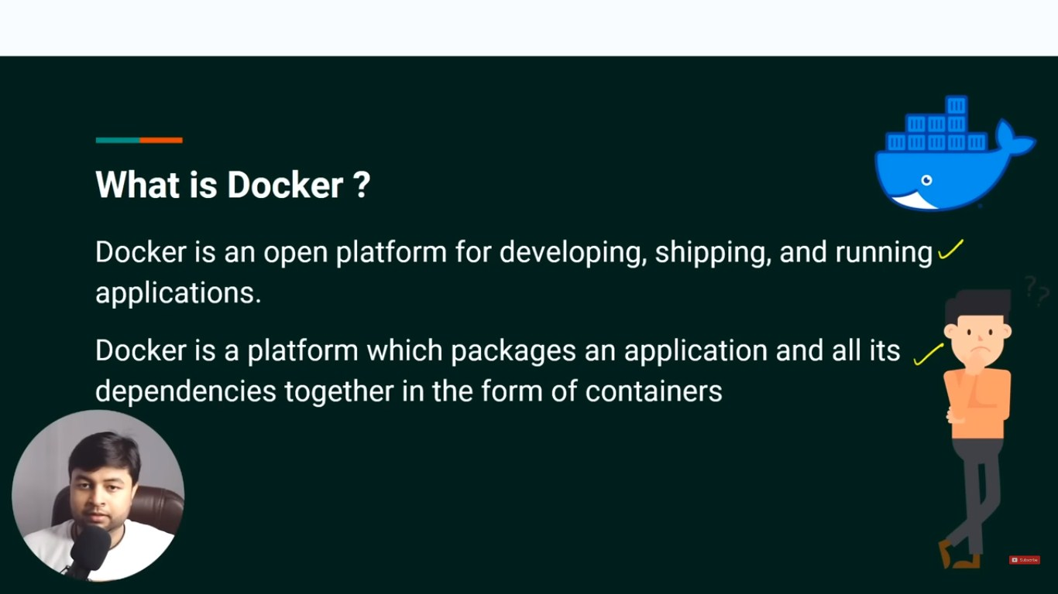

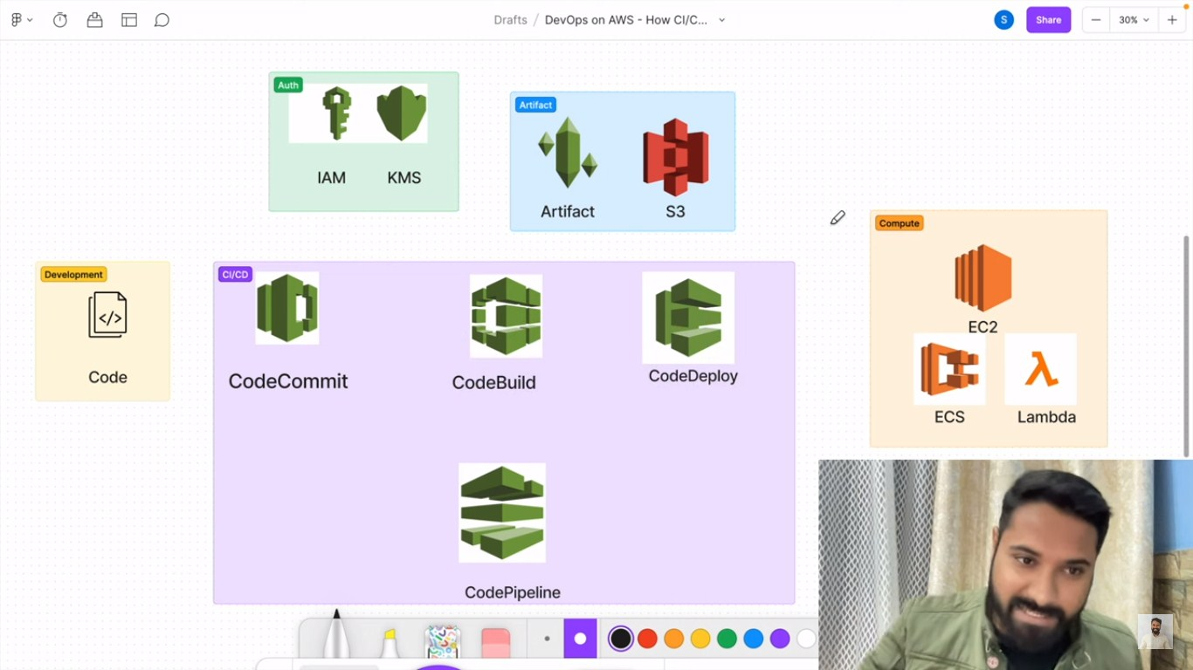

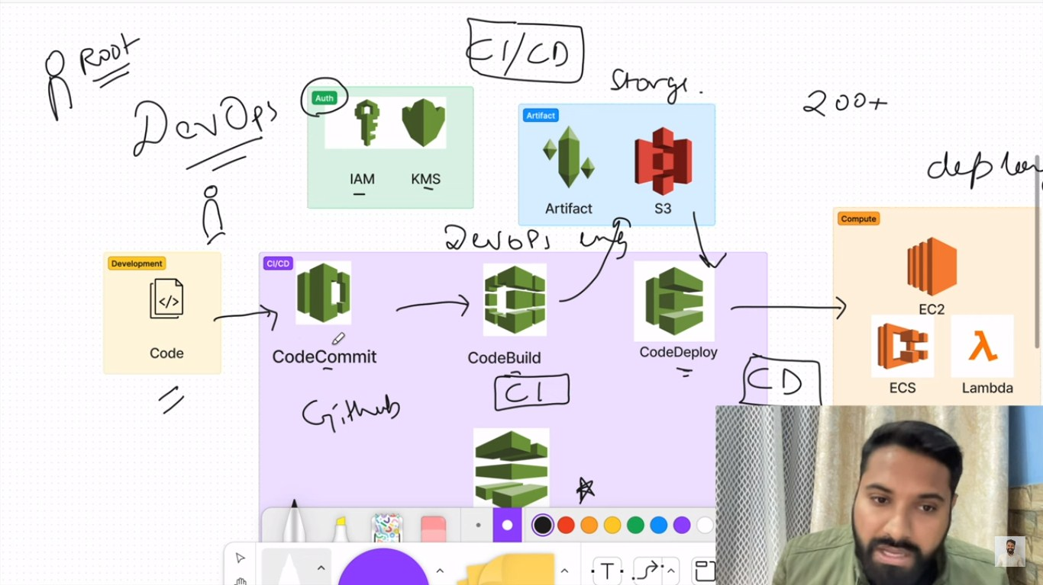

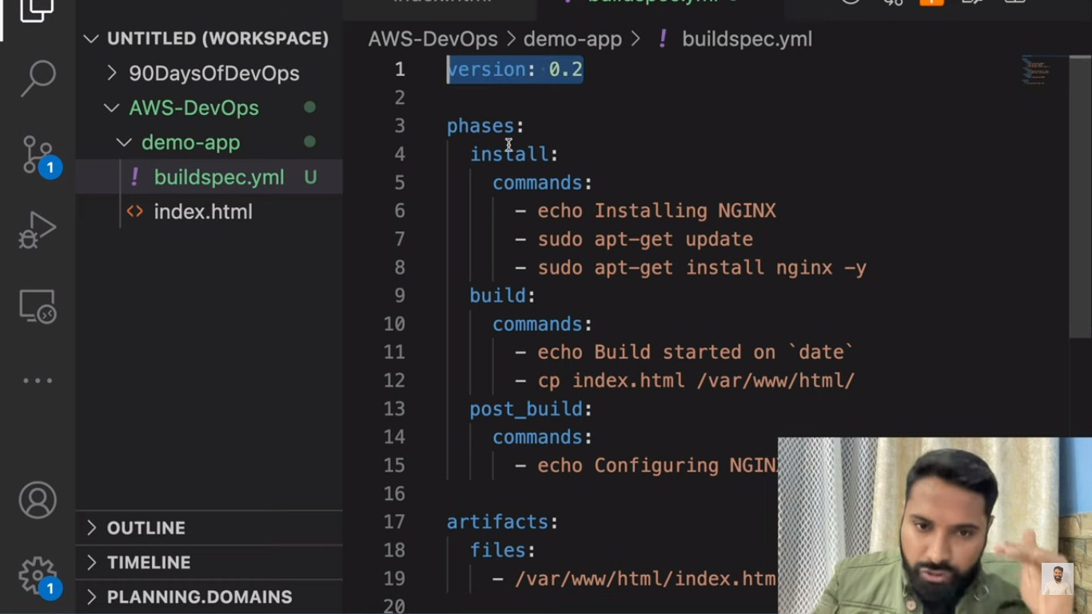

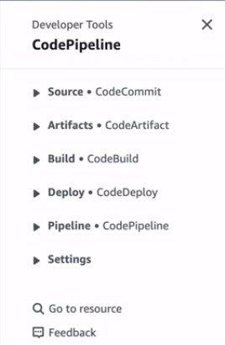

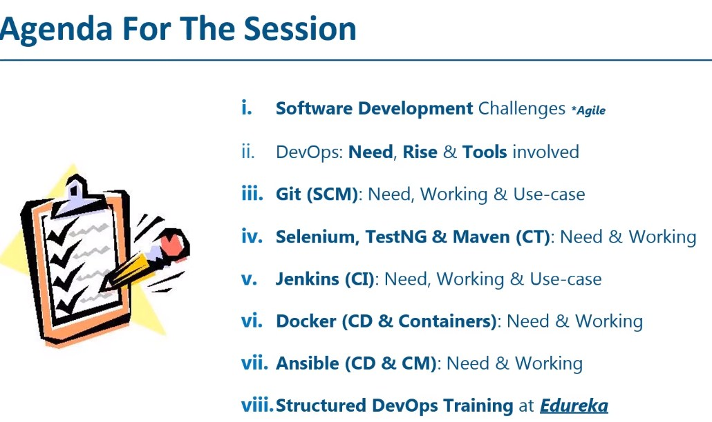

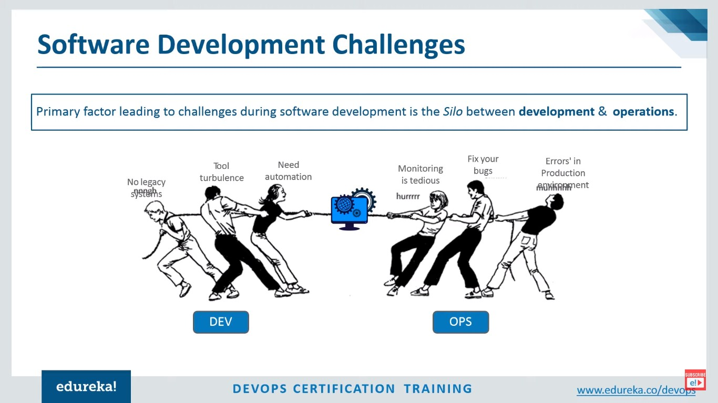

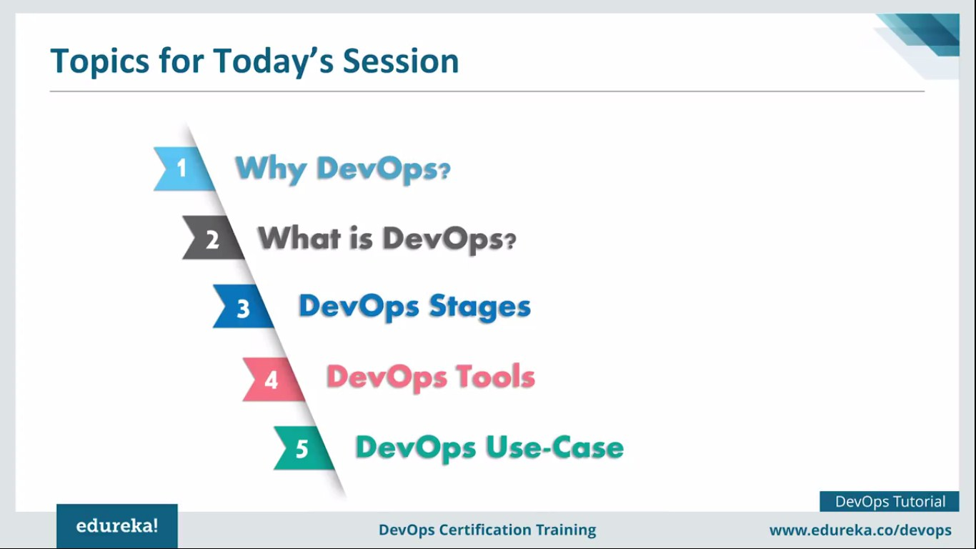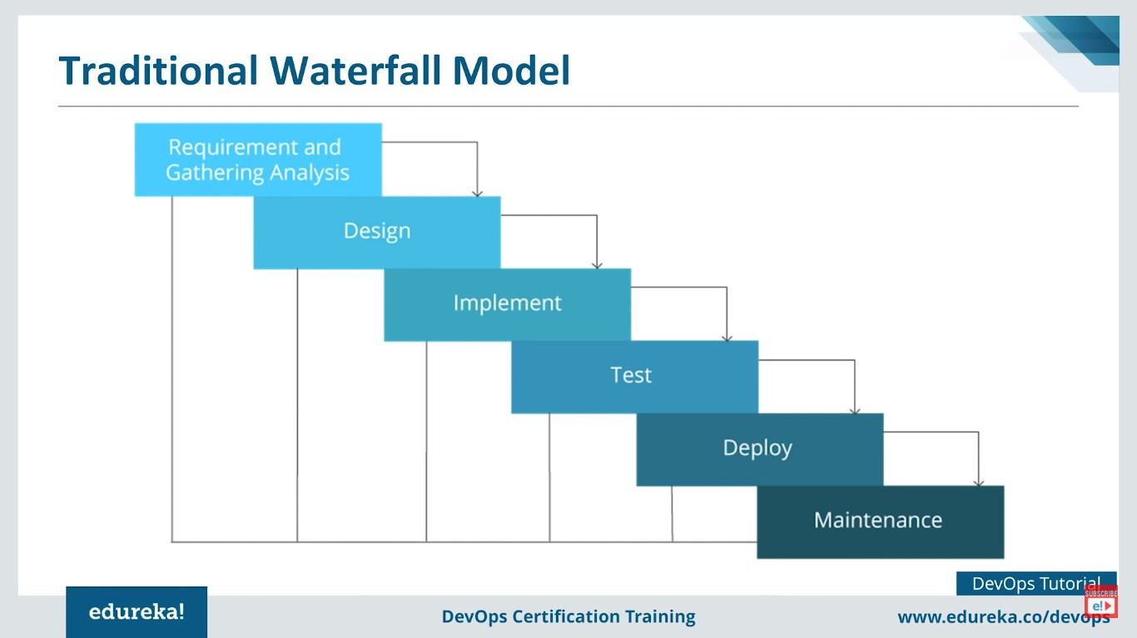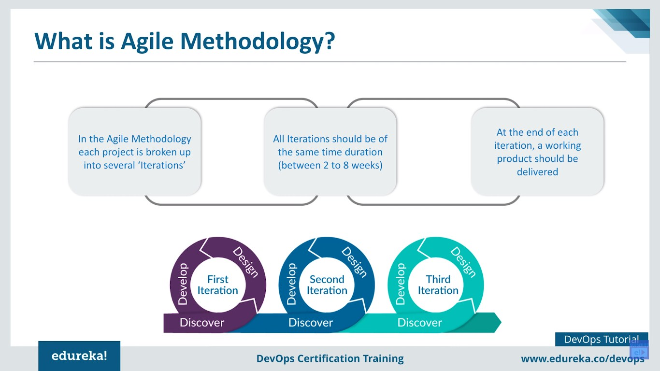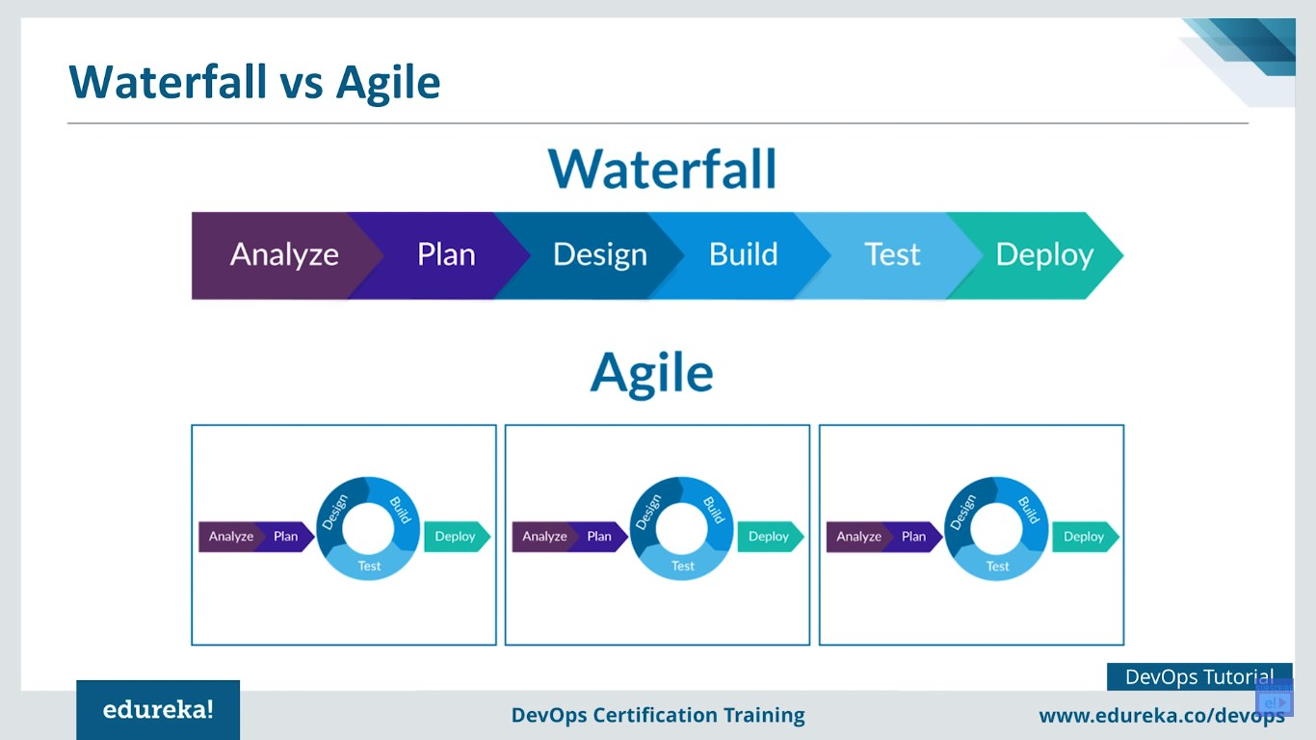

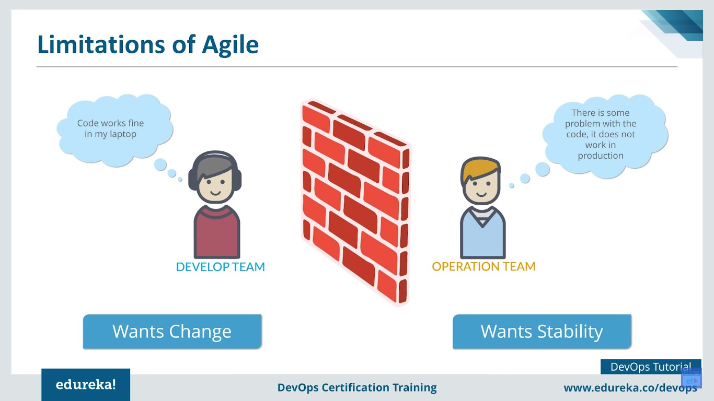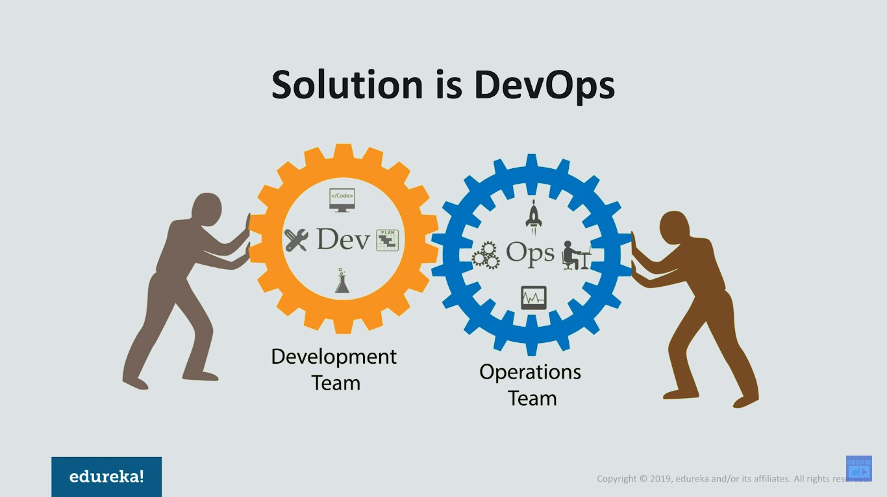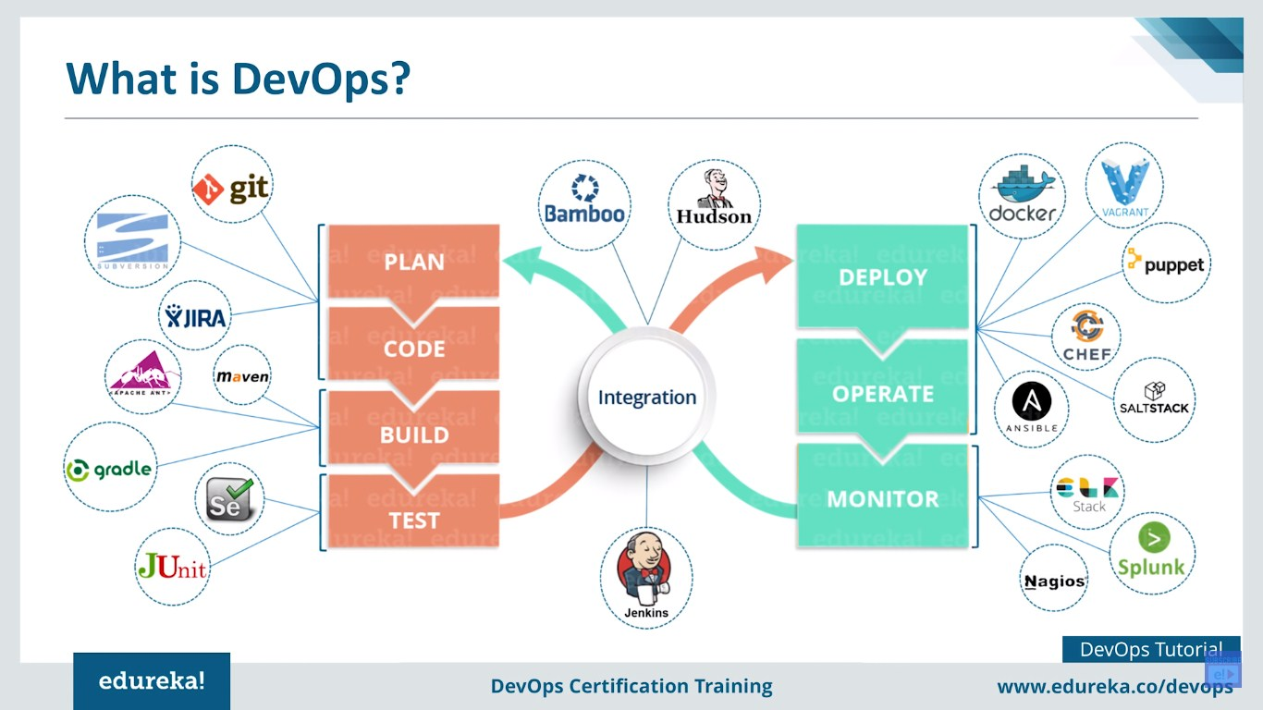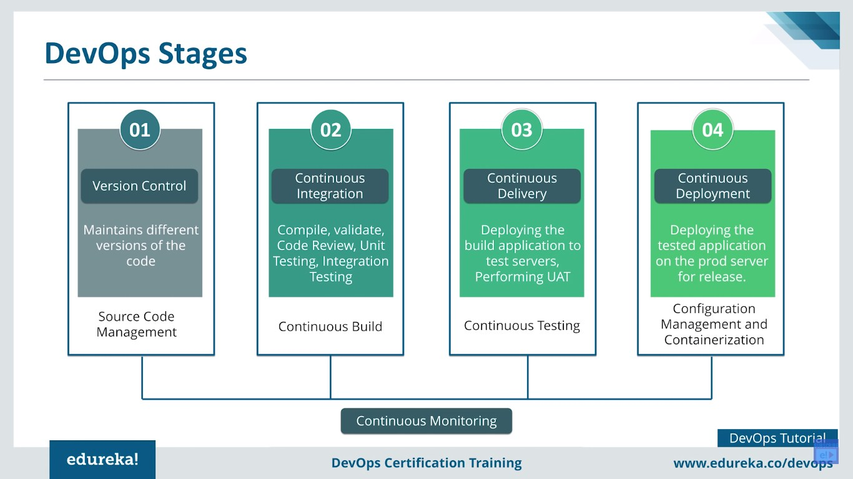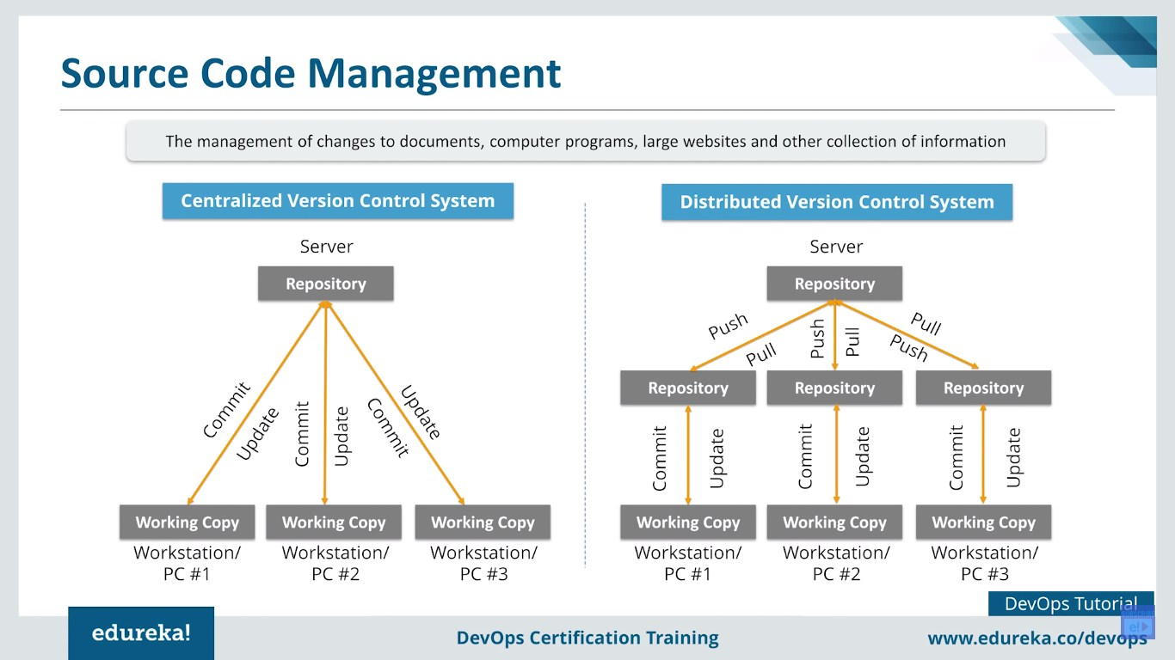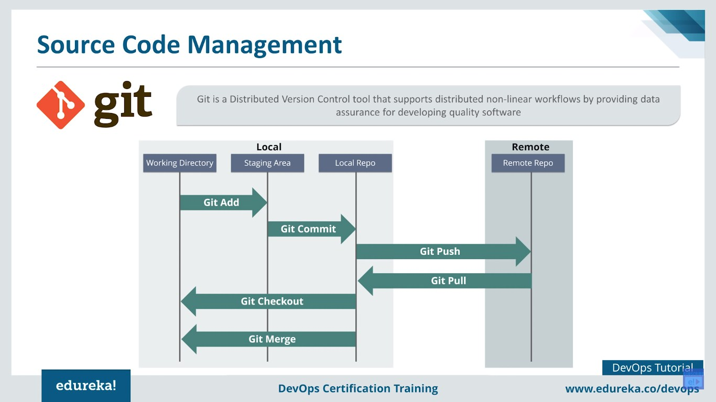

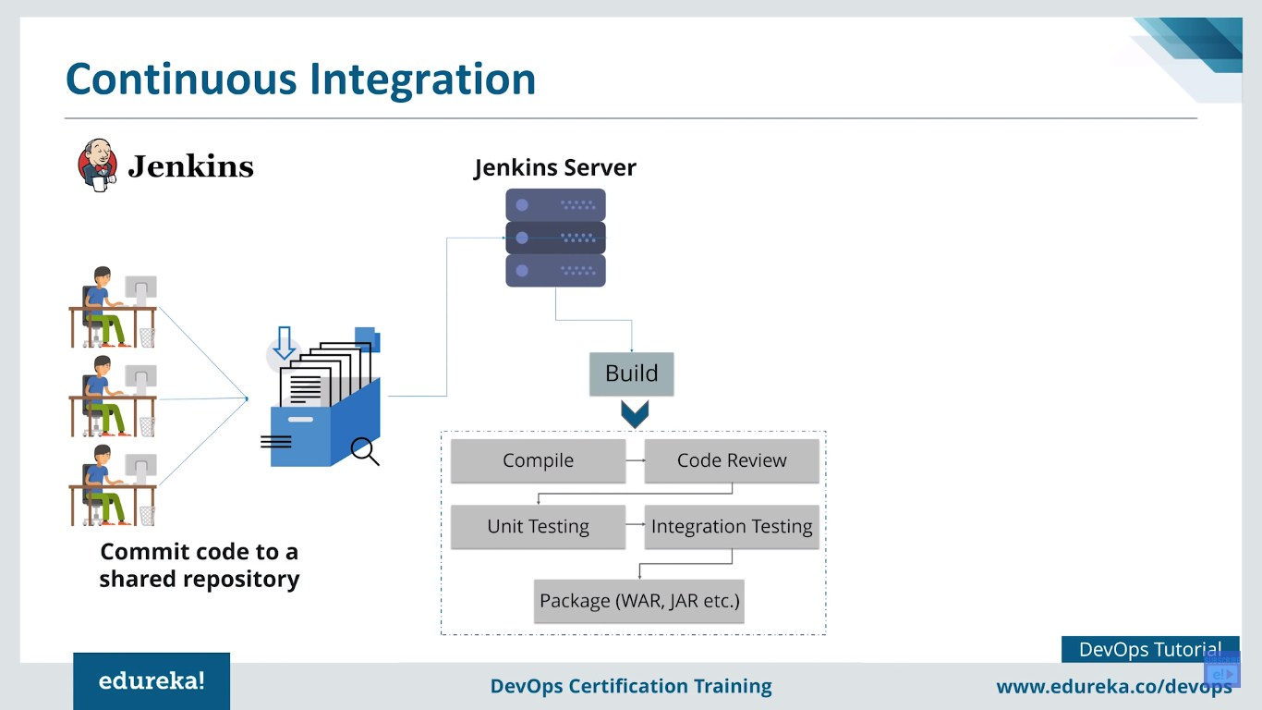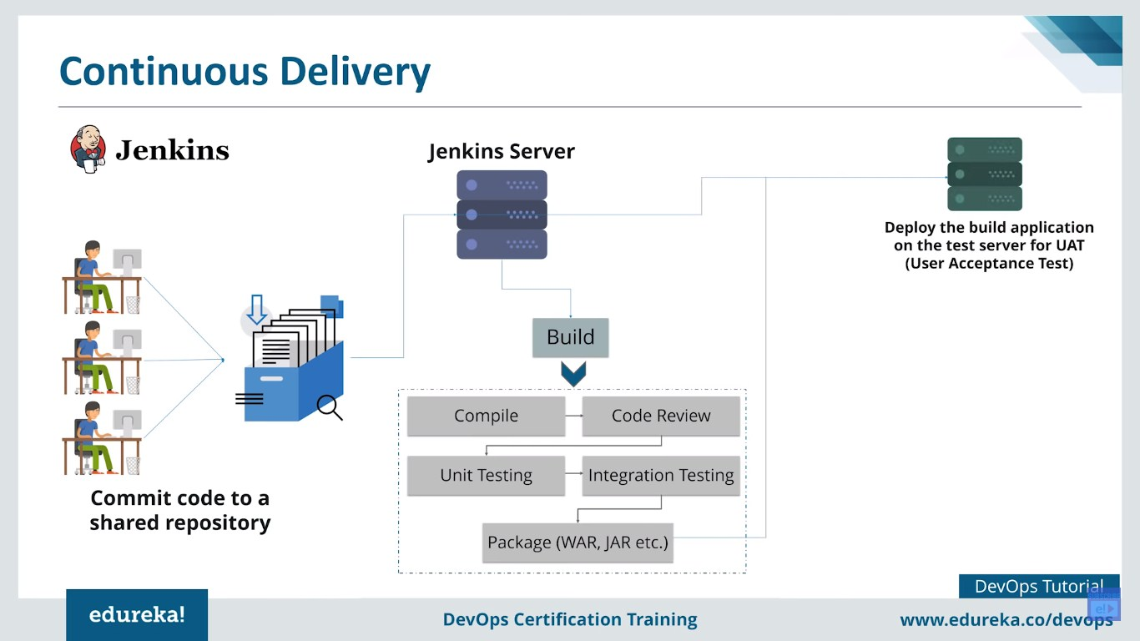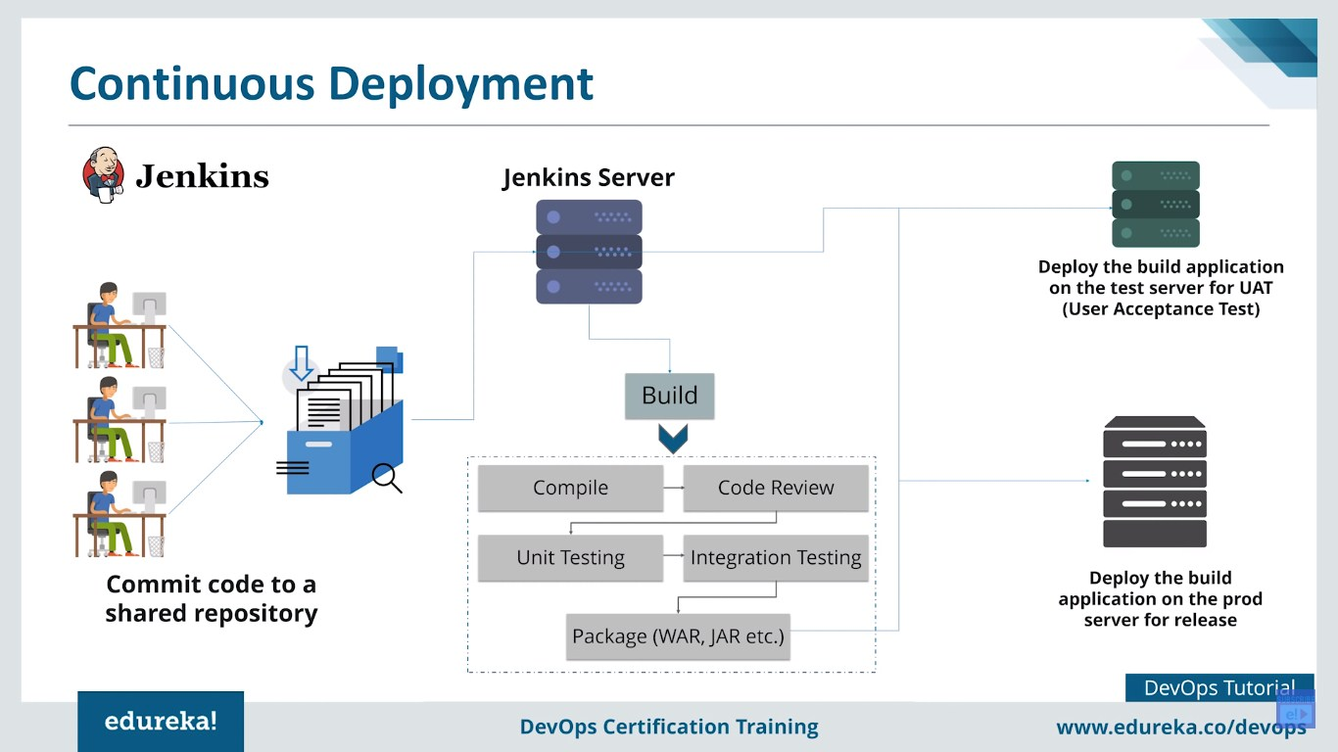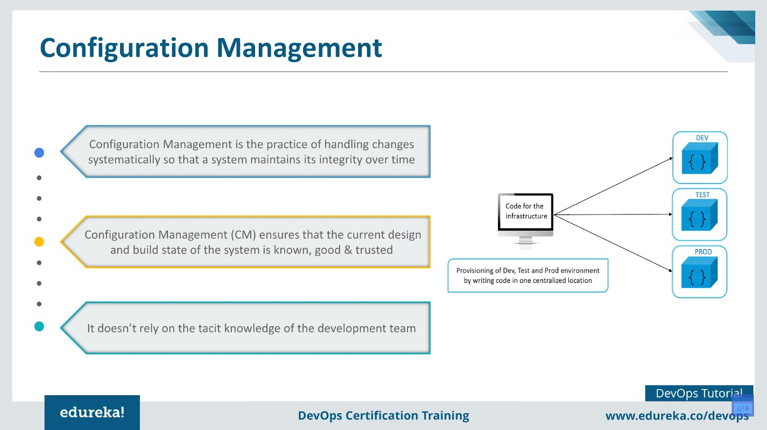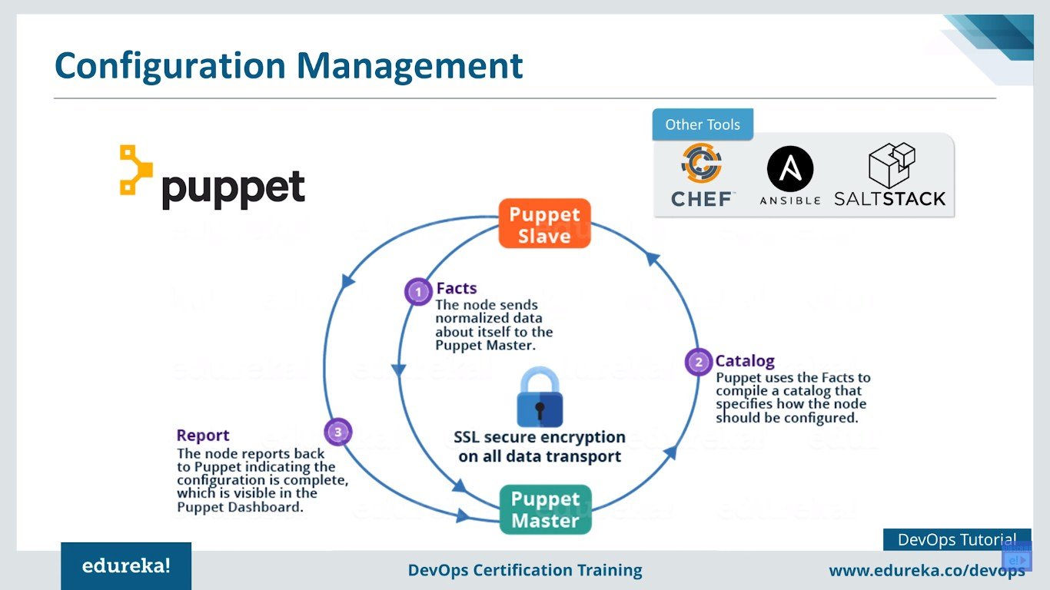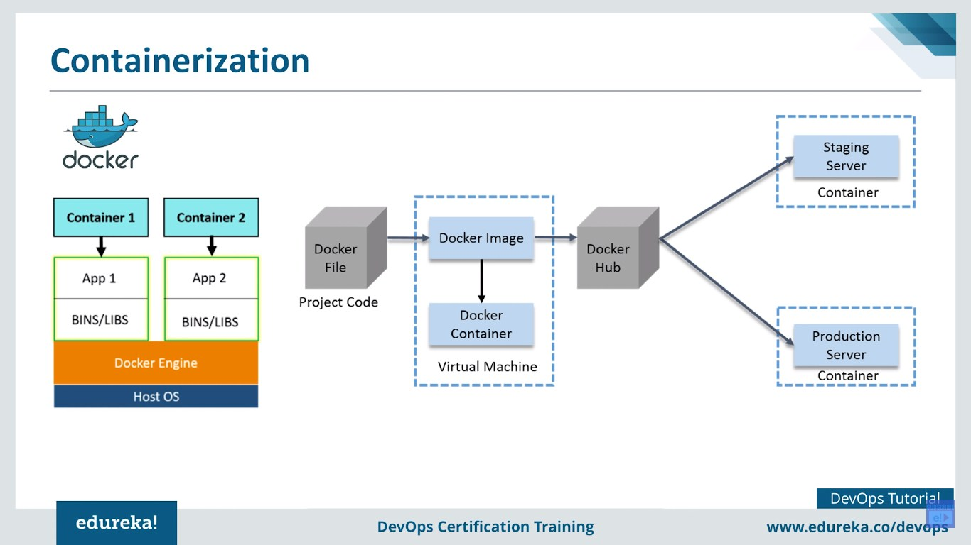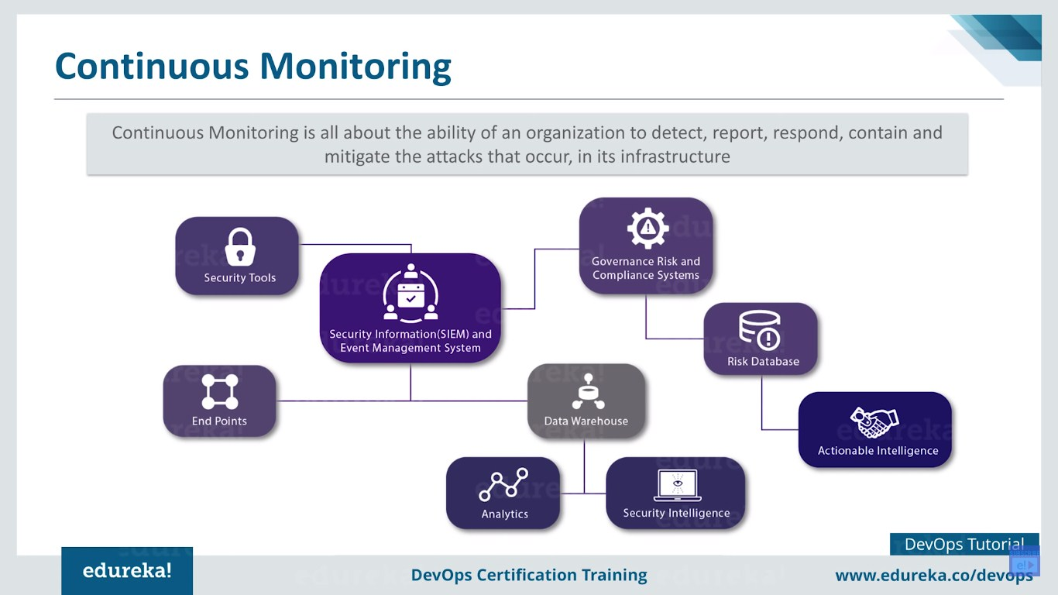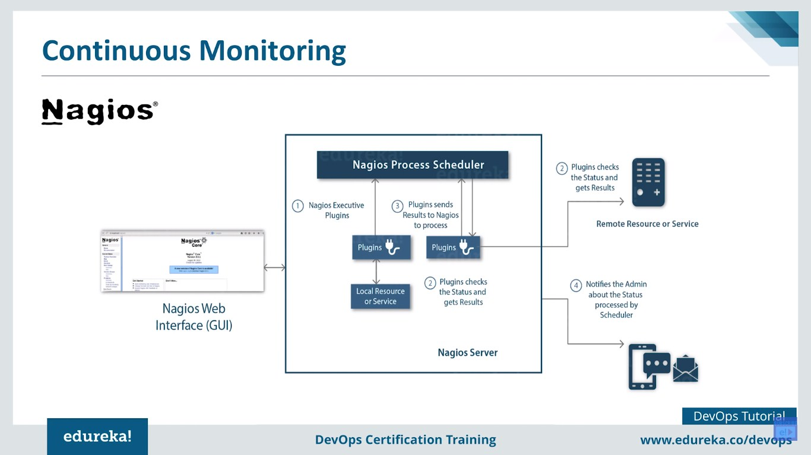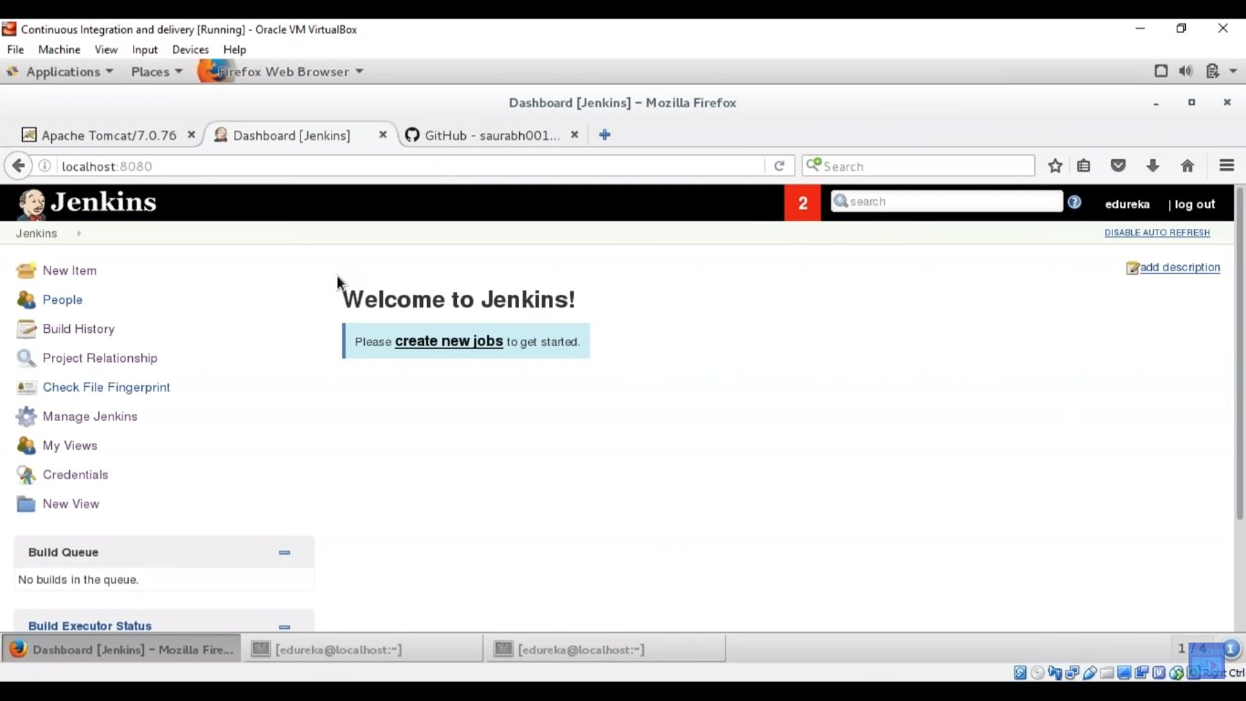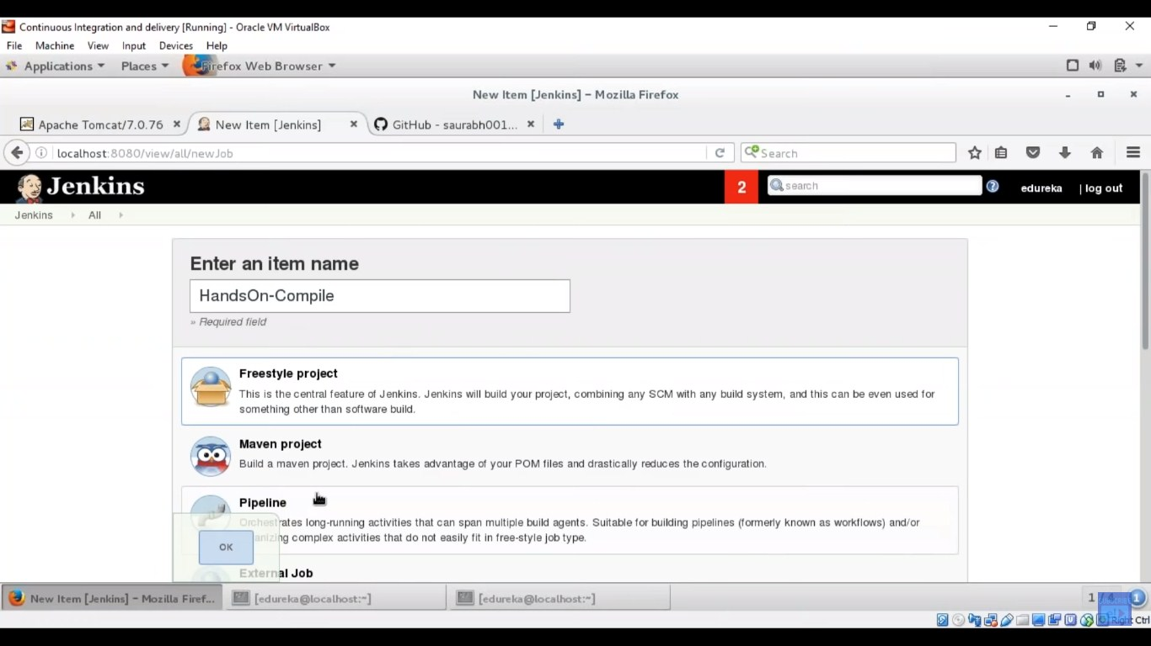

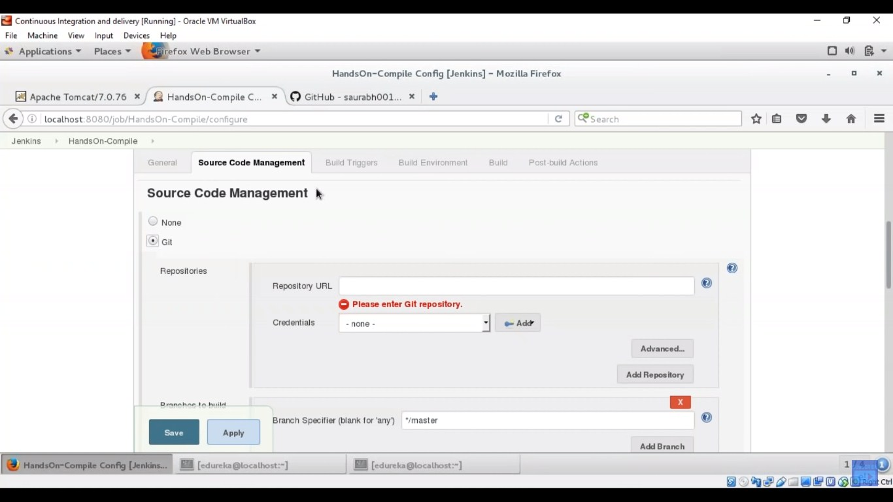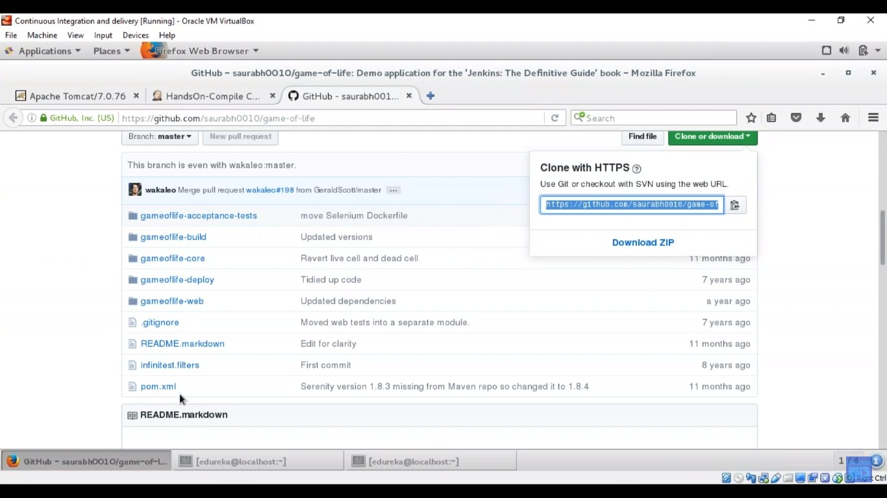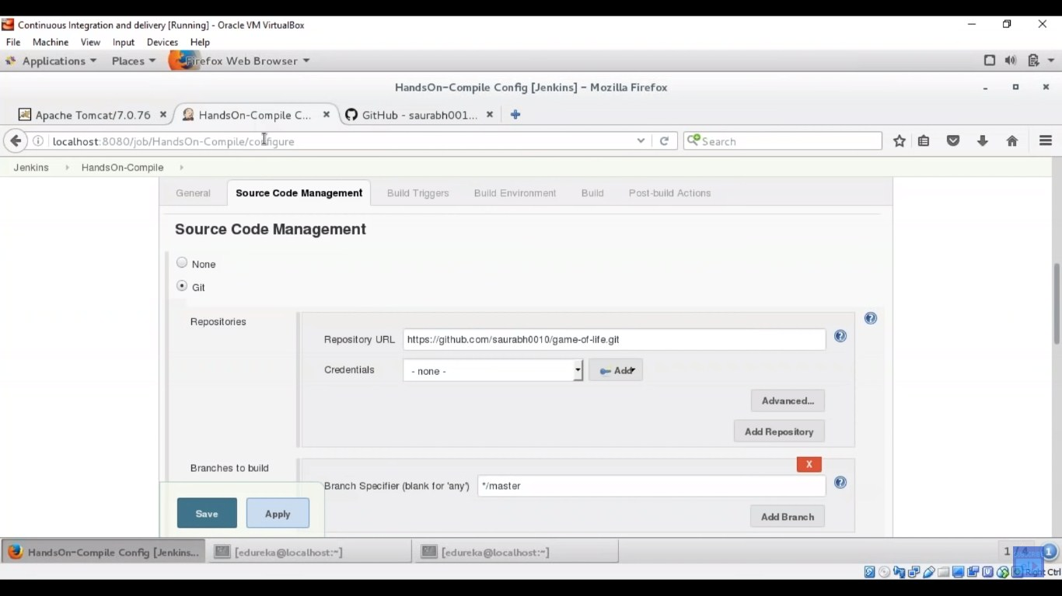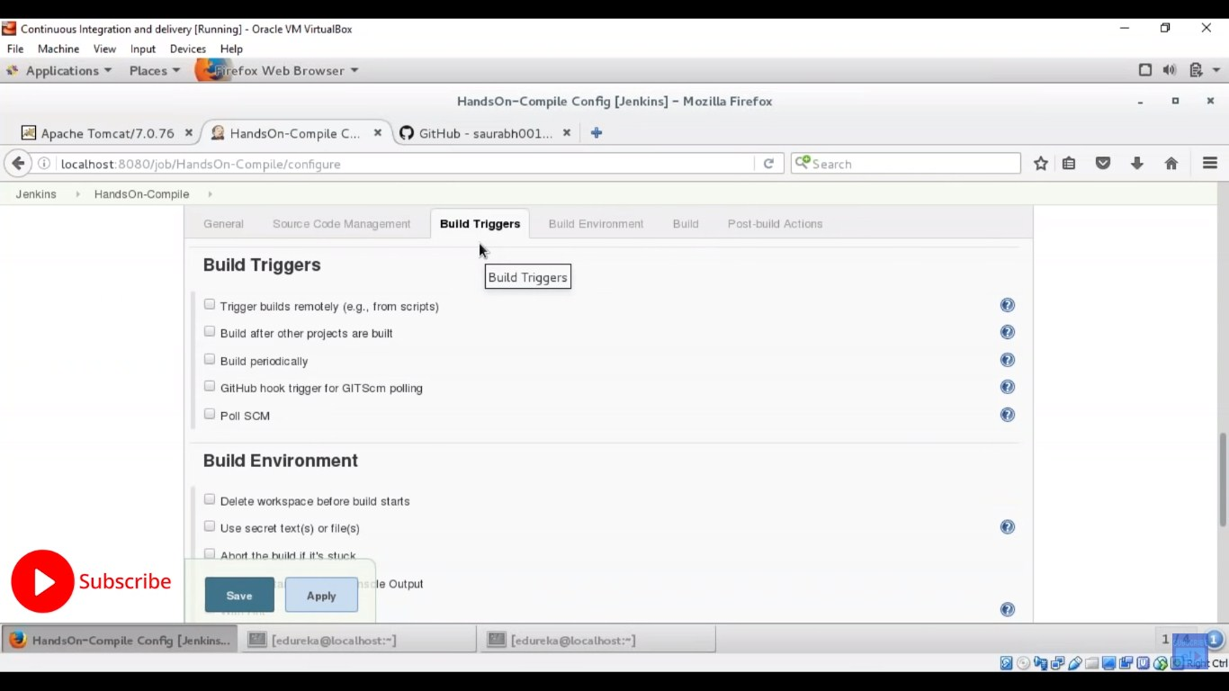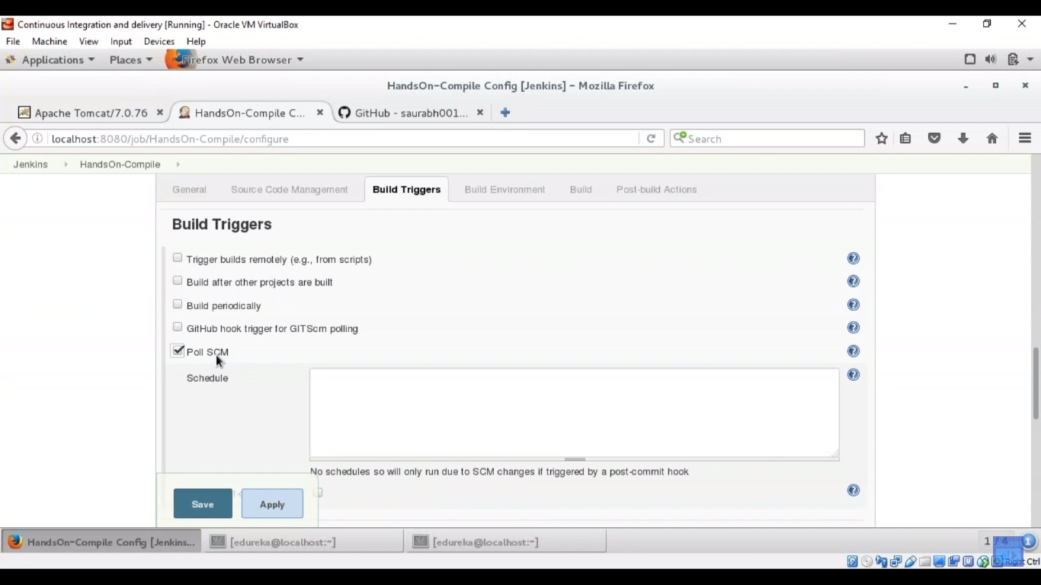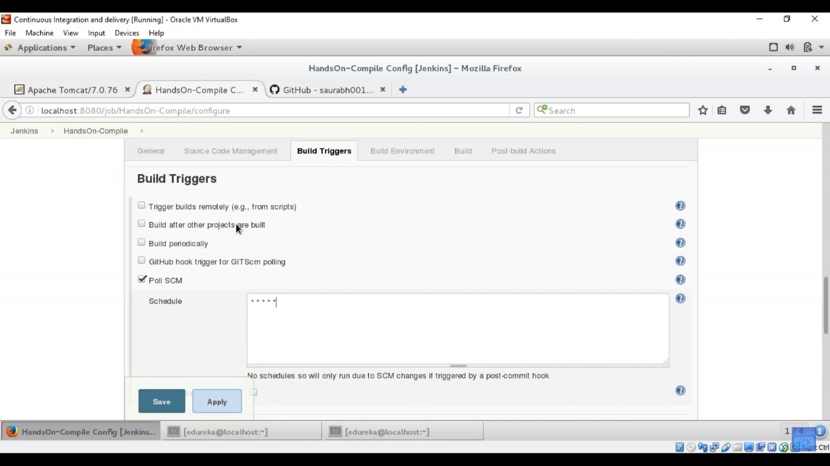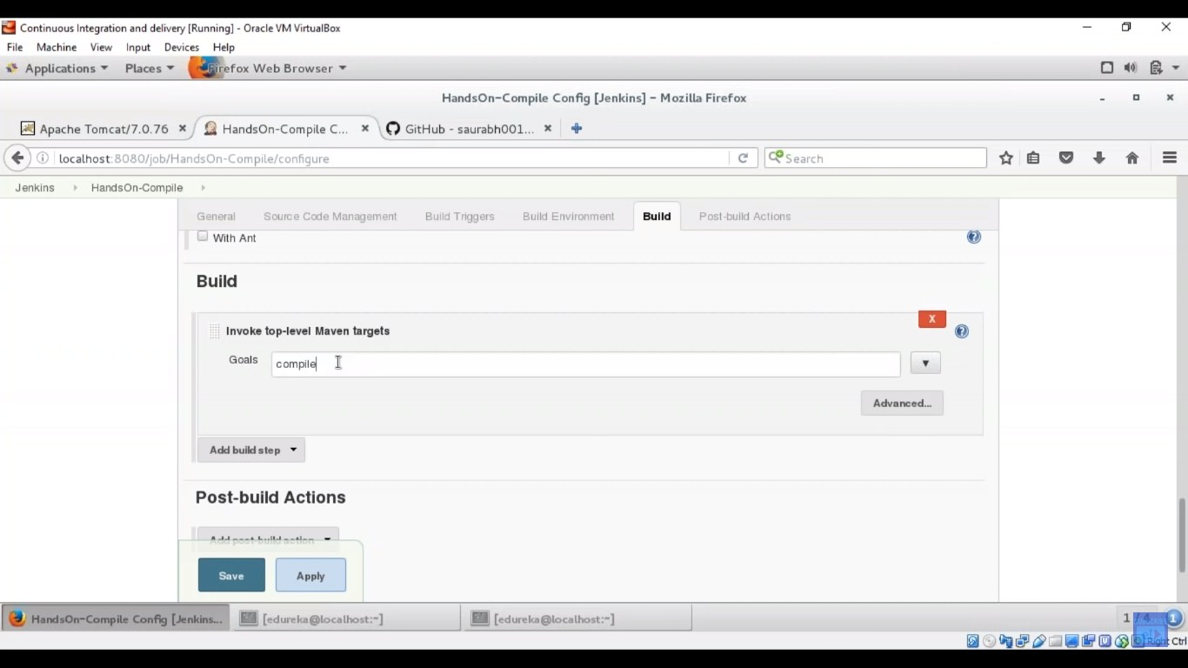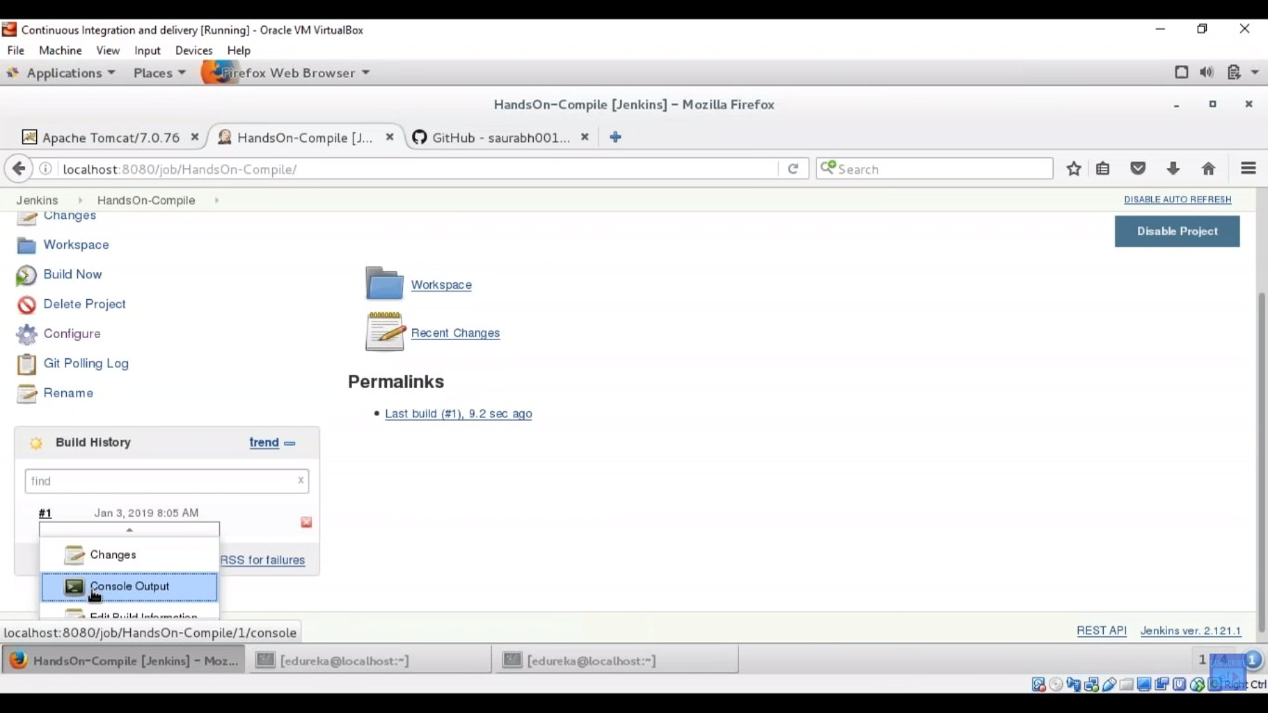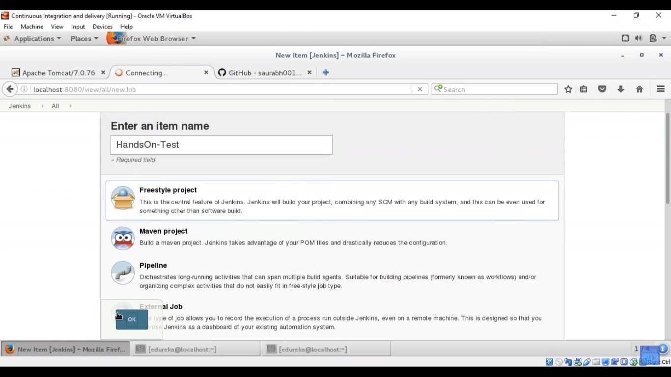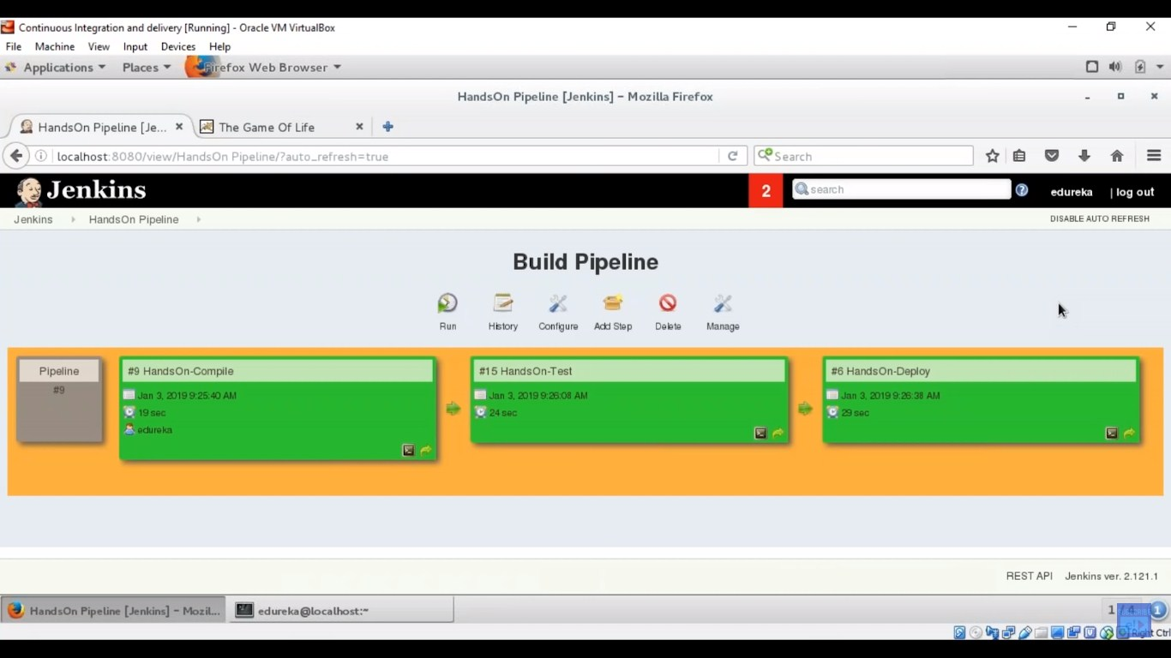

**New tutorial**

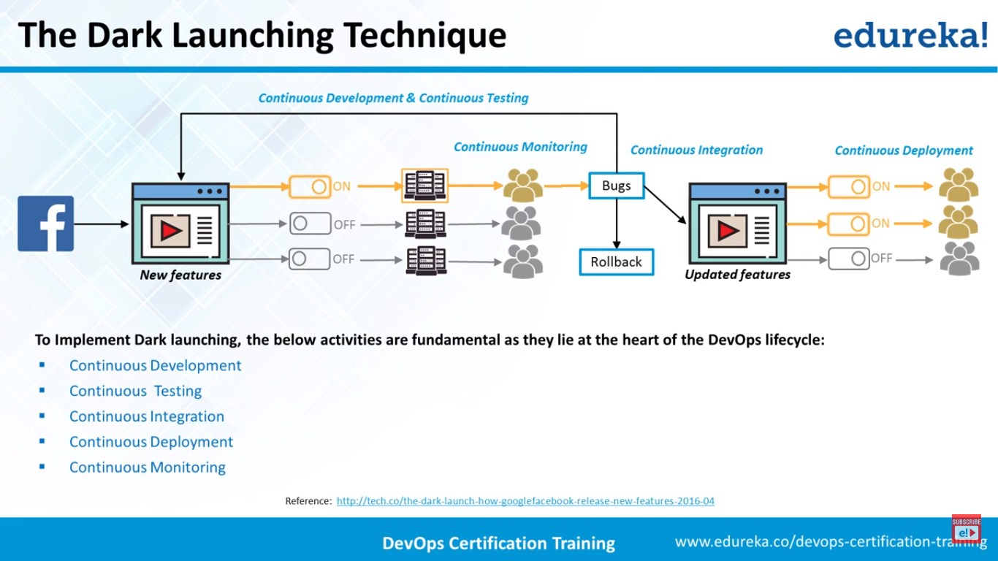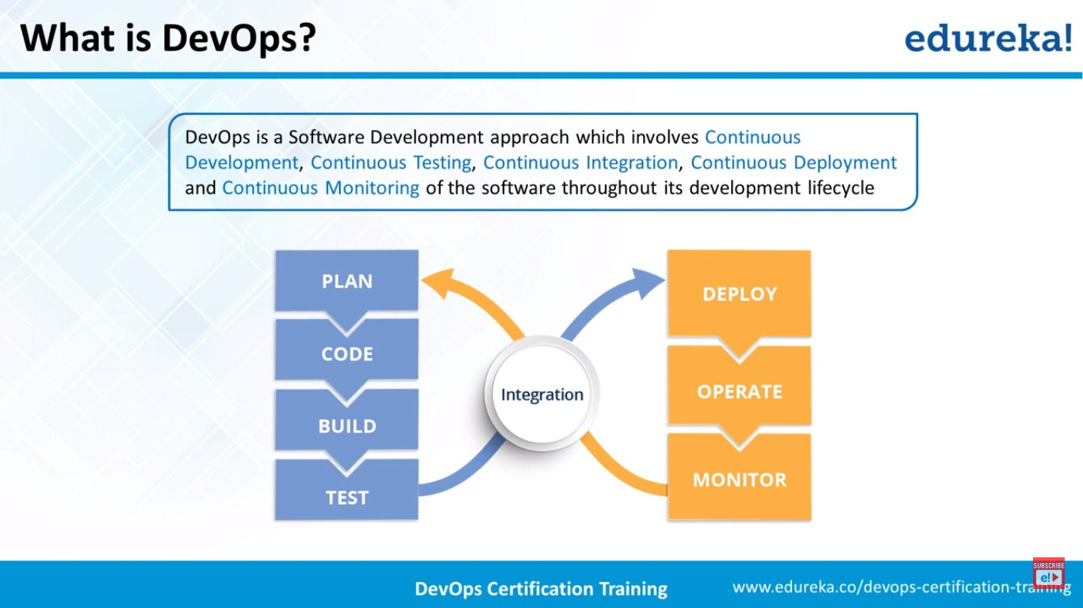

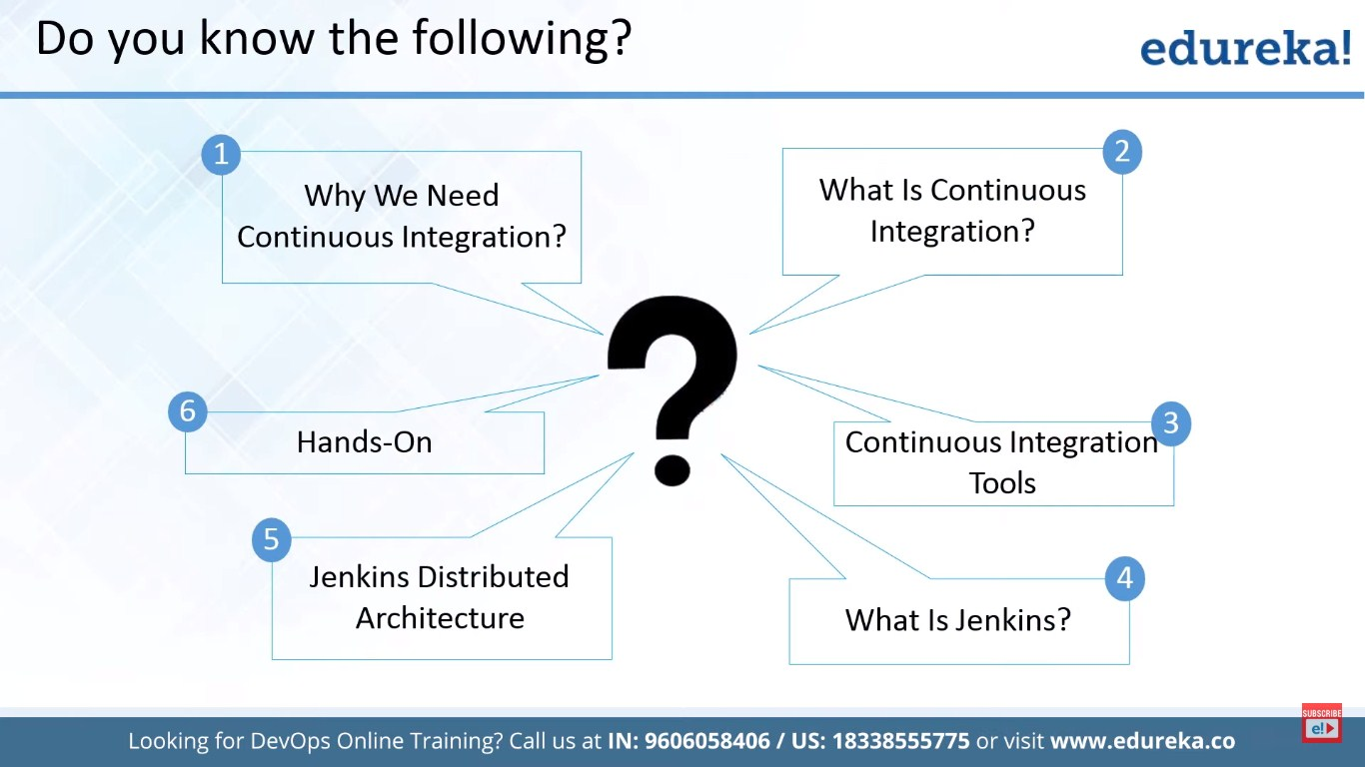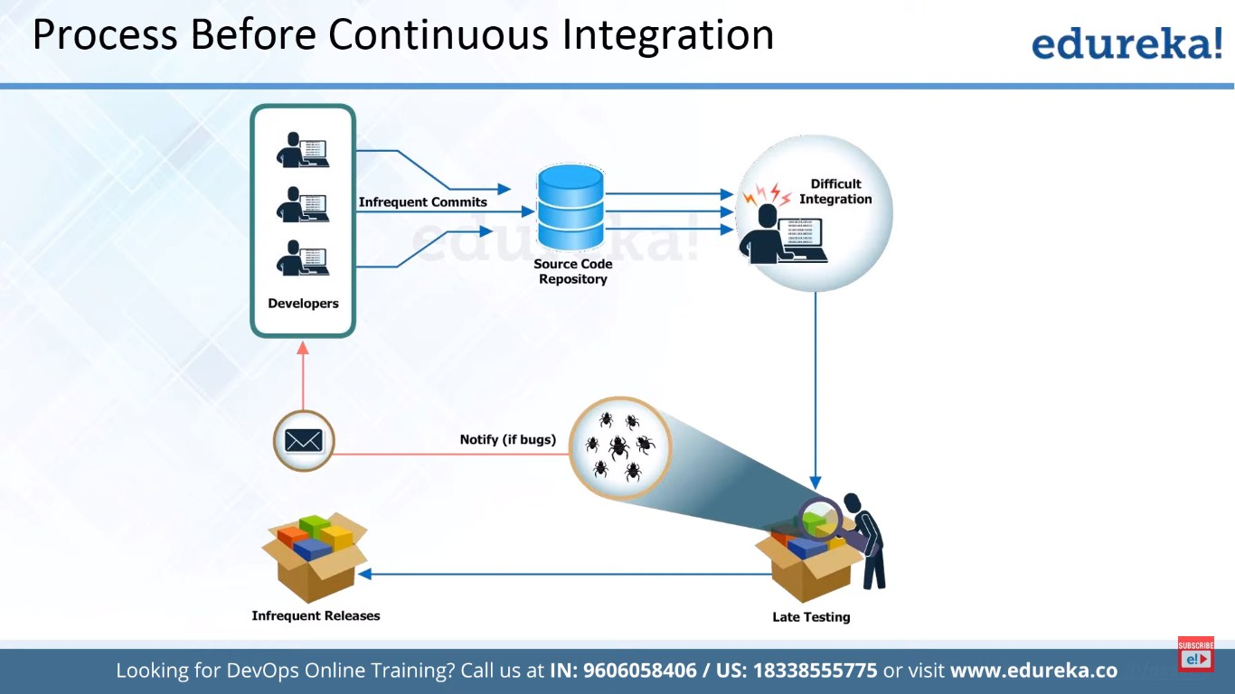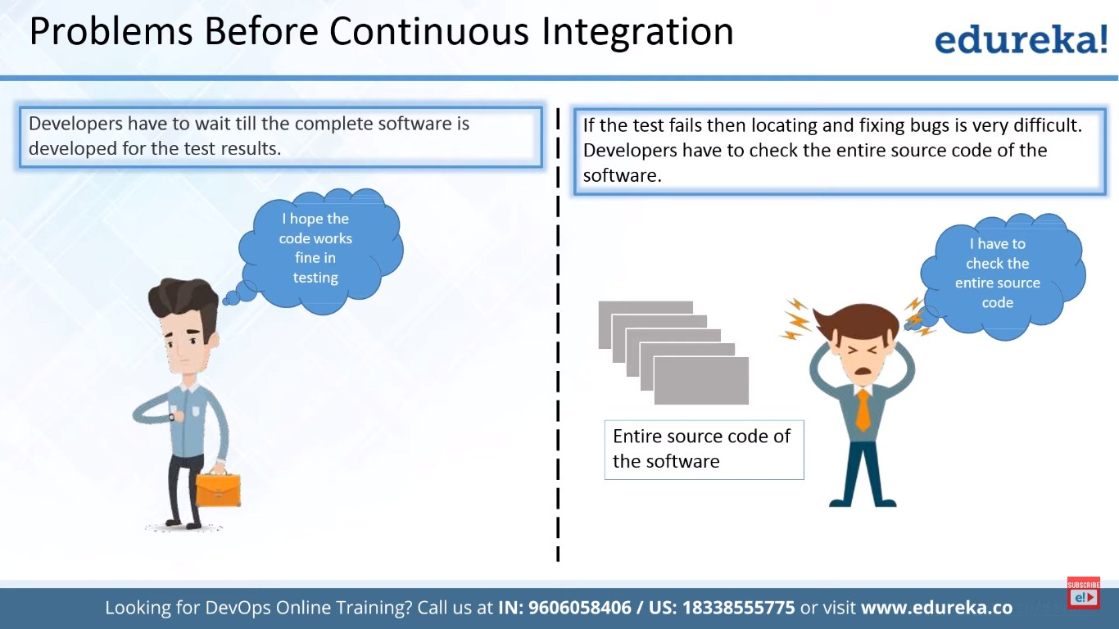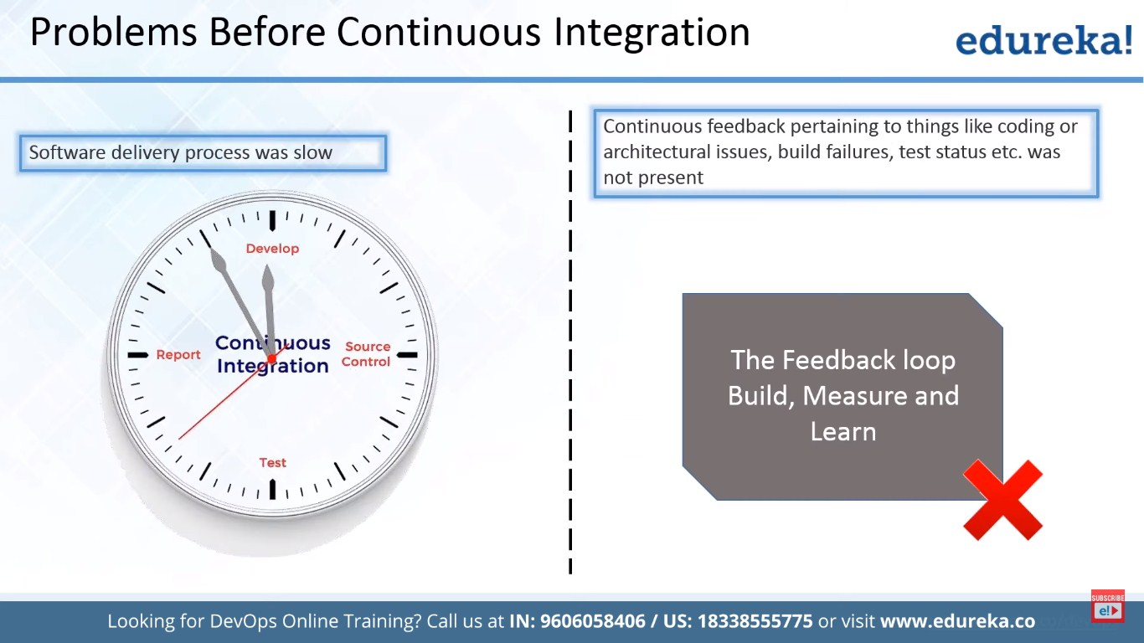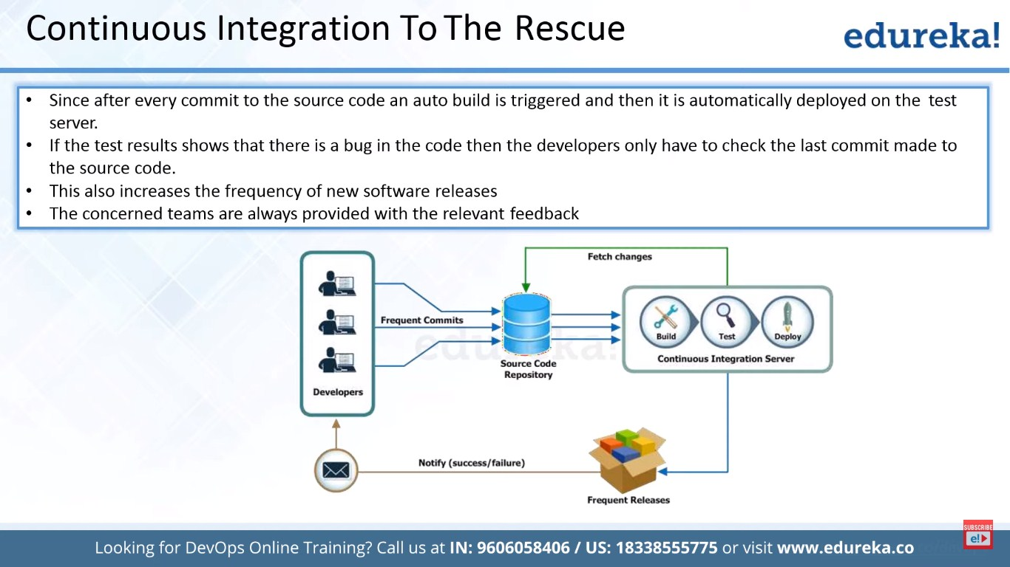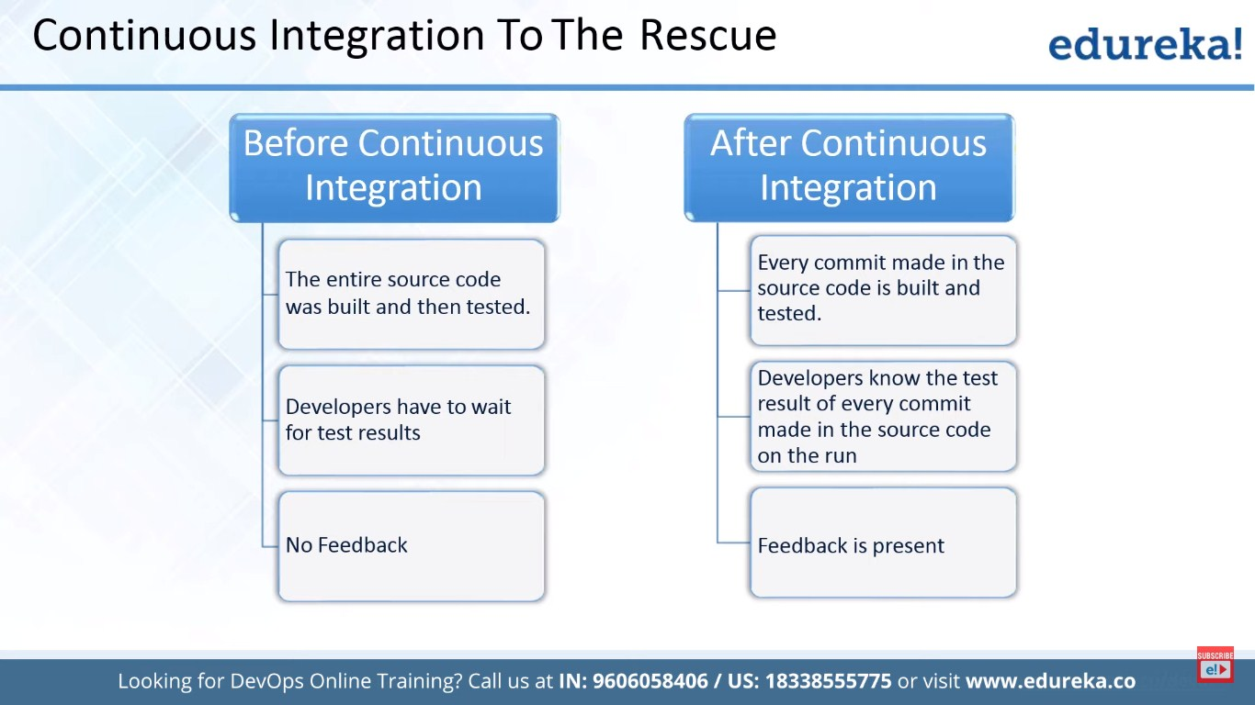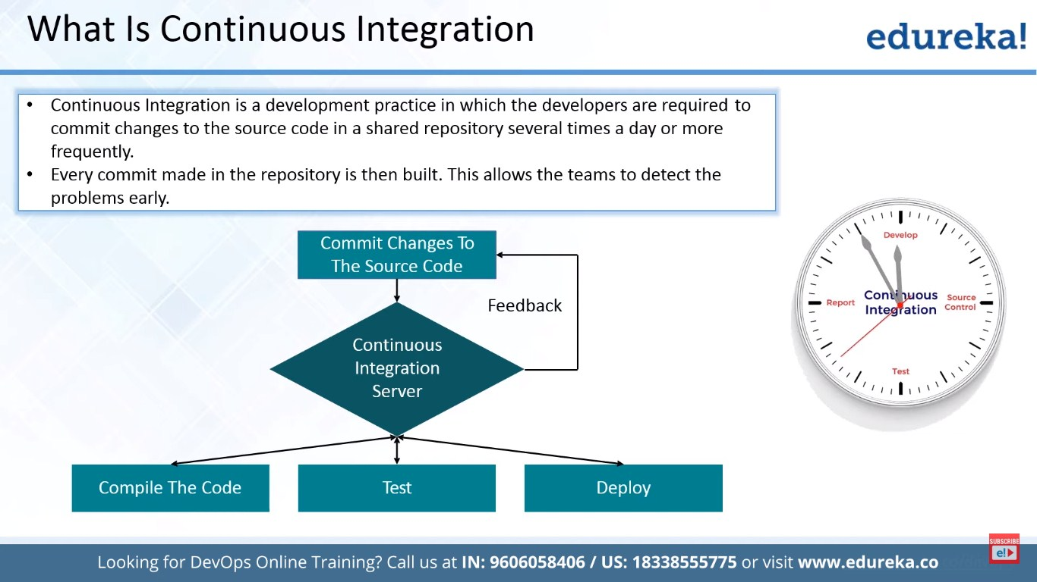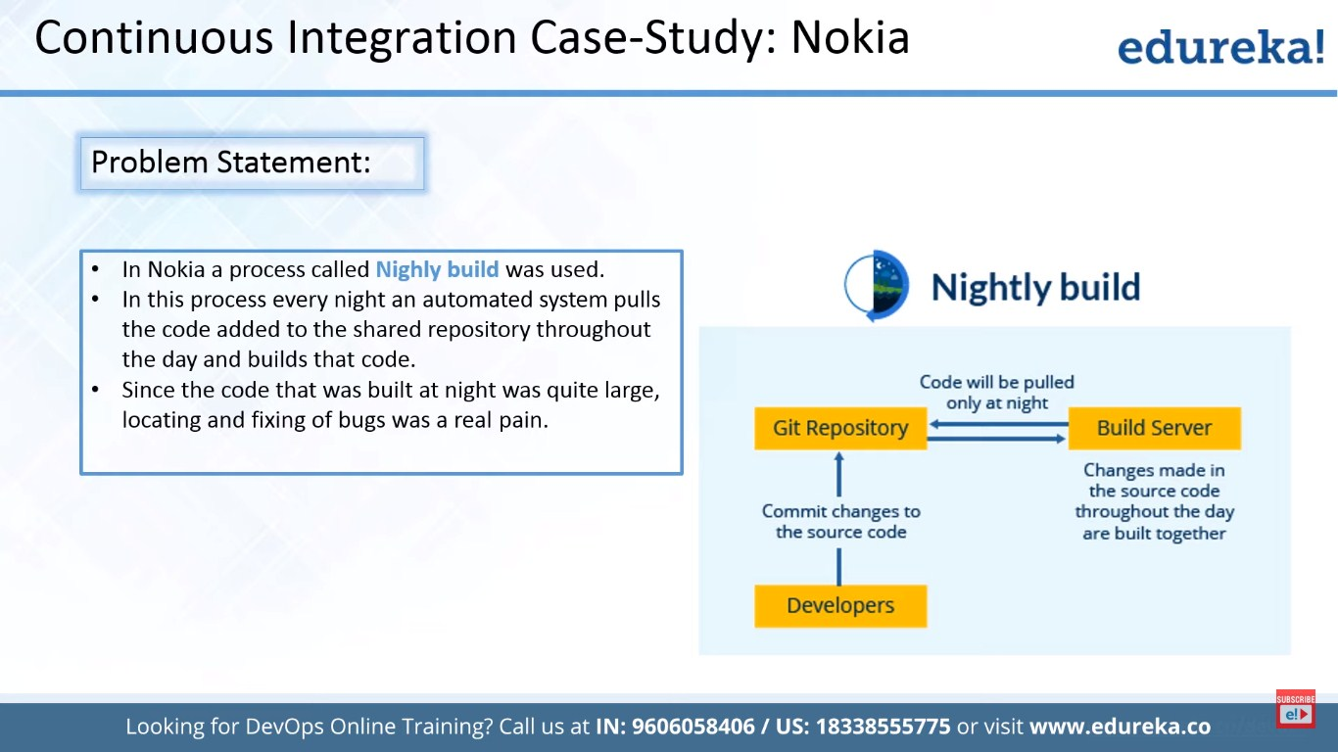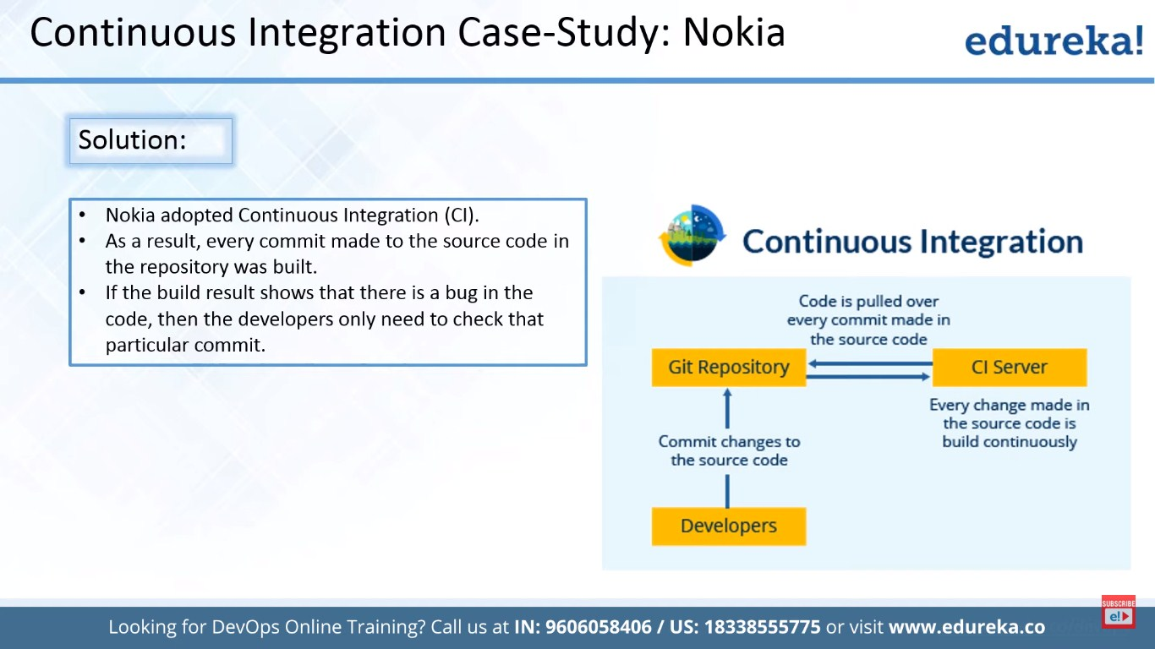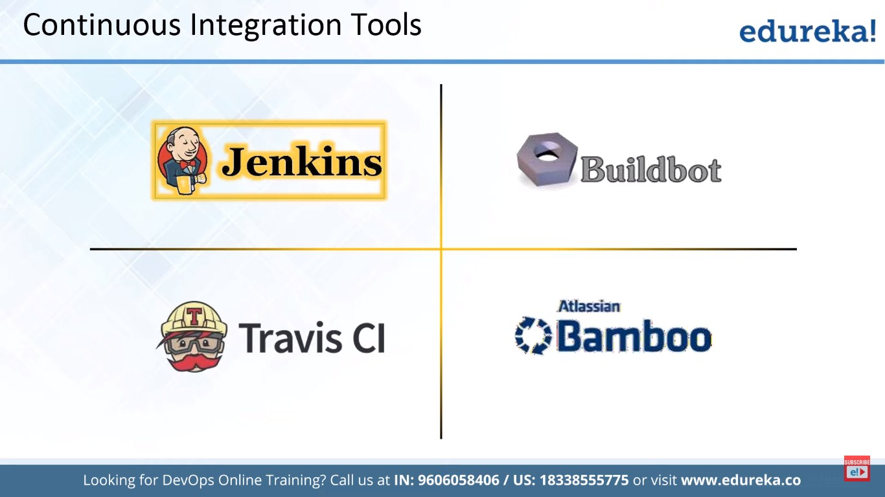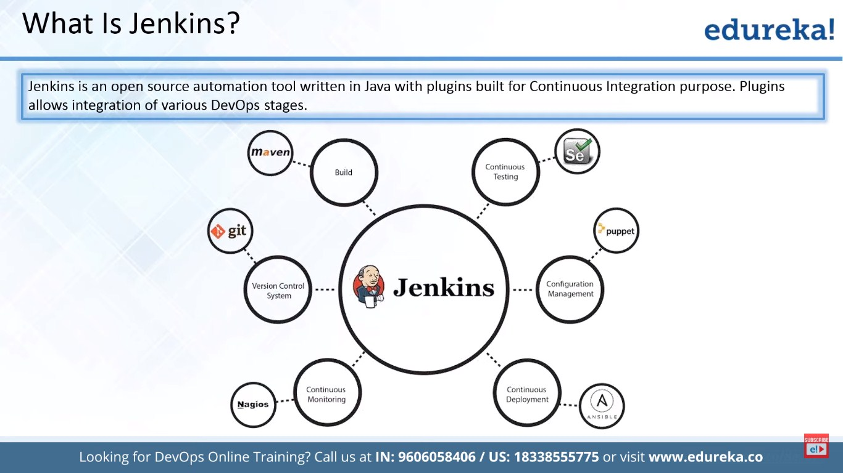

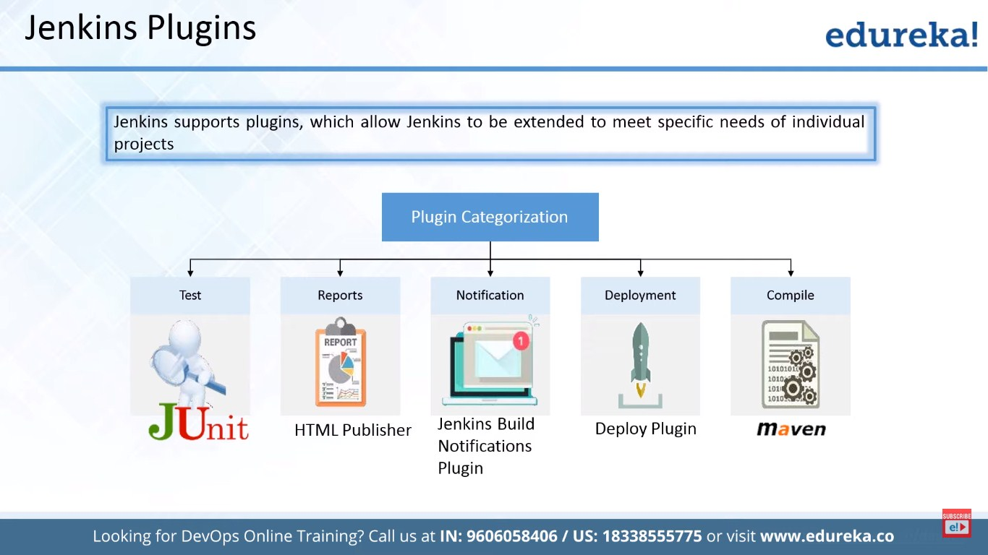

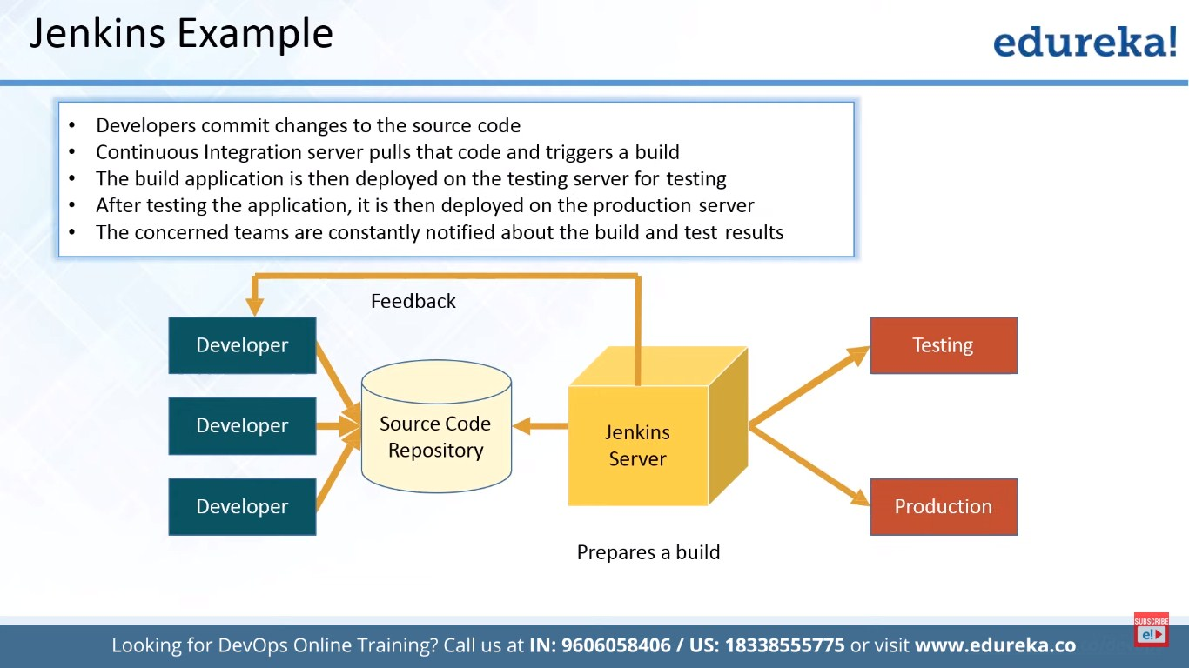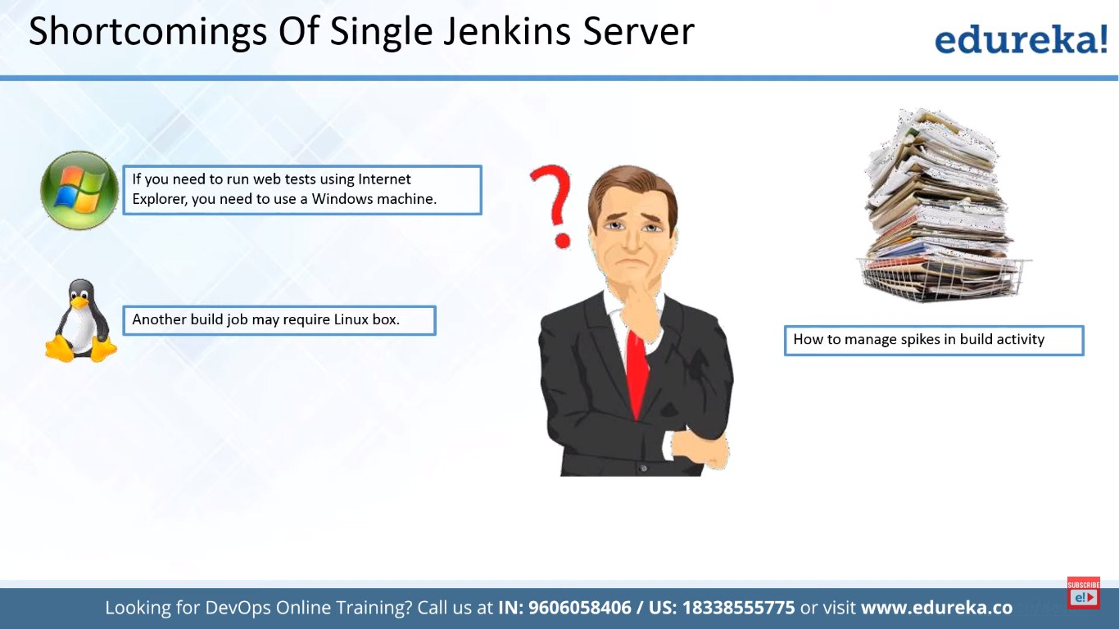

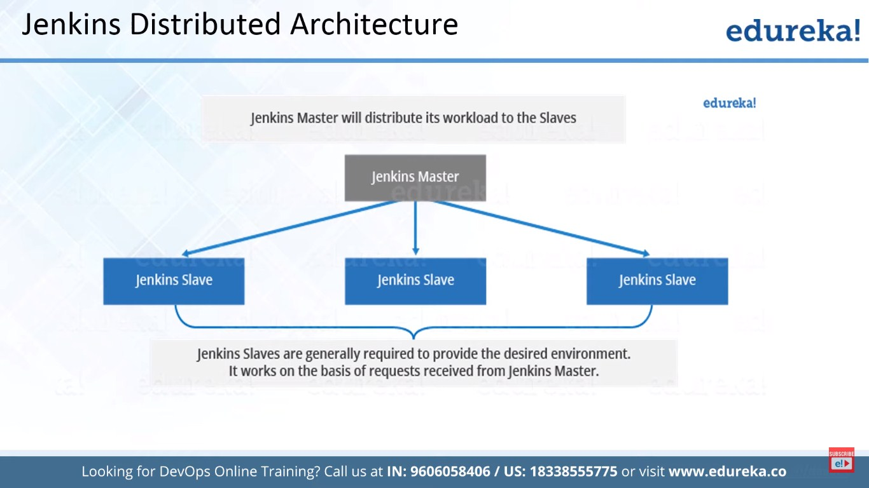

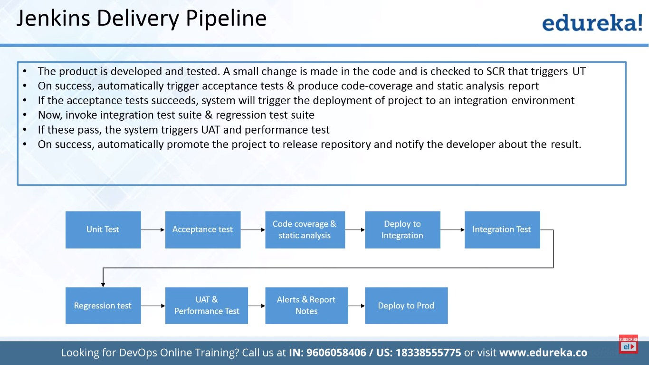

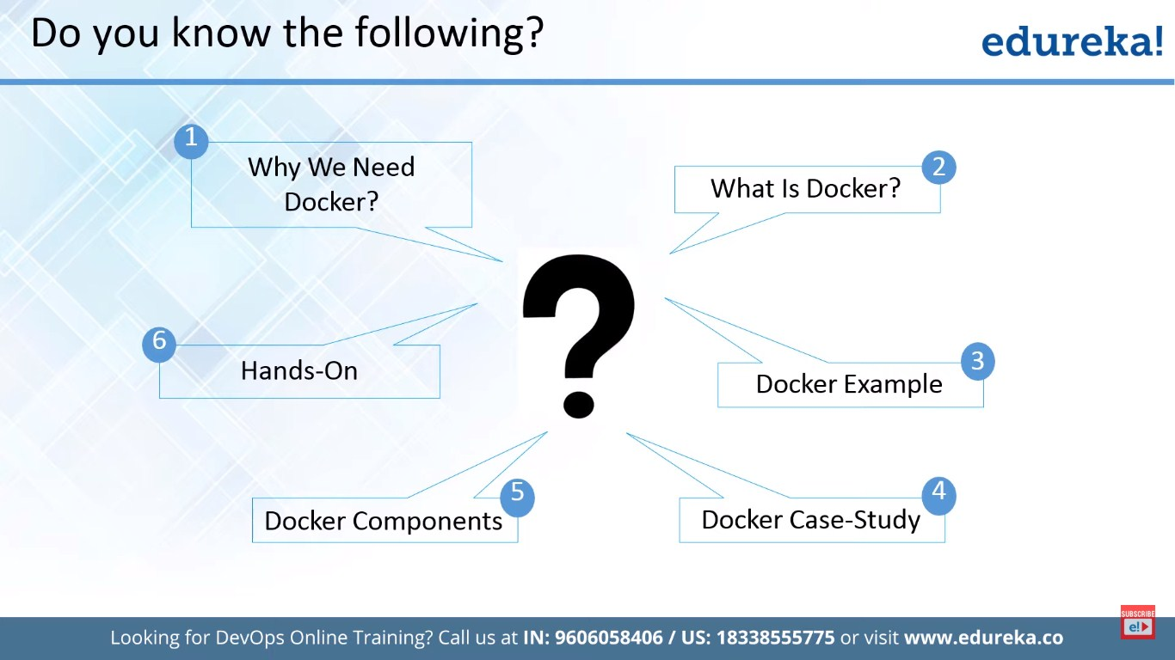

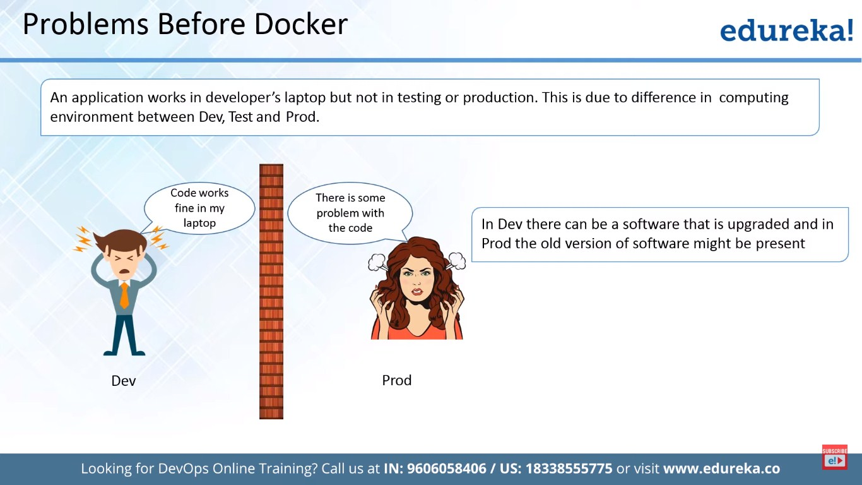

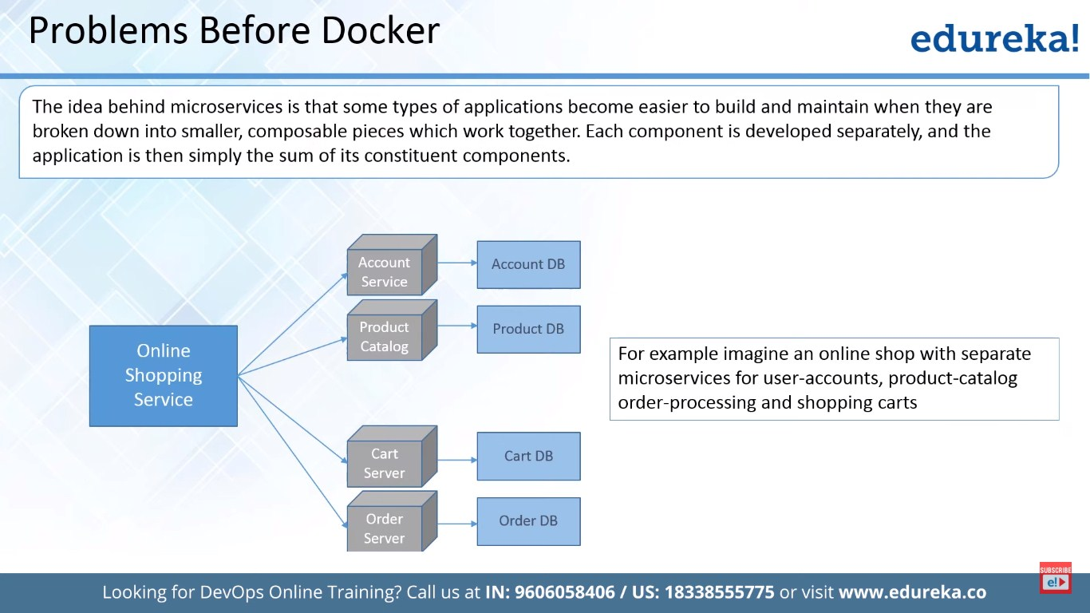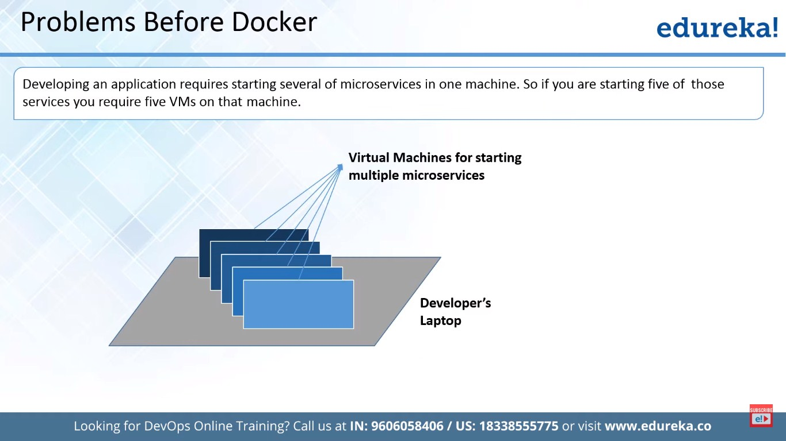

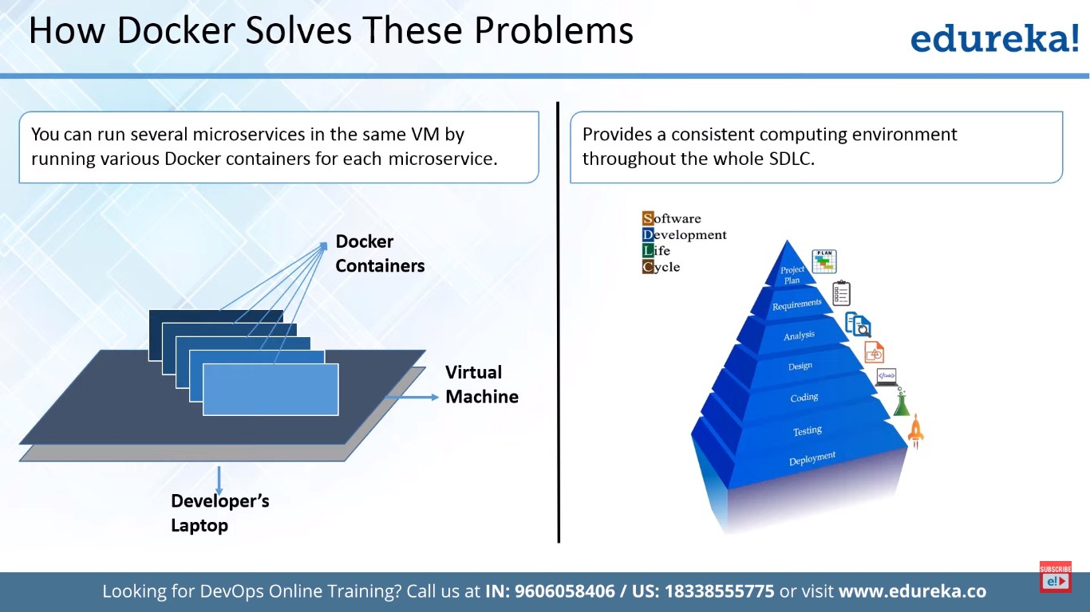

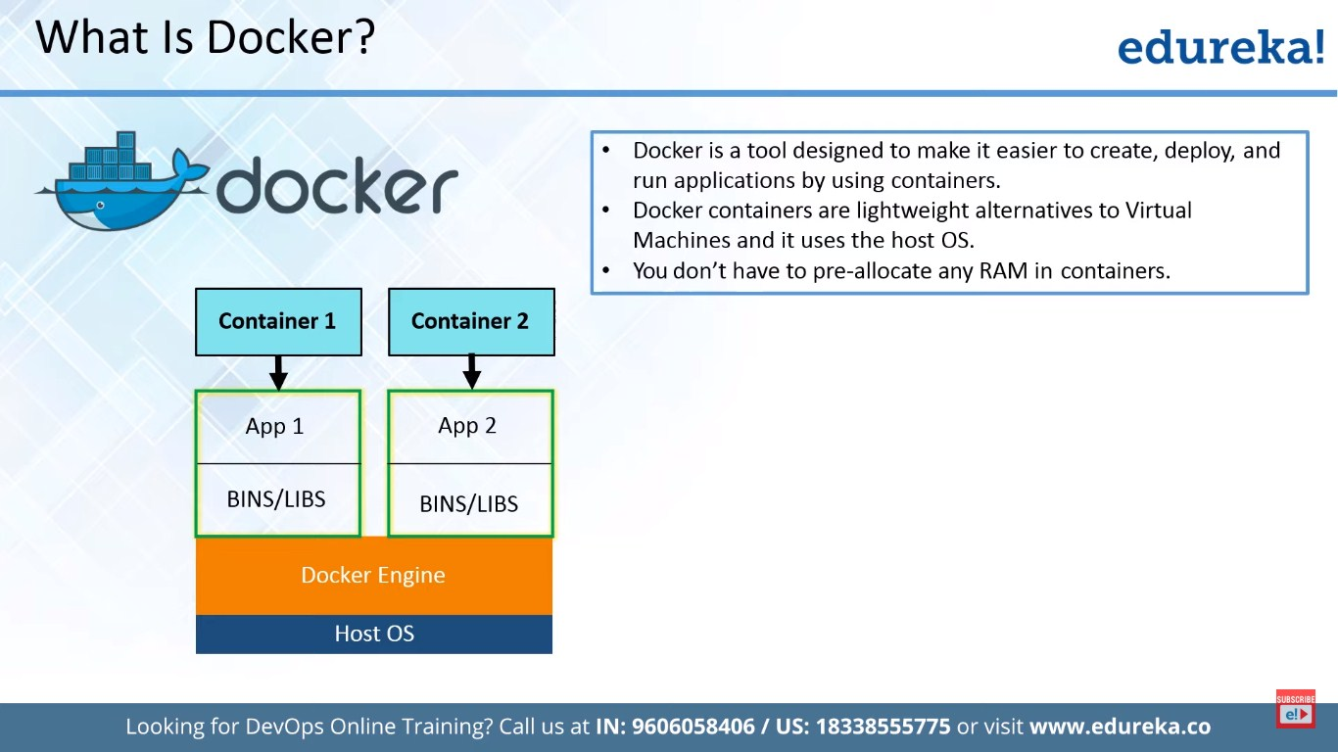

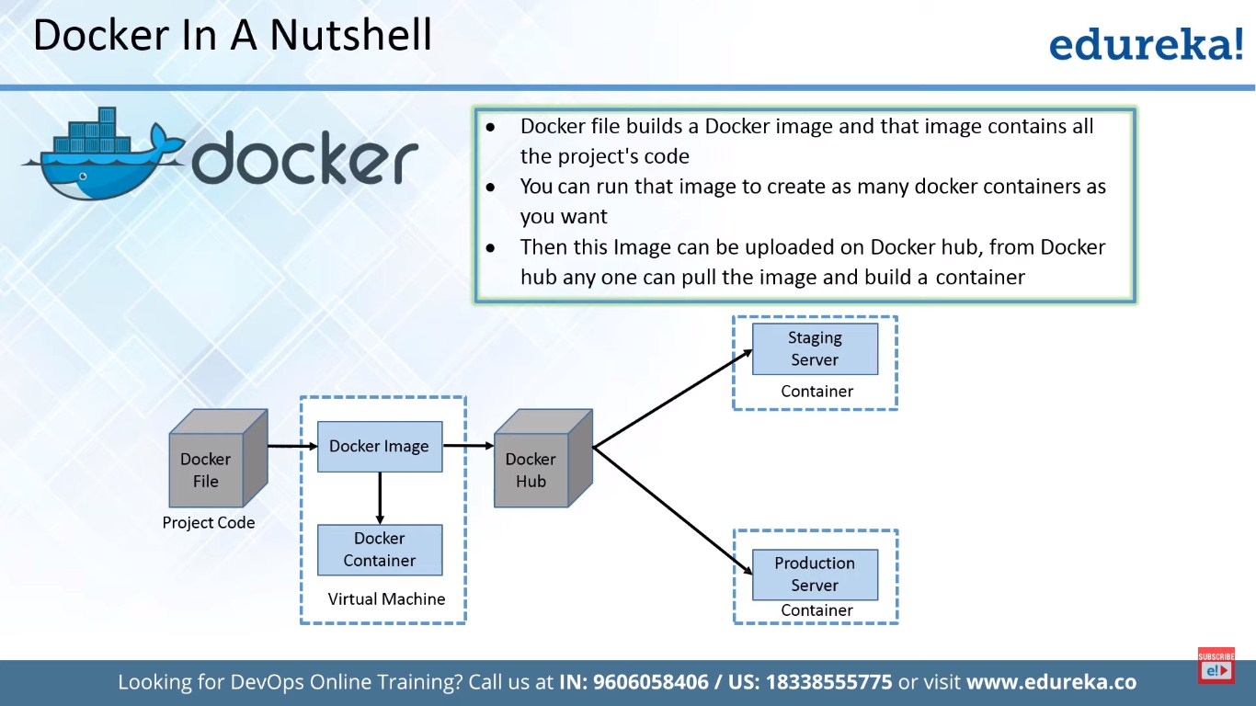

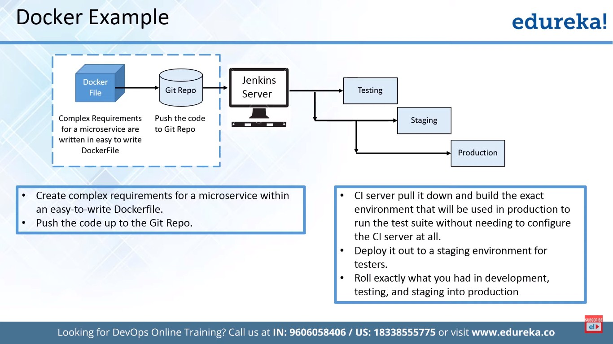

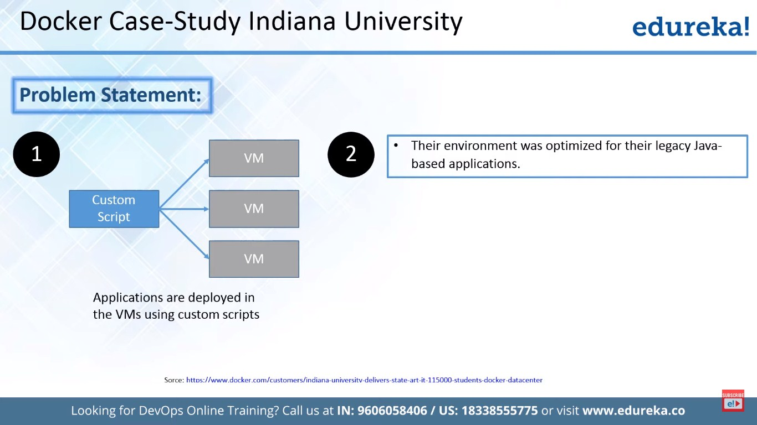

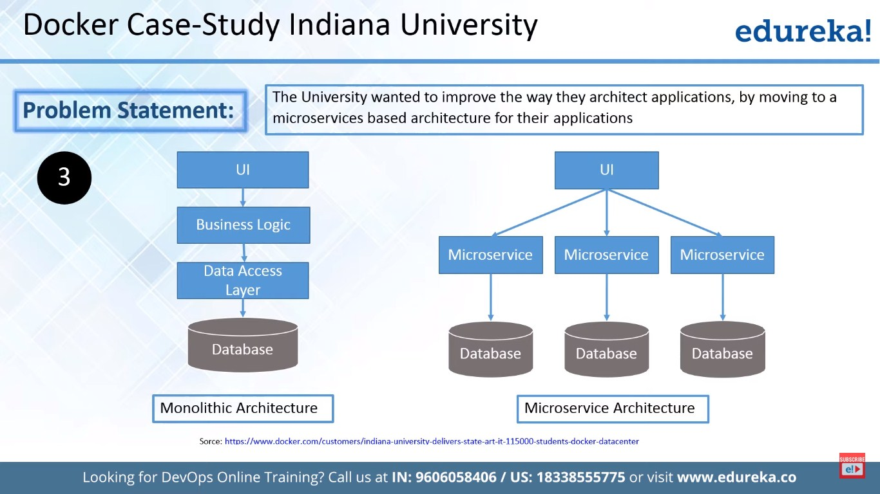

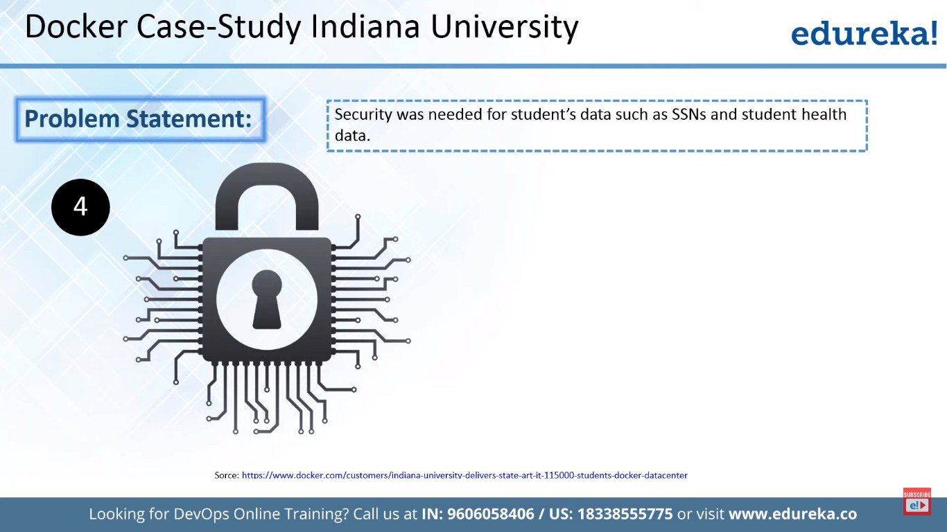

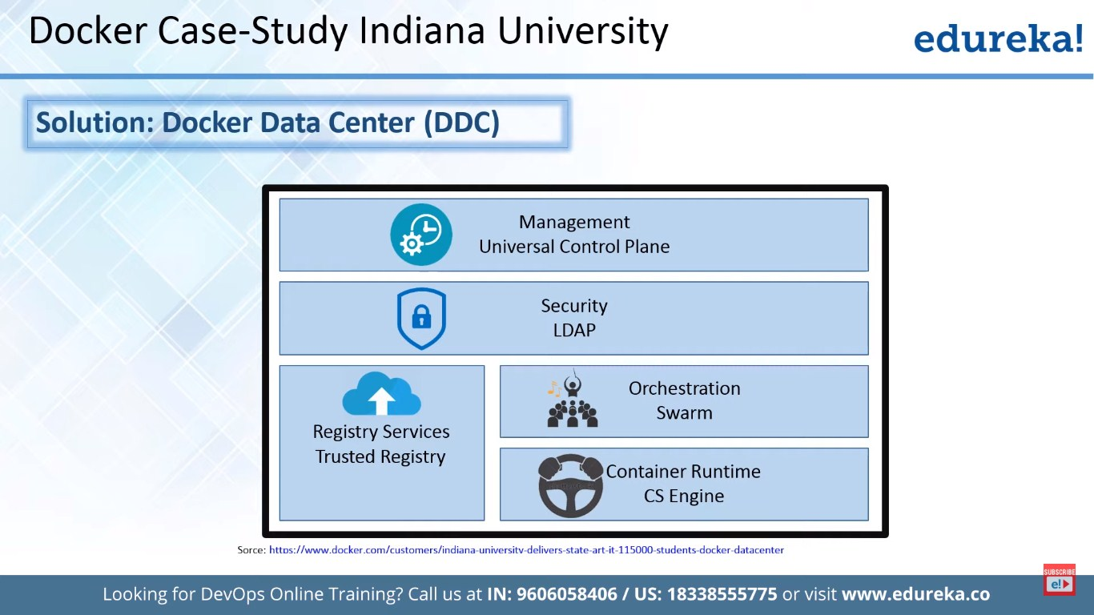

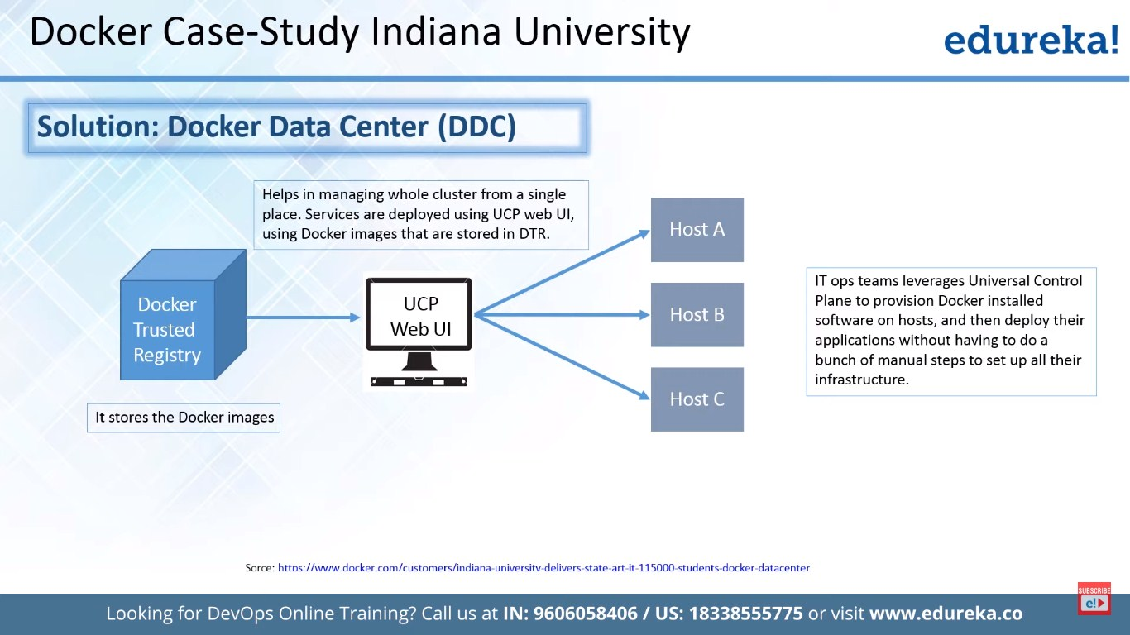

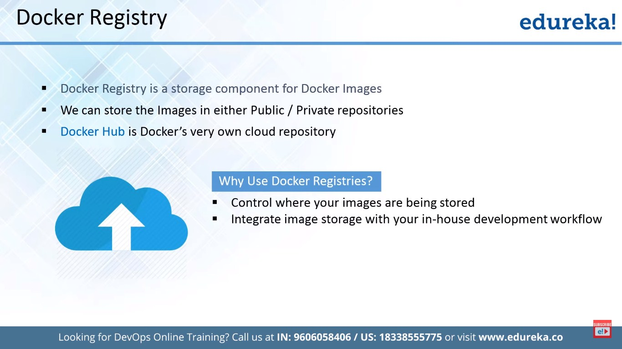

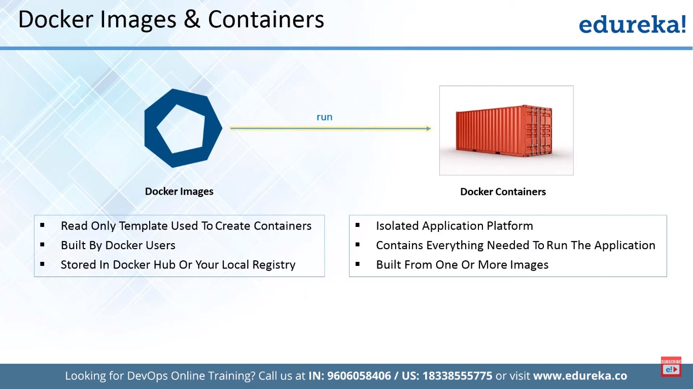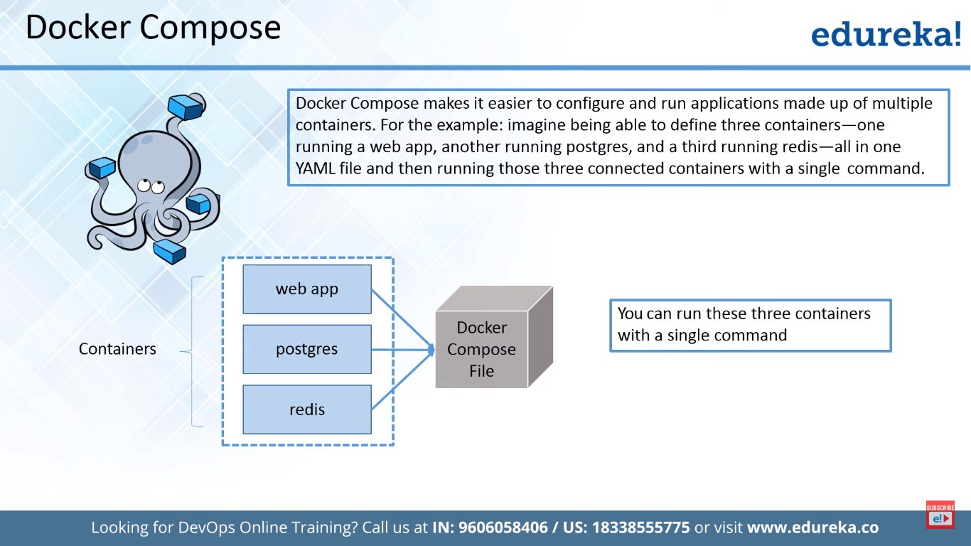

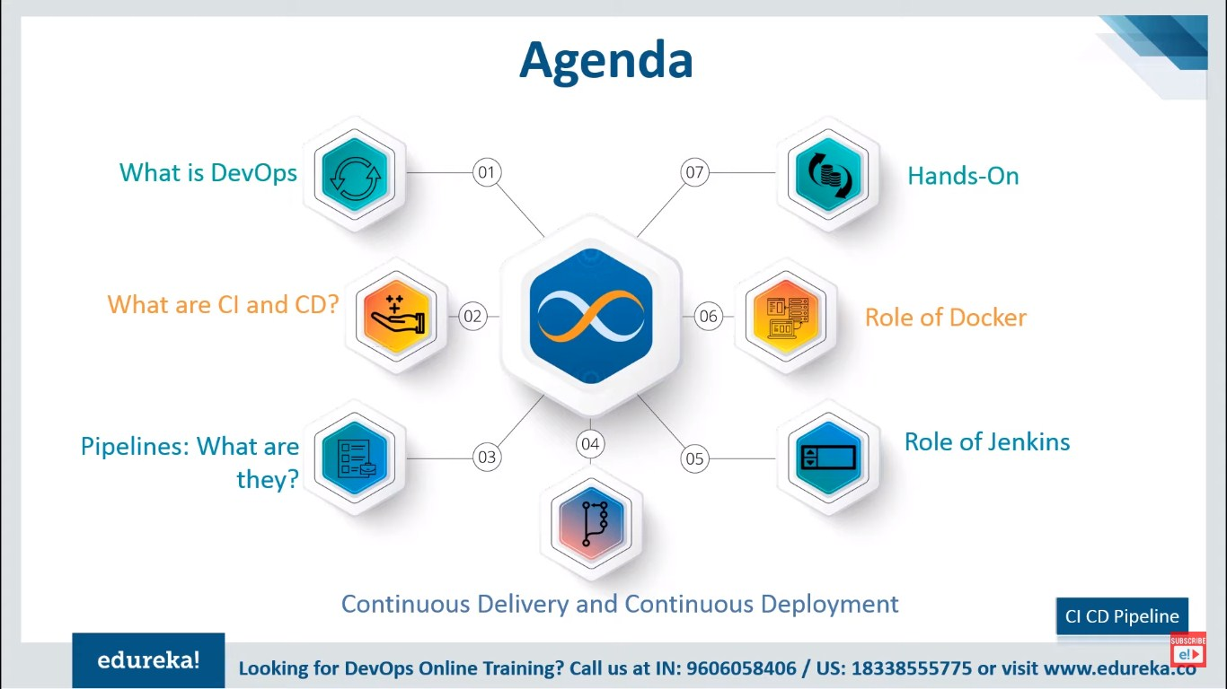

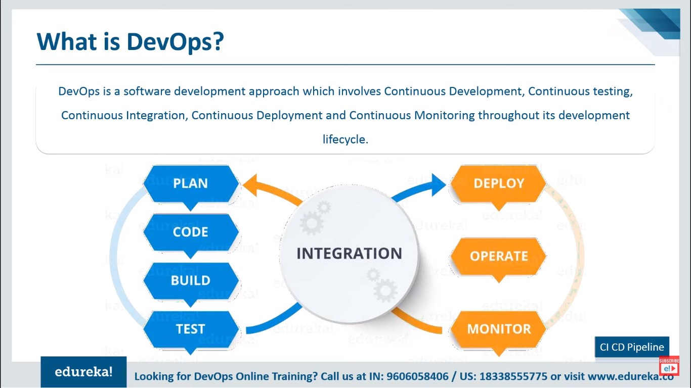

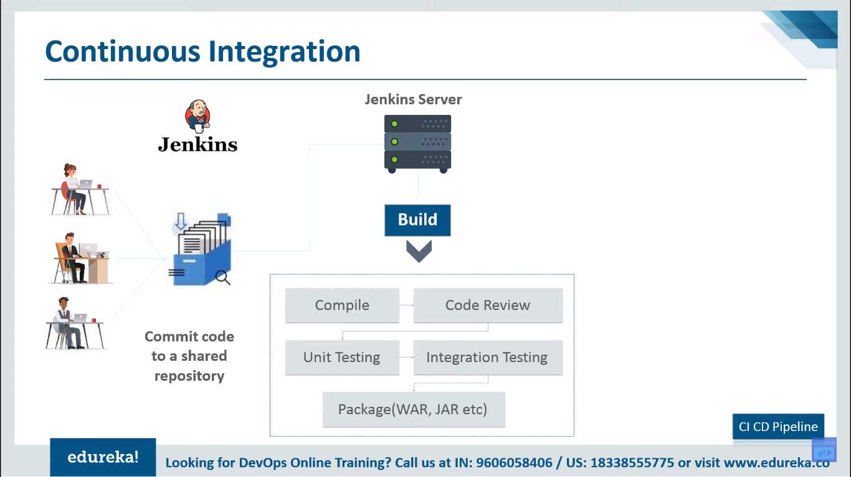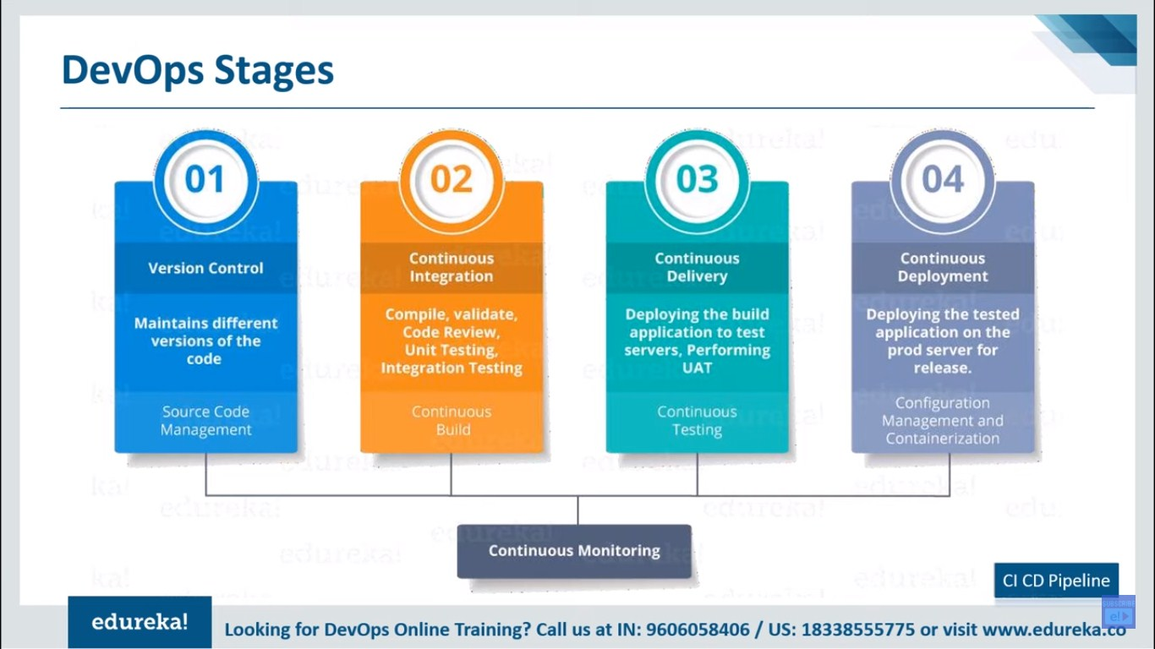

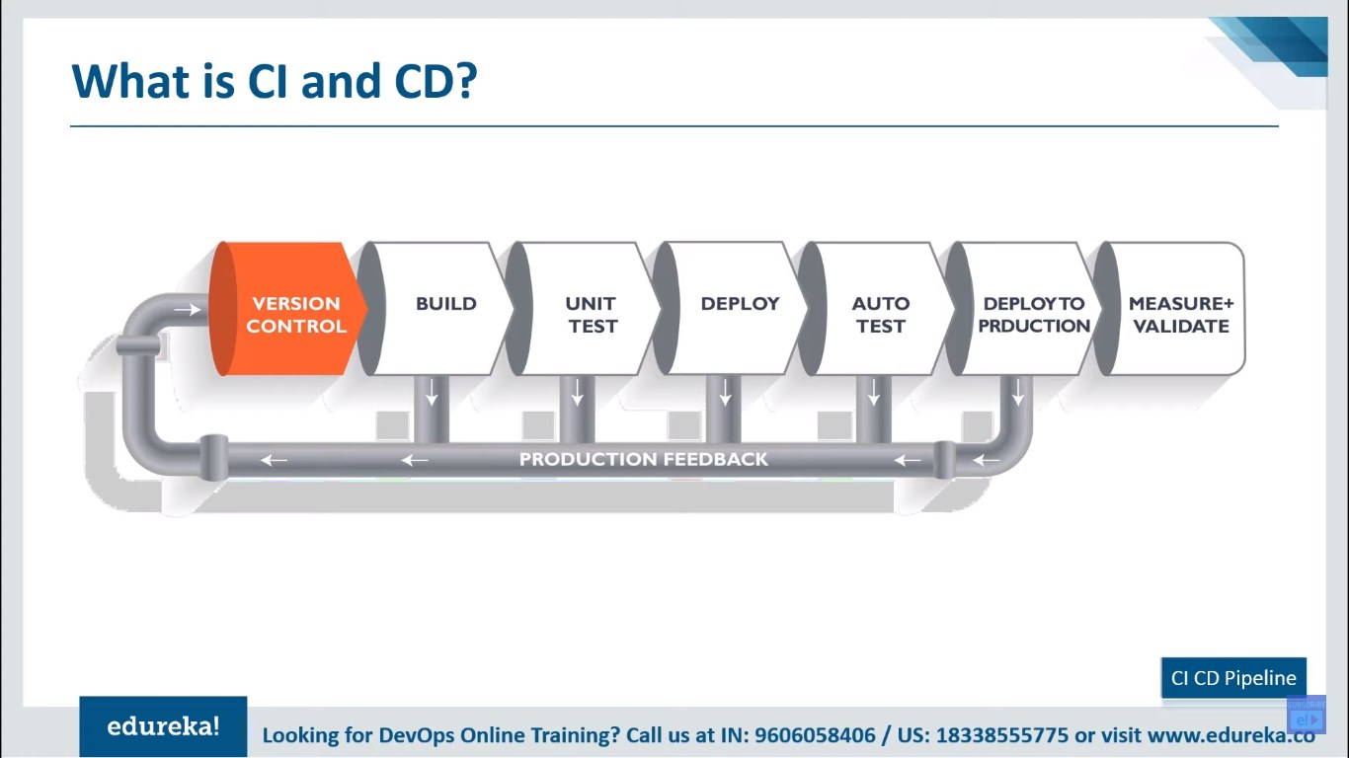

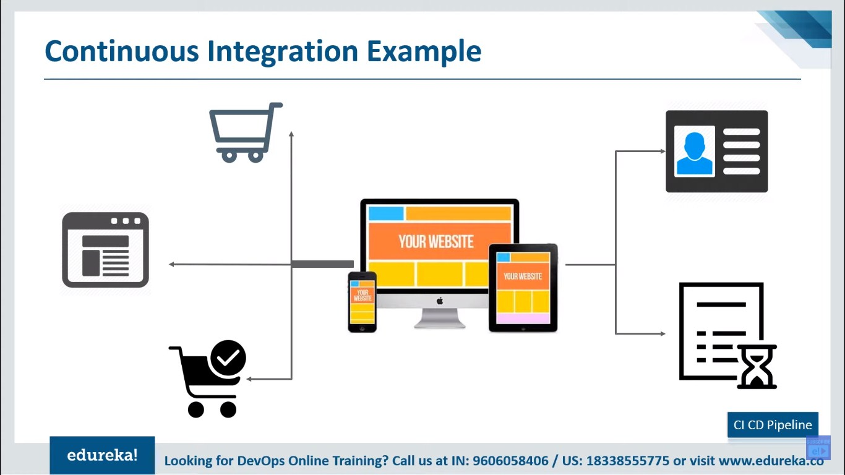

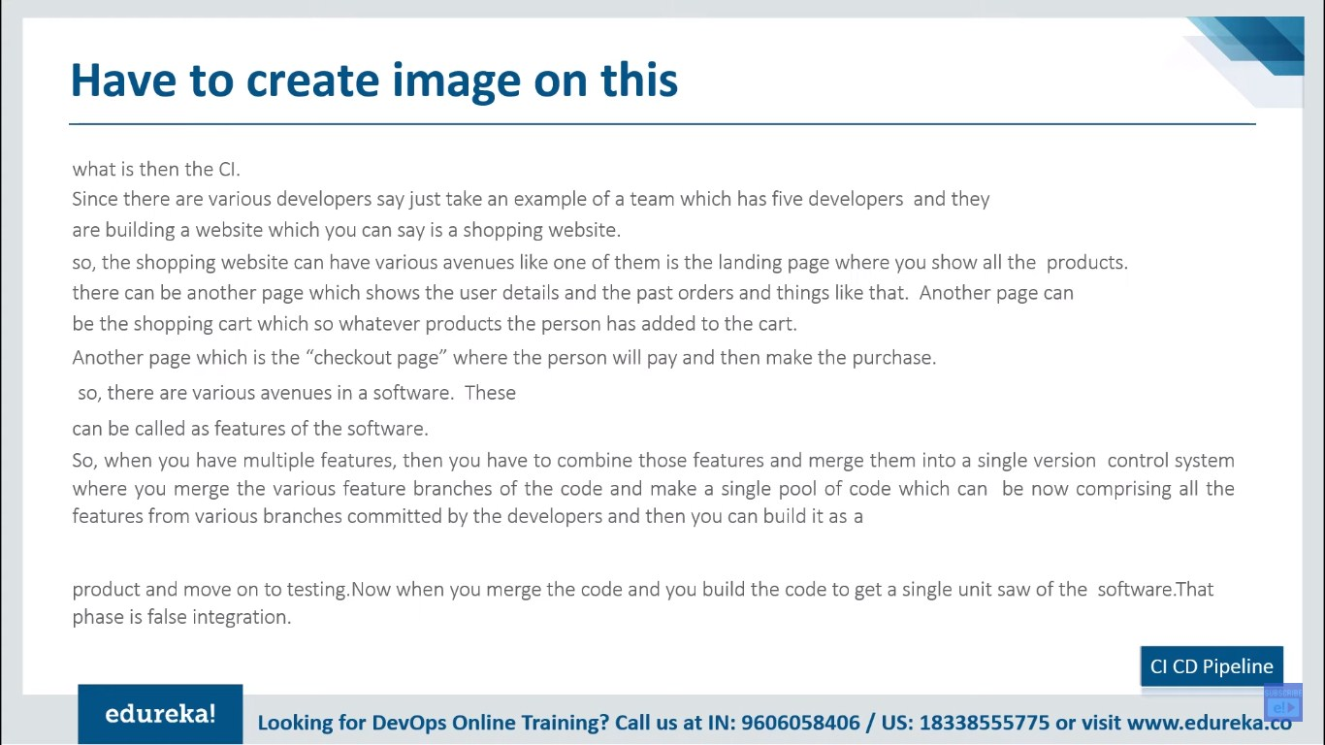

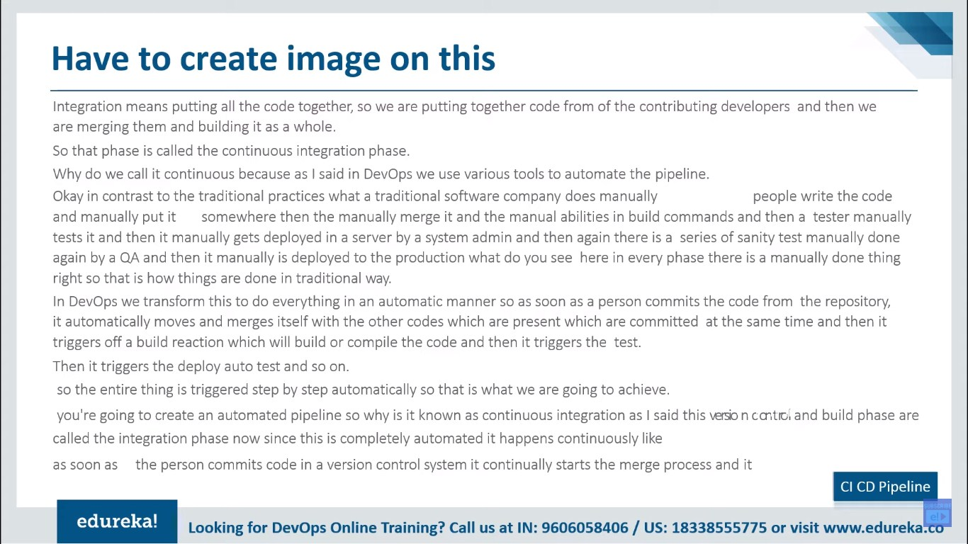

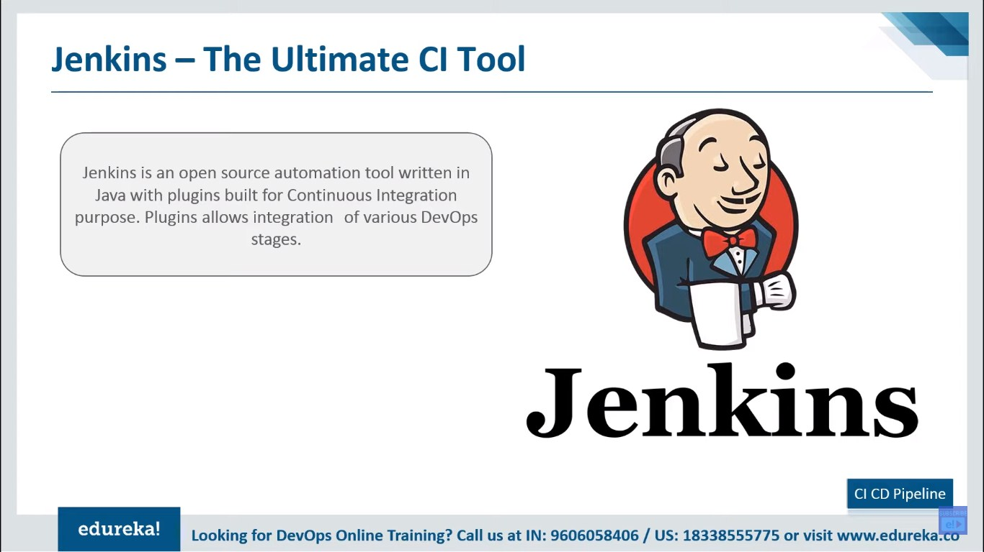

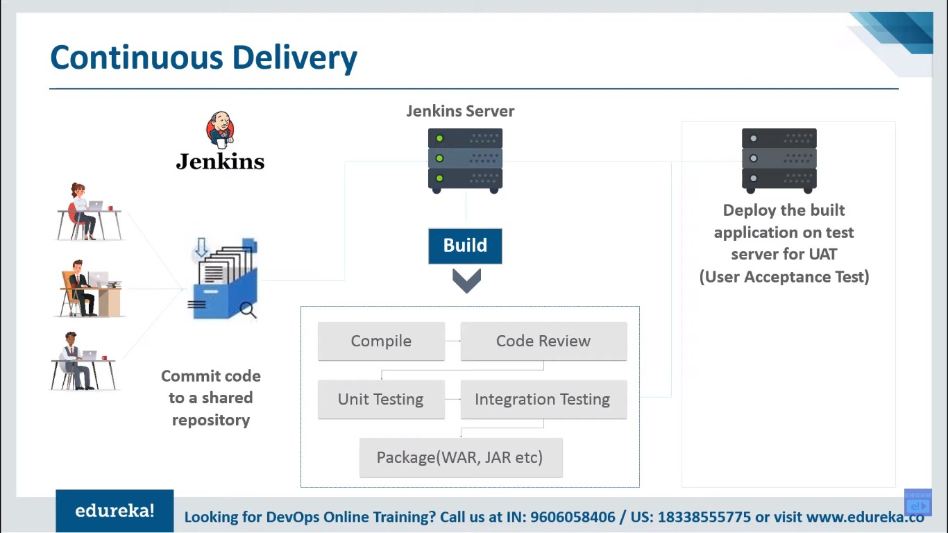

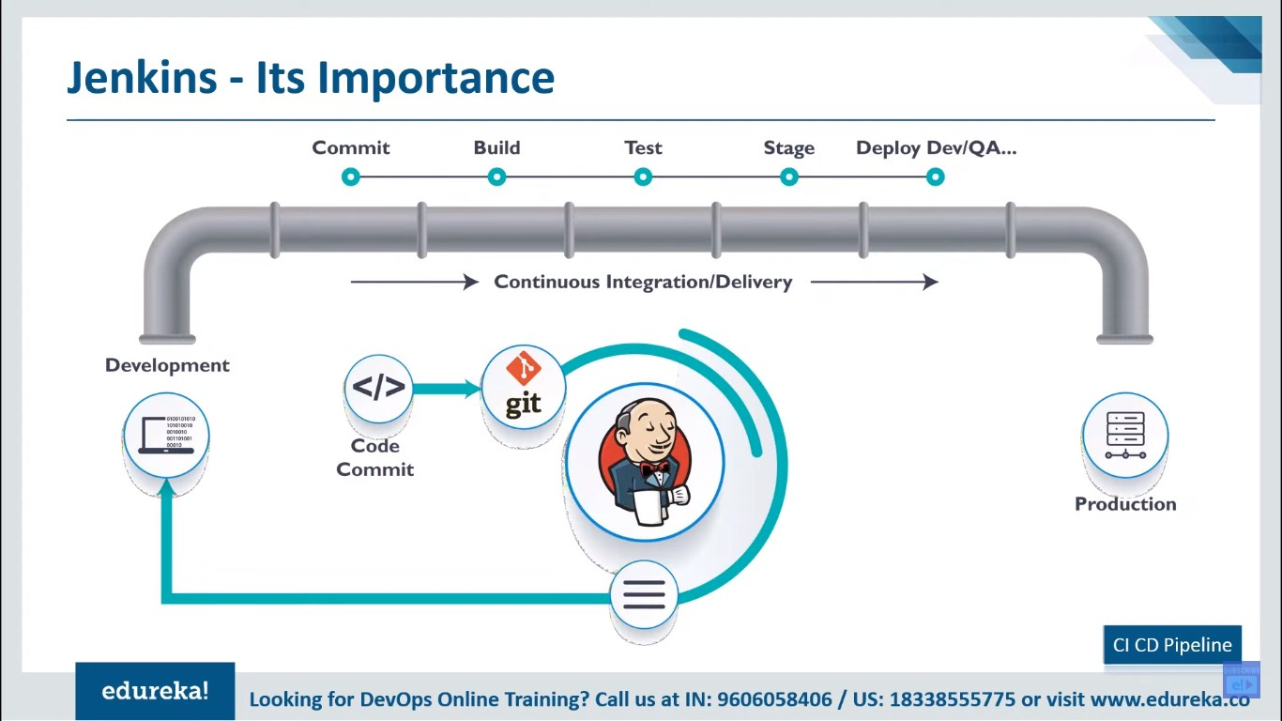

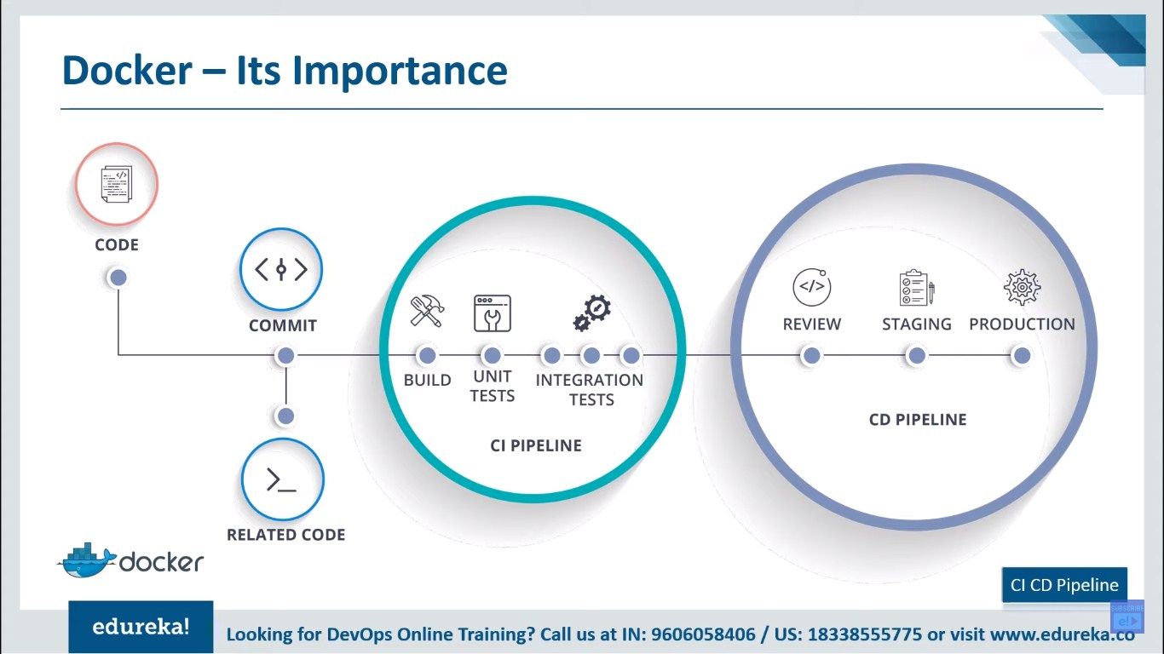

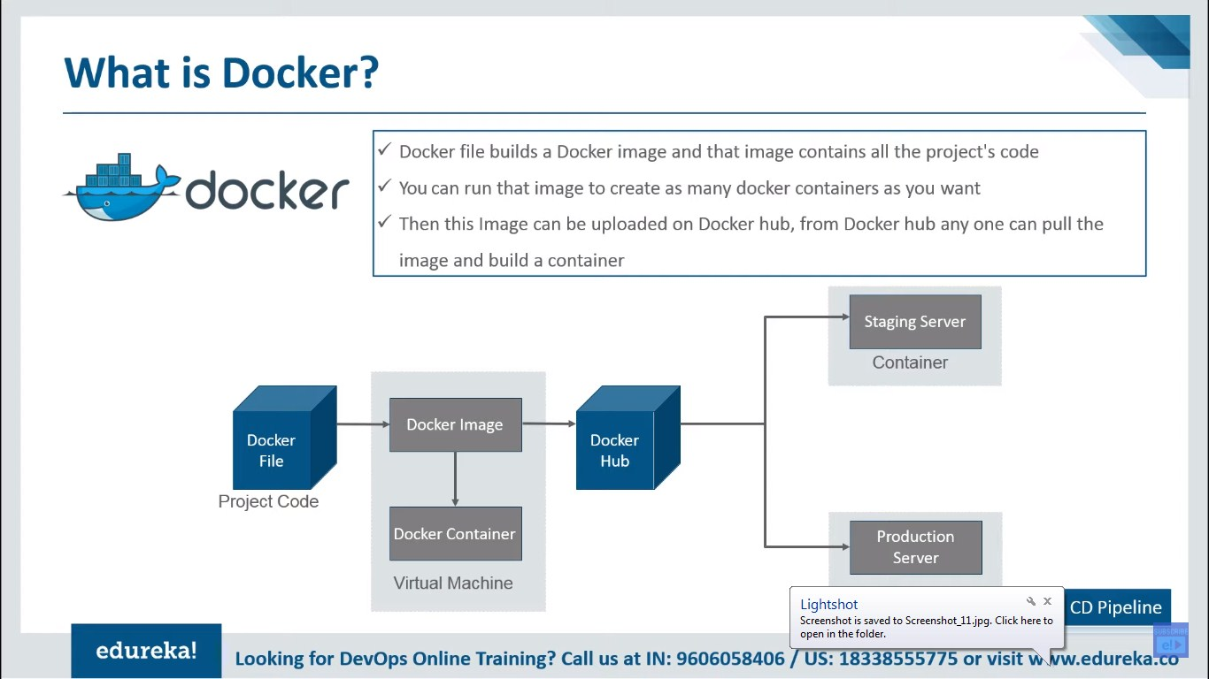

**Dev OPS Another**

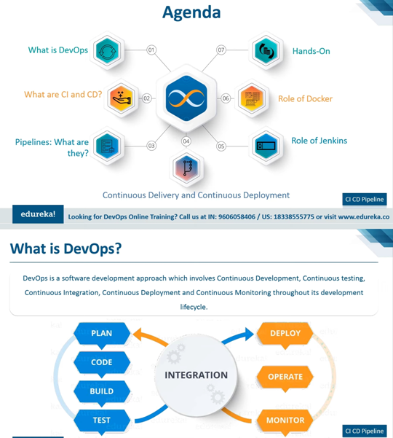

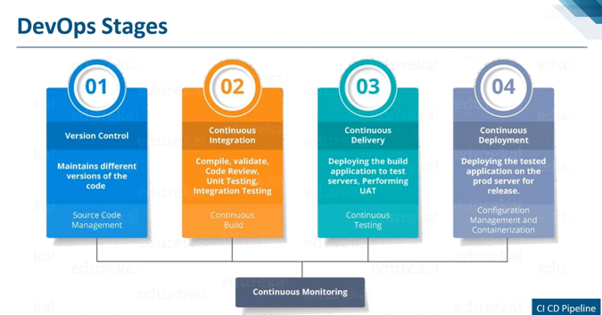

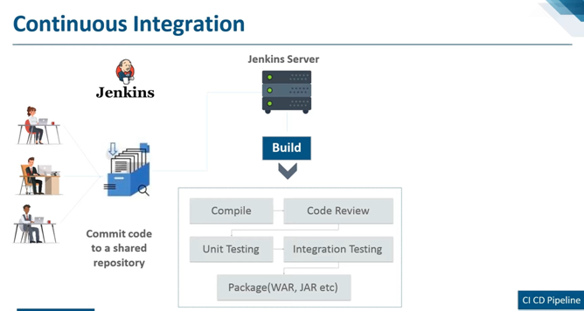

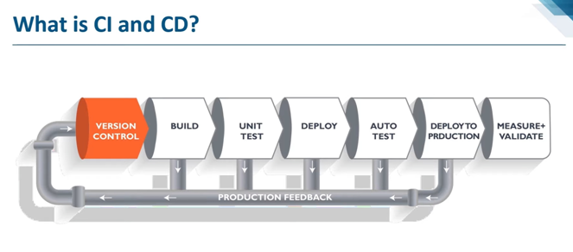

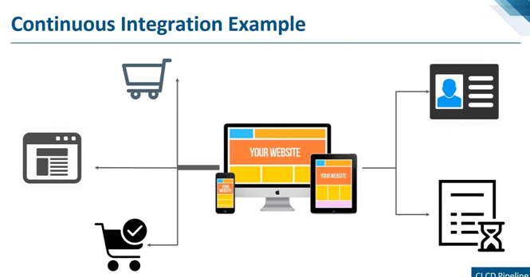

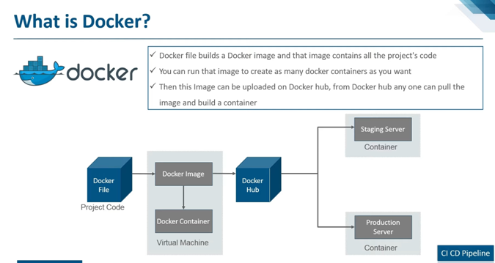

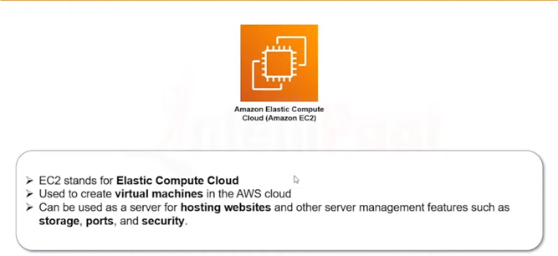

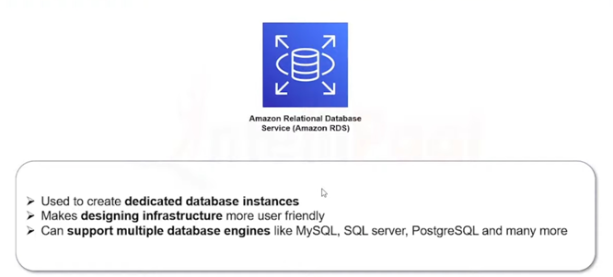

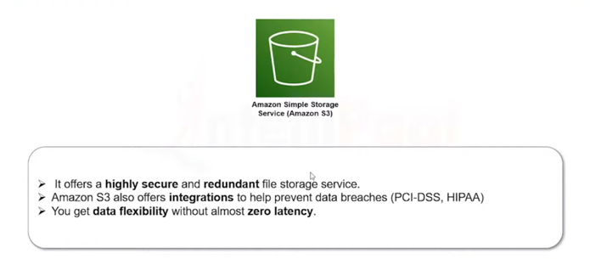

**Jenkins**

Certainly! Jenkins is a popular open-source automation server that helps automate parts of the software development process. It supports building, deploying, and automating any project.

Here's a basic tutorial to get you started with Jenkins:

### Step 1: Install Jenkins

1. **Download Jenkins:** Visit the [Jenkins official website](https://www.jenkins.io/download/) and download the latest stable version for your operating system.
2. **Install Jenkins:** Follow the installation instructions provided for your specific operating system.
3. **Start Jenkins:** Once installed, start the Jenkins service. You can access Jenkins by opening a web browser and navigating to **http://localhost:8080** (by default).
4. **Unlock Jenkins:** During the first run, Jenkins will ask for an initial password. Retrieve this password from the Jenkins server's file system and follow the setup process.

### Step 2: Configure Jenkins

1. **Install Plugins:** Jenkins uses plugins to extend its functionality. After unlocking Jenkins, you can choose to install suggested plugins or select them manually. Common plugins include Git, GitHub, and Maven.
2. **Create Admin User:** Set up the admin user credentials for your Jenkins instance.
3. **Configure Jenkins URL:** Configure the Jenkins URL to match your environment.

### Step 3: Create a New Jenkins Job

1. **Create a New Job:**
   * Click on "New Item" on the Jenkins dashboard.
   * Enter a name for your job and select the type of job you want to create (Freestyle project is a good start).
2. **Configure Source Code Management:**
   * If your project is in Git, enter the repository URL and credentials if required.
3. **Build Trigger:**
   * Define when the build should be triggered (e.g., on code commit, scheduled, etc.).
4. **Build Steps:**
   * Add build steps, such as shell commands, to execute during the build process.
5. **Post-build Actions:**
   * Define actions to be taken after the build, such as archiving artifacts or triggering other jobs.
6. **Save and Build:**
   * Save your job configuration and manually trigger the first build to verify everything is set up correctly.

### Step 4: Explore Jenkins Features

1. **View Build History:**
   * Check the build history on the job dashboard.
2. **Console Output:**
   * Examine the console output for detailed information about the build process.
3. **Configure Jenkins Global Settings:**
   * Explore and configure Jenkins global settings as needed.

### Step 5: Jenkins Pipelines (Optional)

Jenkins supports defining pipelines as code using the Jenkinsfile. A Jenkinsfile can be stored in your version control system and provides a way to define complex build and deployment workflows.

1. **Create a Jenkinsfile:**
   * Create a file named **Jenkinsfile** in your project repository.
2. **Pipeline Syntax:**
   * Define stages, steps, and post-build actions using the Jenkins pipeline syntax.
3. **Configure Jenkins to Use Jenkinsfile:**
   * Configure your Jenkins job to use the Jenkinsfile from your version control system.

**How to integrate jenkins with gitlab**

Integrating Jenkins with GitLab allows you to automate builds, tests, and deployments triggered by changes in your GitLab repositories. Here's a step-by-step guide on how to integrate Jenkins with GitLab:

### Prerequisites:

1. **Install Jenkins:** Make sure Jenkins is installed and running on your server. You can follow the installation steps provided in the Jenkins documentation.
2. **Set up a GitLab Account:** You need a GitLab account and a repository with a project to integrate with Jenkins.

### Integration Steps:

#### 1. Install Required Jenkins Plugins:

* Open Jenkins and navigate to "Manage Jenkins" > "Manage Plugins."
* In the "Available" tab, search for and install the following plugins:
  + Git Plugin
  + GitLab Plugin
  + Pipeline Plugin (if you plan to use Jenkins Pipeline)

Restart Jenkins after installing the plugins.

#### 2. Configure GitLab Integration in Jenkins:

* In Jenkins, go to "Manage Jenkins" > "Configure System."
* Scroll down to the "GitLab" section.
* Configure the following:
  + **Connection Settings:**
    - Check "Enable authentication."
    - Set the "Connection name."
    - Enter the GitLab server URL.
    - Add an "API Token" for authentication.
  + **Webhook:**
    - Check "Enable authentication."
    - Set a "Secret Token" (you'll need this when configuring the GitLab webhook).
* Click "Save" at the bottom of the page.

#### 3. Configure Webhook in GitLab:

* In your GitLab project, go to "Settings" > "Webhooks."
* Add a new webhook:
  + Set the "URL" to your Jenkins webhook URL (<http://your-jenkins-server/gitlab/notify_commit>).
  + Add the "Secret Token" configured in Jenkins.
  + Select the events that should trigger the webhook (e.g., Push events).
  + Save the webhook.

#### 4. Create a Jenkins Job for Your GitLab Project:

* In Jenkins, click "New Item" to create a new job.
* Enter a name for your job and select the type (Freestyle project or Pipeline).
* Configure your source code management (e.g., Git) with your GitLab repository URL.
* Set up any build triggers (e.g., Poll SCM or webhook trigger for Jenkins Pipeline).
* Configure build steps, post-build actions, etc.
* Save the job.

#### 5. Test the Integration:

* Make a change in your GitLab repository and push it.
* Check the Jenkins job to see if it triggers a build.

### Additional Notes:

* For Jenkins Pipeline users, you can define your build steps and pipeline in a Jenkinsfile in your GitLab repository.
* Jenkins and GitLab should be accessible to each other over the network.
* Ensure proper firewall and security group configurations if Jenkins and GitLab are running on different servers.

**Step of creation ci cd pipeline**

Creating a CI/CD (Continuous Integration/Continuous Deployment) pipeline with Jenkins typically involves defining a set of steps to automate the build, test, and deployment processes. Below is a basic guide for creating a CI/CD pipeline using Jenkins:

### Prerequisites:

1. **Jenkins Installed:** Ensure Jenkins is installed and running on your server. You should also have the necessary plugins installed, such as Git, GitLab, or others based on your version control system and deployment targets.
2. **Source Code Repository:** Your project should be hosted in a version control system (e.g., GitLab, GitHub).

### Steps to Create a CI/CD Pipeline:

#### 1. Create a New Jenkins Job:

* Open Jenkins and click on "New Item."
* Enter a name for your job (e.g., "MyApp_CI_CD_Pipeline").
* Choose the type of project (e.g., Freestyle project or Pipeline).
* Click "OK."

#### 2. Configure Source Code Management:

* In the job configuration, find the "Source Code Management" section.
* Choose your version control system (e.g., Git).
* Provide the repository URL and credentials if necessary.

#### 3. Define Build Steps:

##### For Freestyle Project:

* In the job configuration, find the "Build" section.
* Add build steps, which could include commands to compile code, run tests, etc.

##### For Pipeline Project:

* If using Jenkins Pipeline, you'll define your pipeline in a **Jenkinsfile** in your repository.
* Create a **Jenkinsfile** with stages for build, test, and deployment.

Example **Jenkinsfile**:

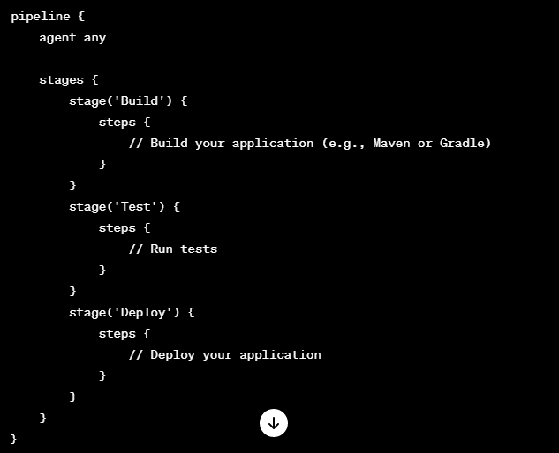

#### 4. Add Post-Build Actions (Optional):

* In the job configuration, find the "Post-build Actions" section.
* Configure actions like archiving artifacts, sending notifications, etc.

#### 5. Save and Run the Pipeline:

* Save the job configuration.
* Manually trigger the pipeline or configure it to be triggered automatically on code changes.

#### 6. Monitor Pipeline Execution:

* View the progress of your pipeline in the Jenkins dashboard.
* Check the console output for each build stage to identify any issues.

#### 7. Add CD (Continuous Deployment) Steps:

* Extend your pipeline to include deployment steps to your target environment.

### Additional Considerations:

* **Environment Variables:** Use Jenkins environment variables for sensitive data like API keys or credentials.
* **Notifications:** Configure notifications (email, Slack, etc.) to alert the team about build and deployment status.
* **Integration with Version Control:** Leverage webhooks or polling to trigger the pipeline on code changes.
* **Testing:** Implement thorough testing stages in your pipeline to catch issues early.

**how to install and configure jenkins on aws server**

Installing and configuring Jenkins on an AWS (Amazon Web Services) server involves several steps. Below is a basic guide to help you set up Jenkins on an AWS EC2 instance. Please note that the following instructions may need adjustments based on your specific setup and requirements.

### Step 1: Launch an EC2 Instance

1. **Sign in to AWS Console:** Log in to the [AWS Management Console](https://aws.amazon.com/console/).
2. **Launch EC2 Instance:**
   * Navigate to the EC2 service.
   * Click "Launch Instance" and choose an Amazon Machine Image (AMI). A popular choice is an Amazon Linux AMI.
   * Select an instance type, configure instance details, add storage, and configure security groups.
3. **Create or Use an Existing Key Pair:**
   * Choose an existing key pair or create a new one. You'll need this key pair to connect to your instance.
4. **Launch the Instance:**
   * Review your settings and click "Launch."
   * Select your key pair and click "Launch Instances."

### Step 2: Connect to Your EC2 Instance

Use an SSH client to connect to your EC2 instance using the private key associated with the key pair you selected during the instance launch.

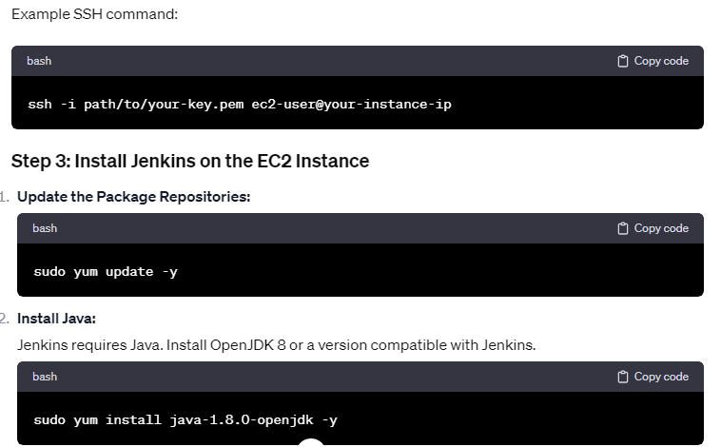

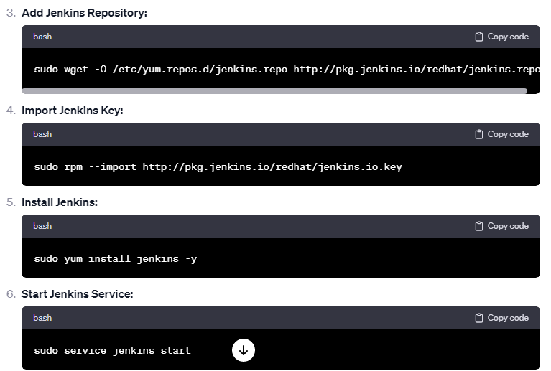 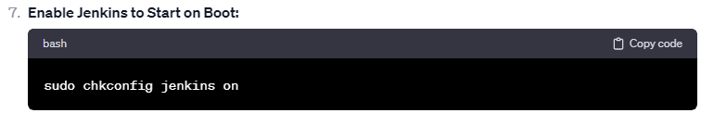

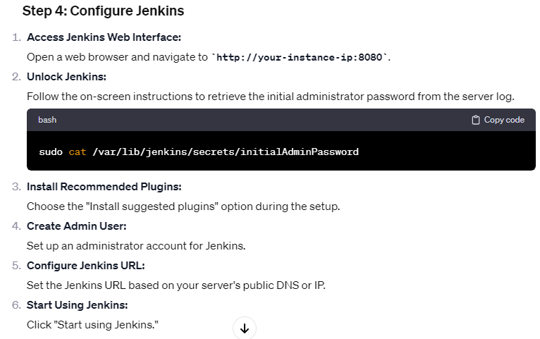

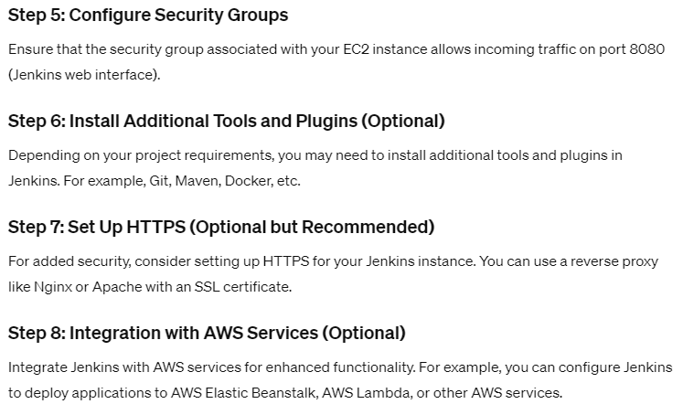

**How to use docker and everything about it**

Docker is a platform that enables developers to automate the deployment of applications inside lightweight, portable containers. Containers are a form of virtualization that allows applications and their dependencies to be packaged together, ensuring consistency across different environments. Here's a comprehensive guide on Docker and its key concepts:

### 1. ****Docker Concepts:****

#### a. ****Image:****

* An image is a lightweight, standalone, and executable package that includes everything needed to run a piece of software, including the code, runtime, libraries, and system tools.

#### b. ****Container:****

* A container is a running instance of a Docker image. It provides a consistent and isolated environment for applications to run, ensuring that they behave the same way regardless of the underlying infrastructure.

#### c. ****Dockerfile:****

* A Dockerfile is a text file that contains instructions for building a Docker image. It specifies the base image, adds dependencies, copies files, and defines commands to run when the container starts.

#### d. ****Registry:****

* A Docker registry is a centralized repository for Docker images. Docker Hub is the default public registry, but you can also use private registries.

### 2. ****Installing Docker:****

* Follow the [official Docker installation guide](https://docs.docker.com/get-docker/) for your operating system.

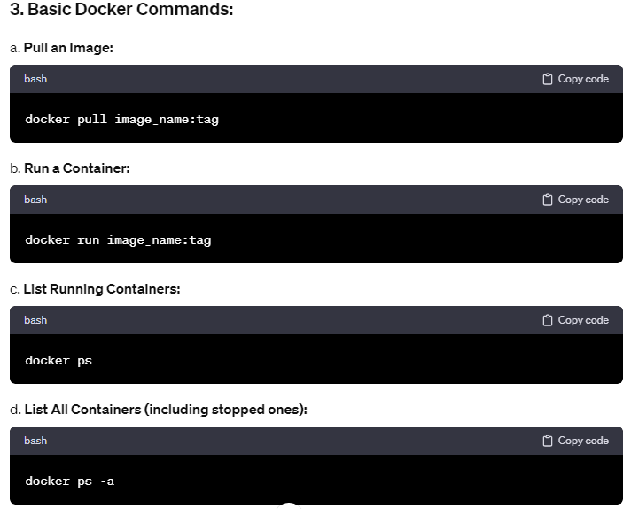 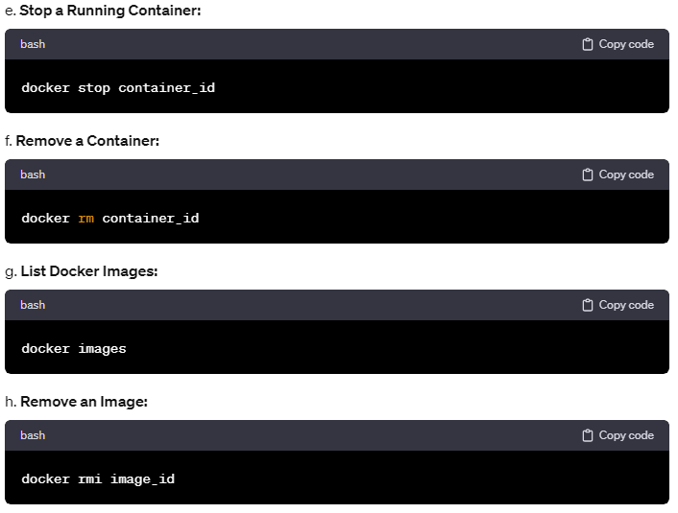

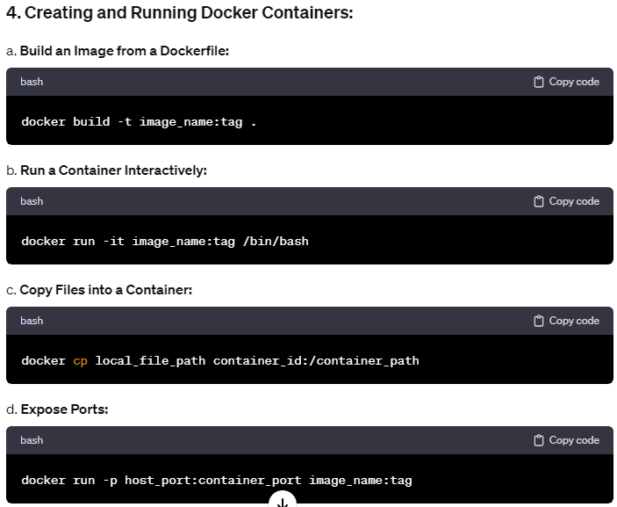 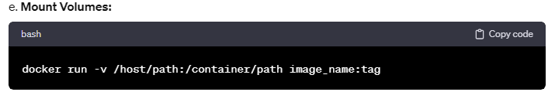

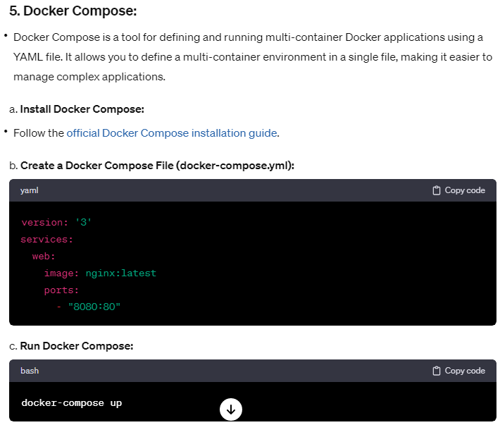 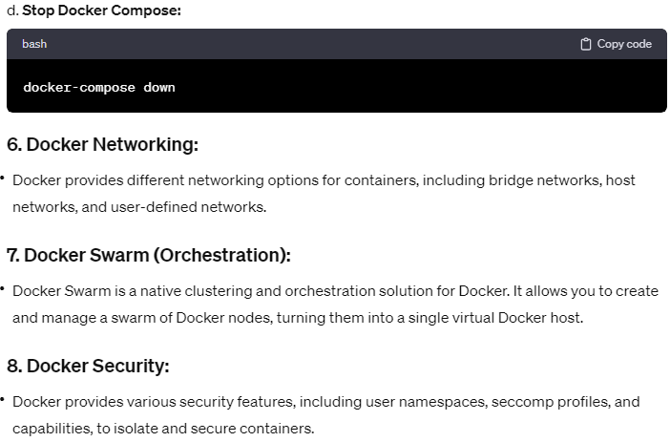

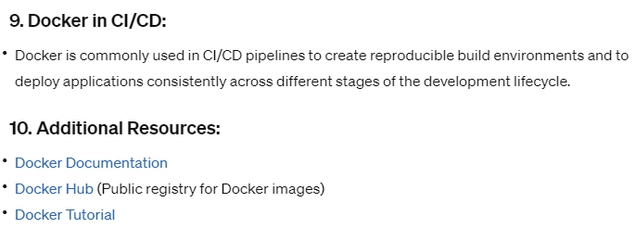

**How to install docker on aws server**

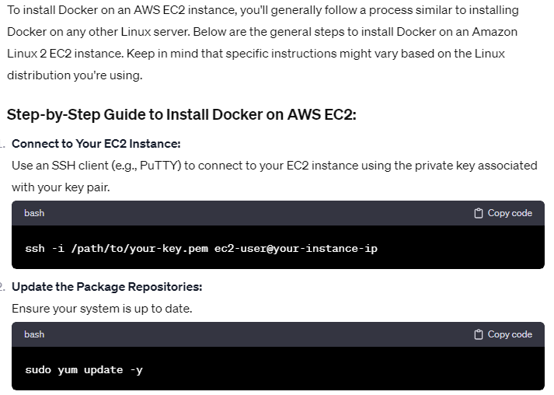

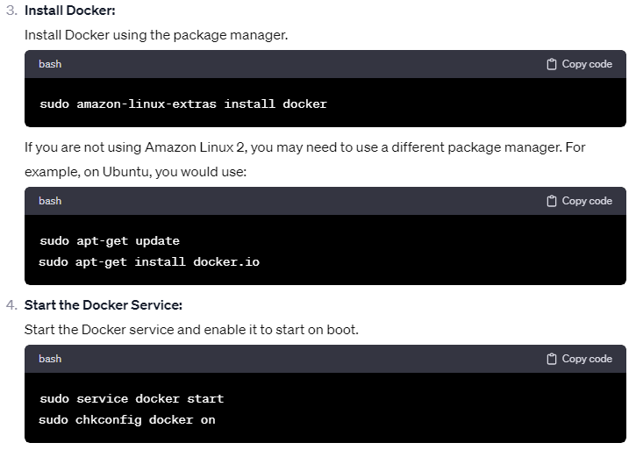 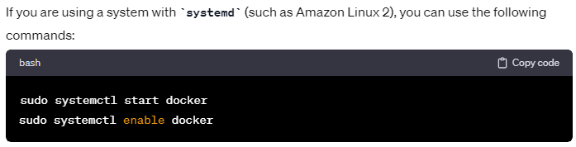

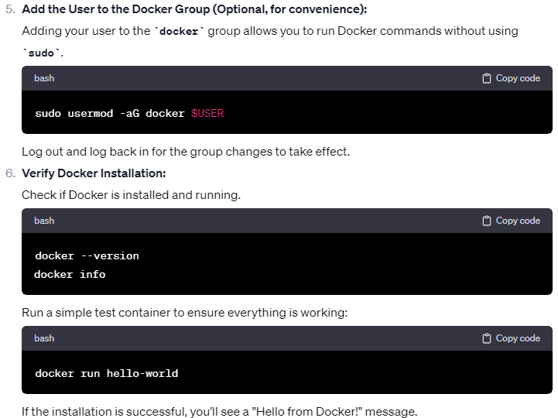

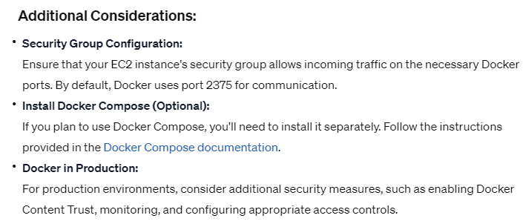

**Wordpress Installation on AWS**

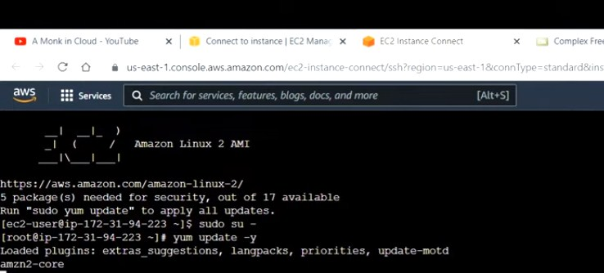

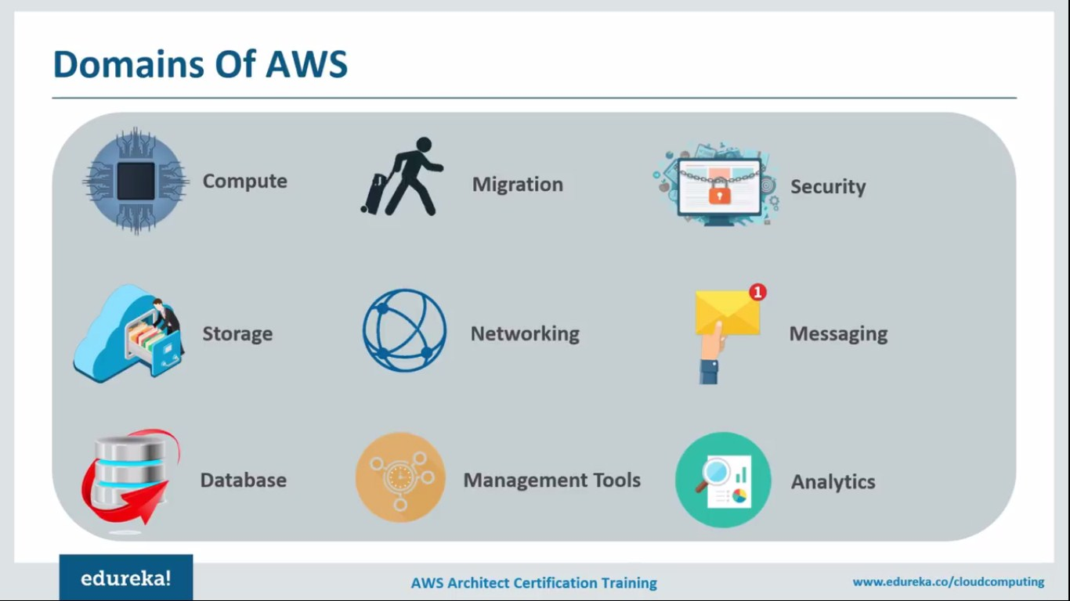

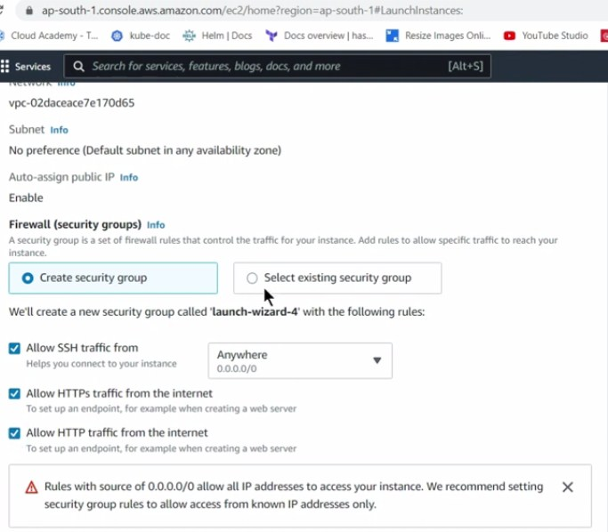

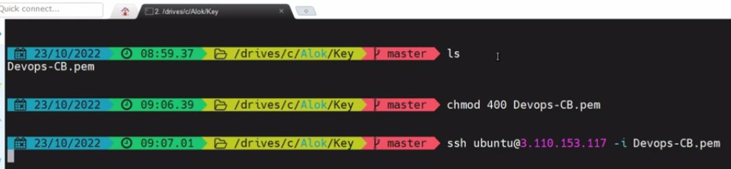

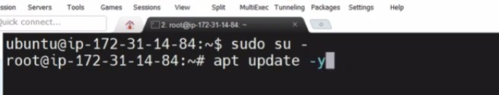

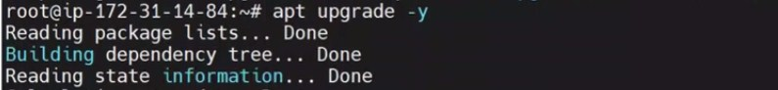



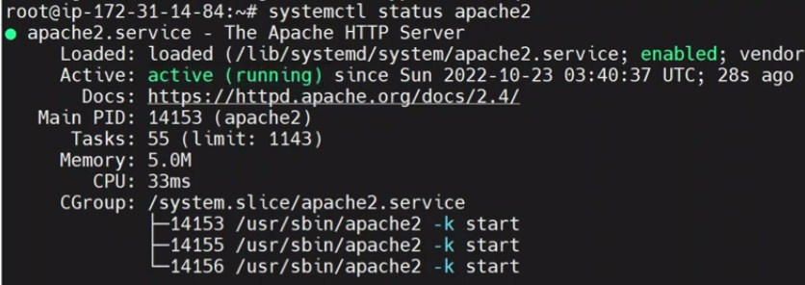









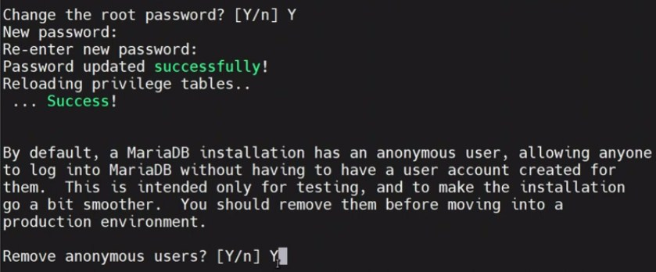

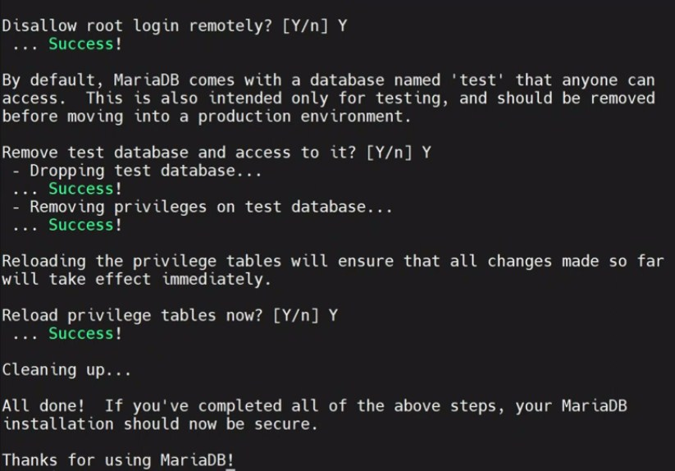

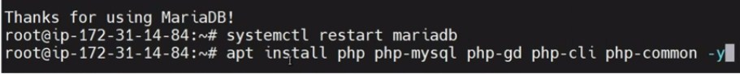



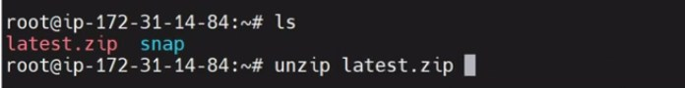

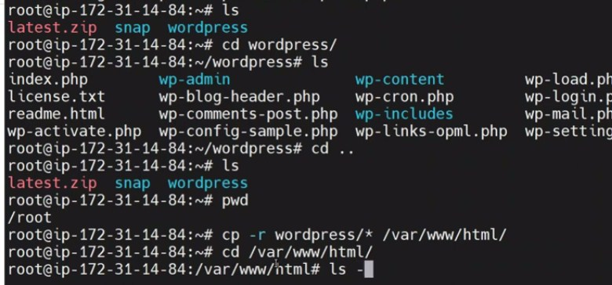

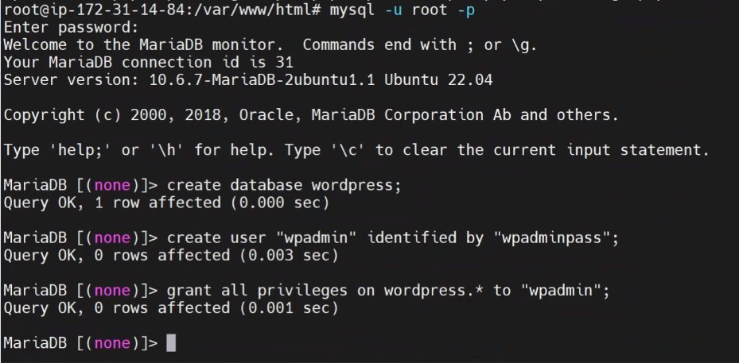

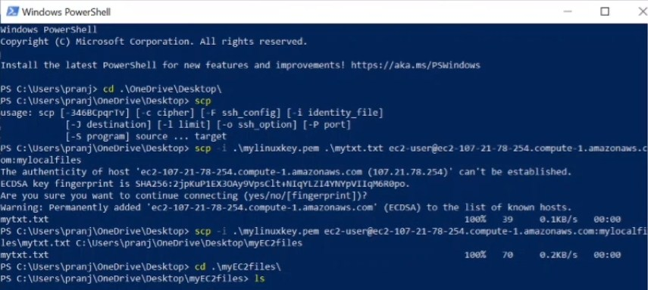

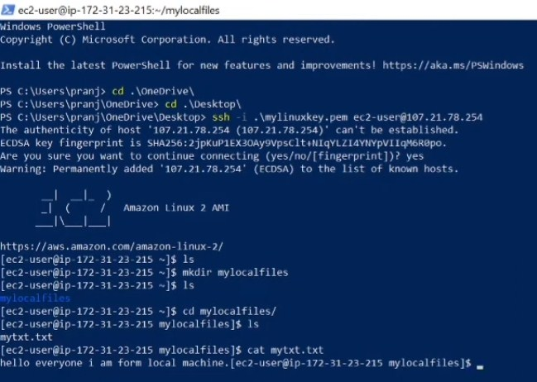

**Wordpres installation on AWS**

1. **Create an AWS Account:** If you don't already have an AWS account, sign up for one at <https://aws.amazon.com/>. You will need to provide billing information, but you can use the AWS Free Tier to get started without incurring charges for the first 12 months.
2. **Launch an EC2 Instance:**
   * Sign in to your AWS Management Console.
   * Navigate to the EC2 Dashboard.
   * Click the "Launch Instance" button to create a new virtual server.
   * Choose an Amazon Machine Image (AMI) based on your requirements. You can use an Amazon Linux AMI, which is suitable for most purposes.
   * Select an instance type, which determines the server's hardware resources. The t2.micro instance is part of the Free Tier.
   * Configure instance details, such as the number of instances, network settings, and storage.
   * Add storage for your instance. You can use the default settings or adjust the storage size as needed.
   * Configure security groups to control incoming traffic to your instance. At a minimum, allow SSH (port 22) and HTTP/HTTPS (ports 80 and 443).
   * Review and launch the instance, and create a new key pair or use an existing one to securely connect to your instance.
3. **Connect to Your EC2 Instance:**
   * Once the instance is running, use SSH to connect to it. Use the private key from the key pair you selected during instance launch.
   * The command to connect will look like this:

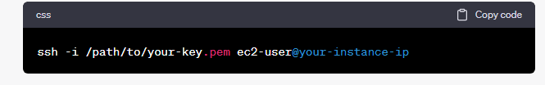

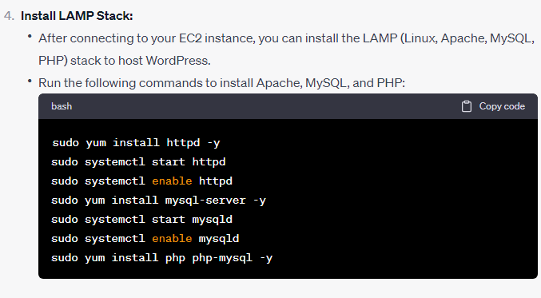

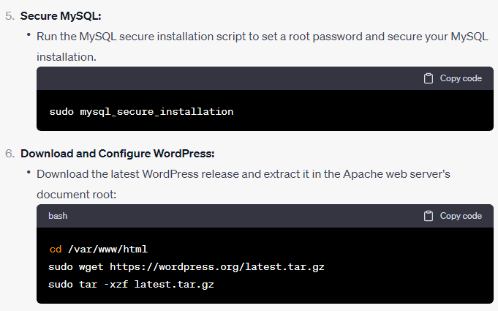

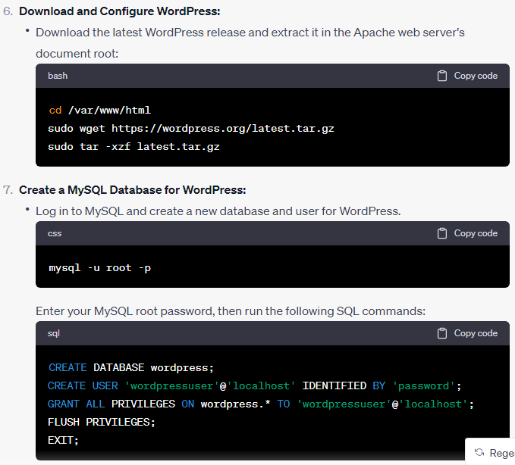

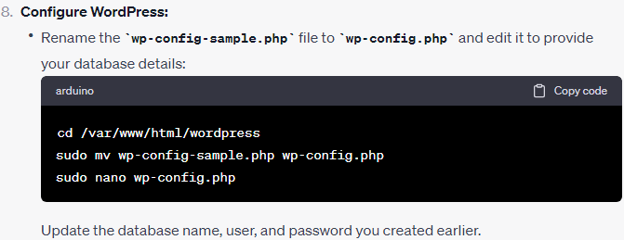

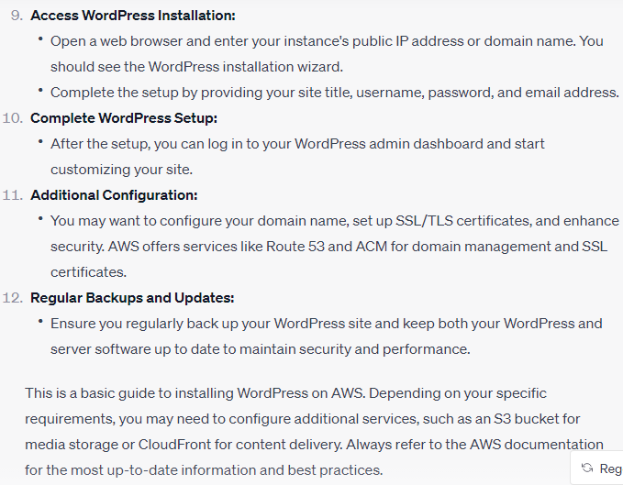

**LAMP Setup**

<https://www.digitalocean.com/community/tutorials/how-to-install-linux-apache-mysql-php-lamp-stack-on-ubuntu-20-04>

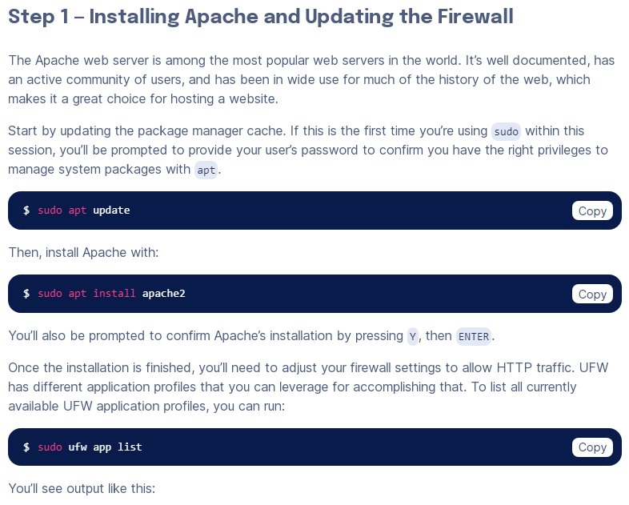 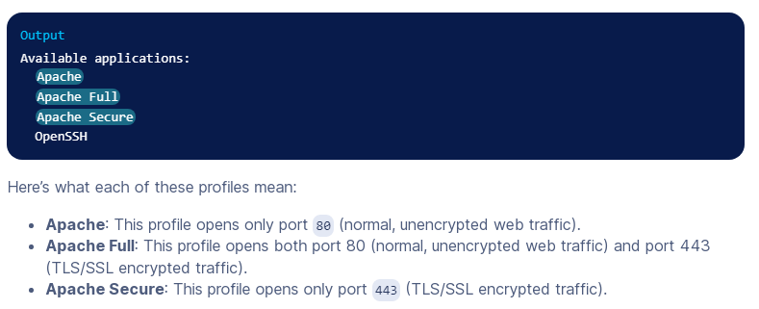

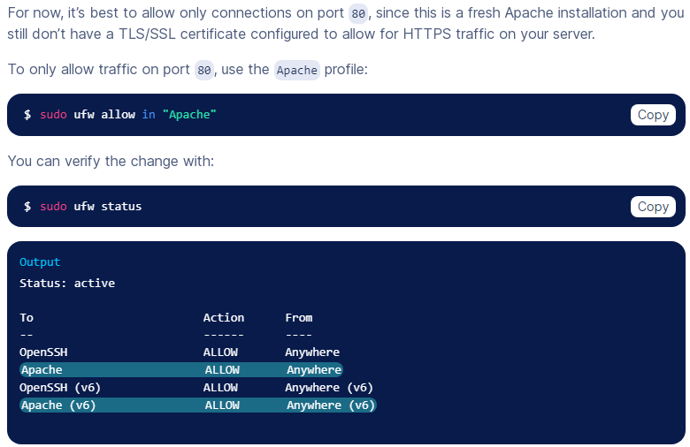

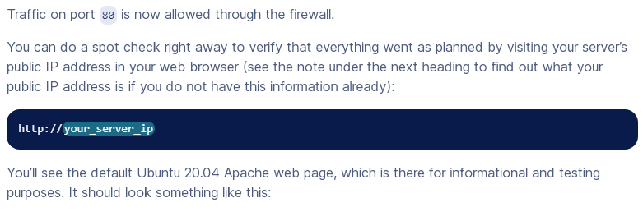

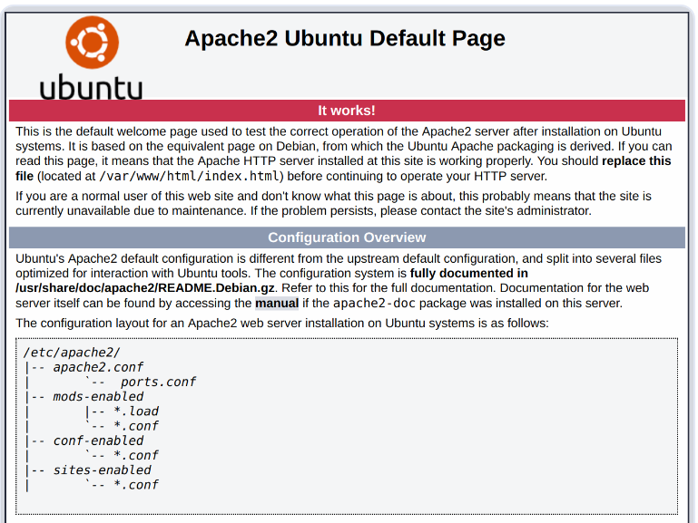 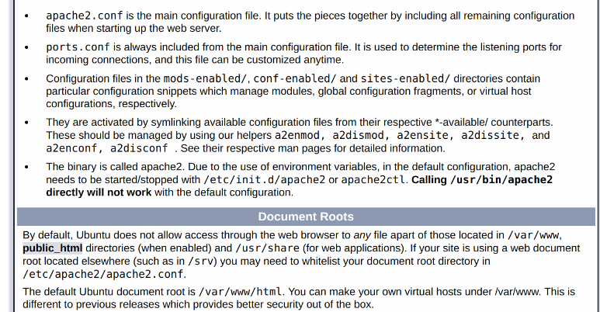 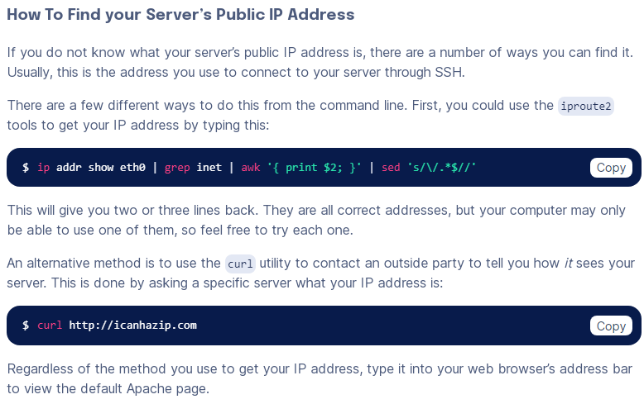 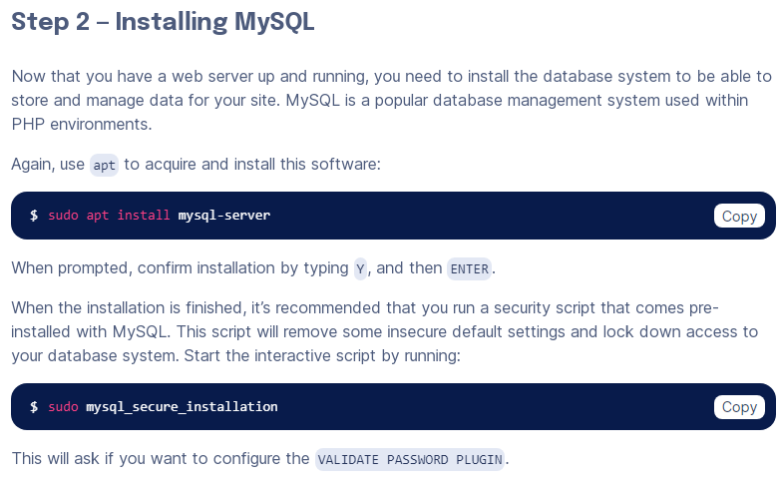 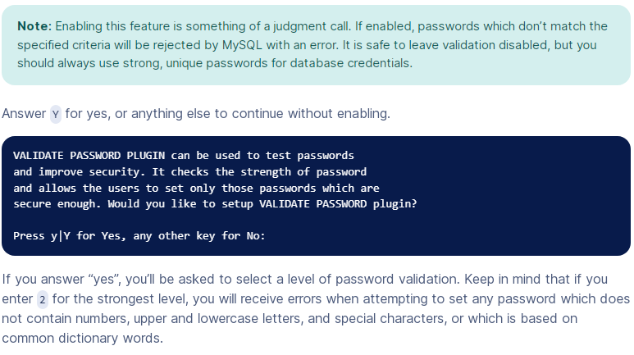 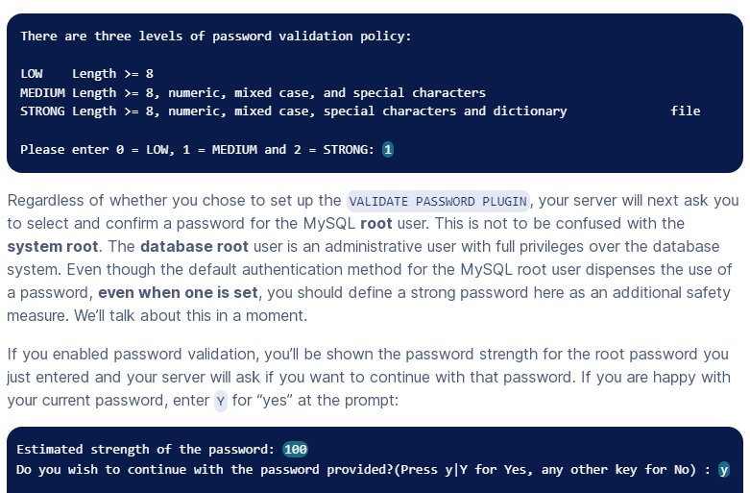 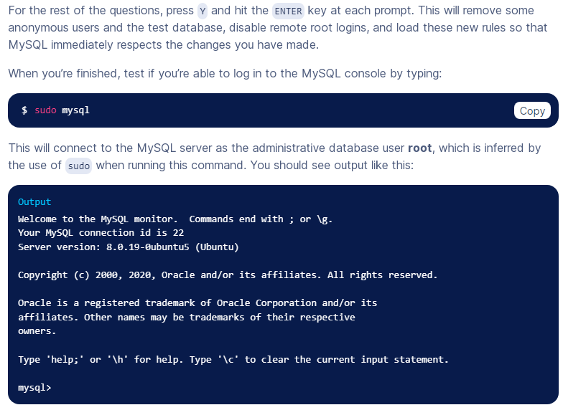 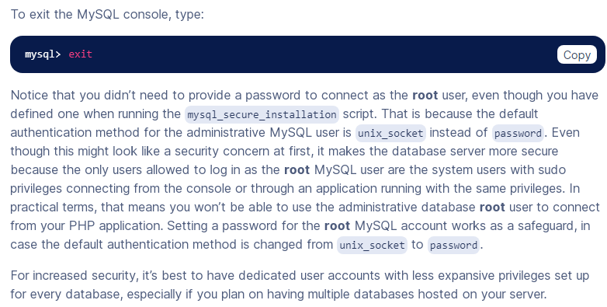 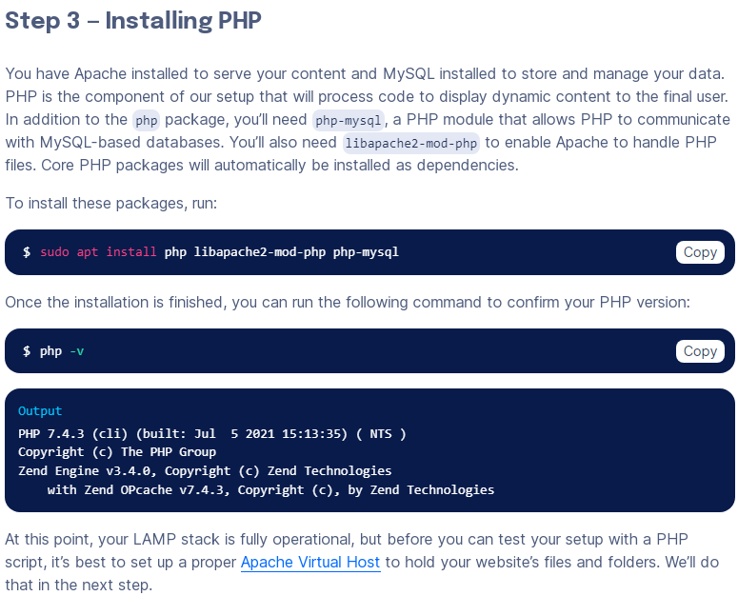

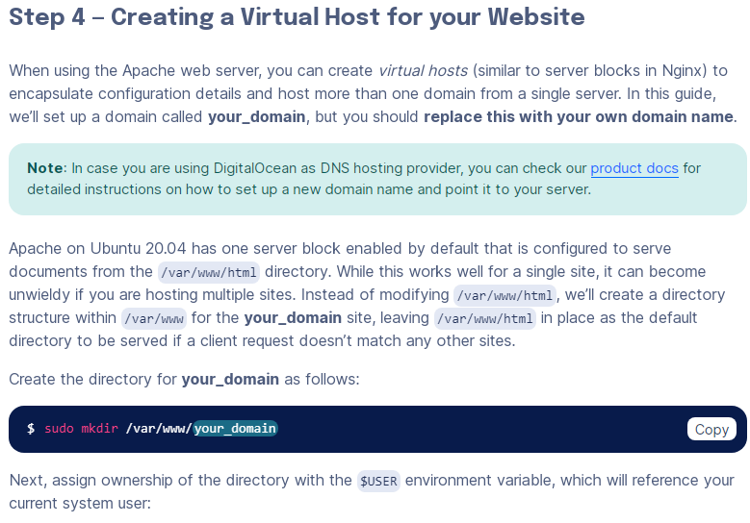

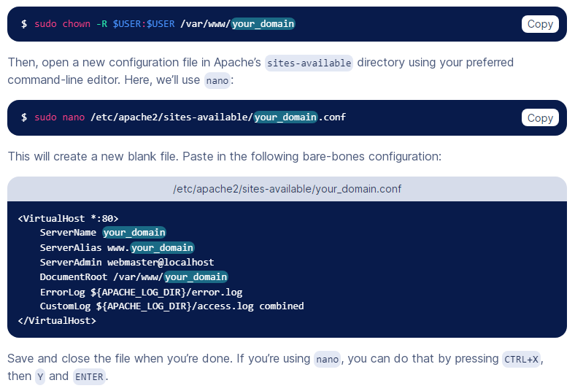

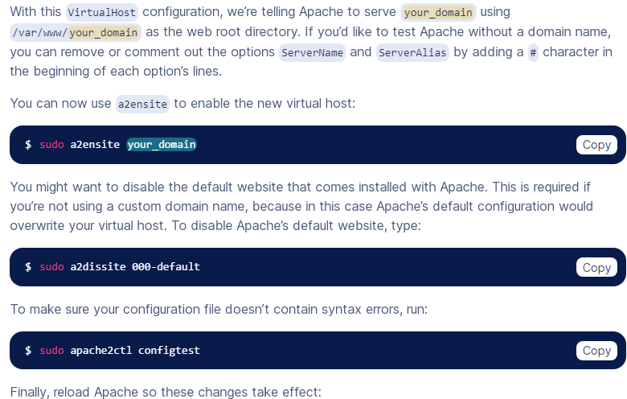 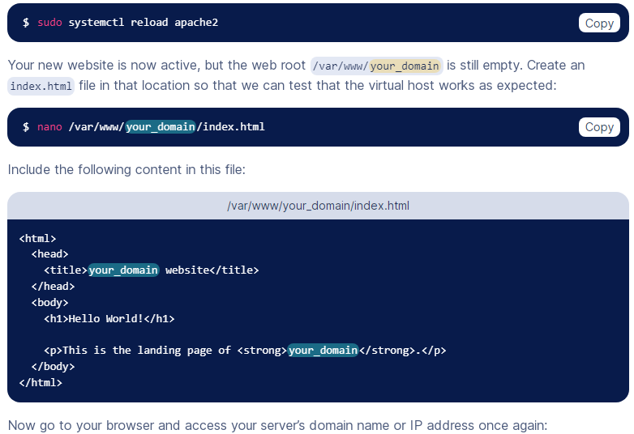 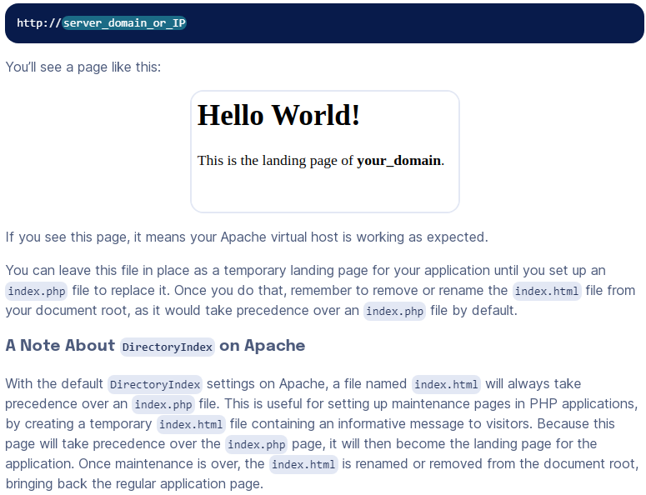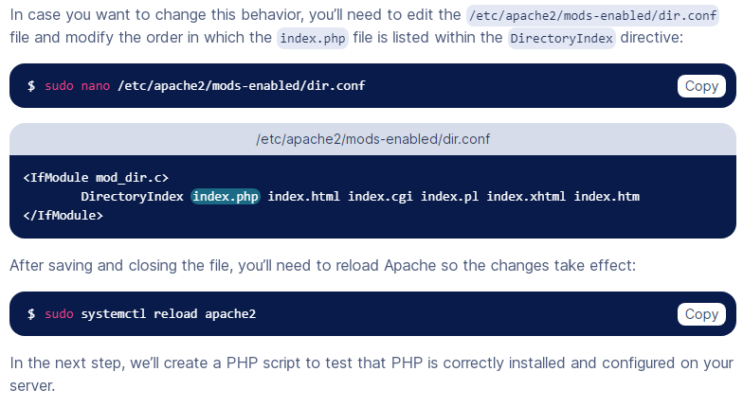 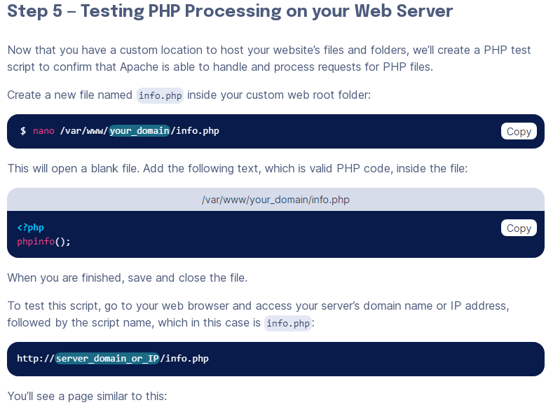 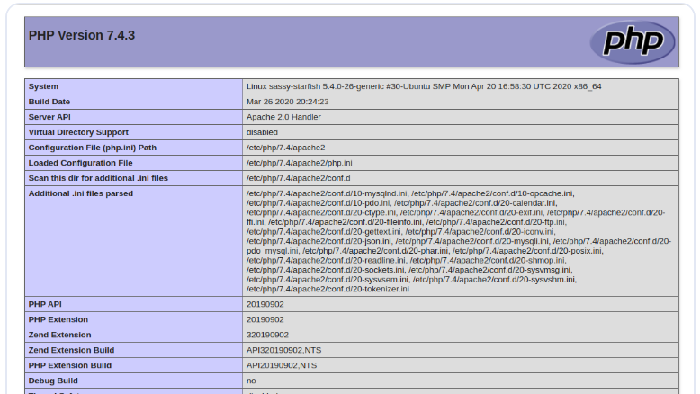 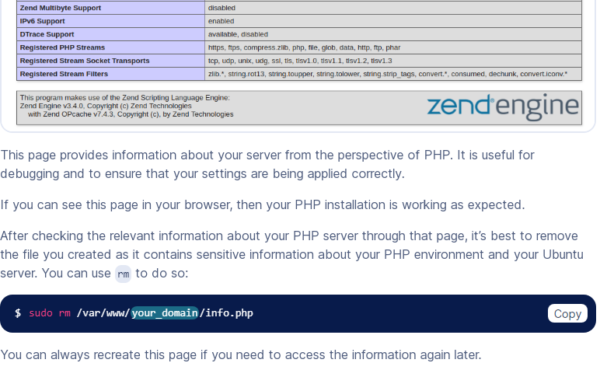 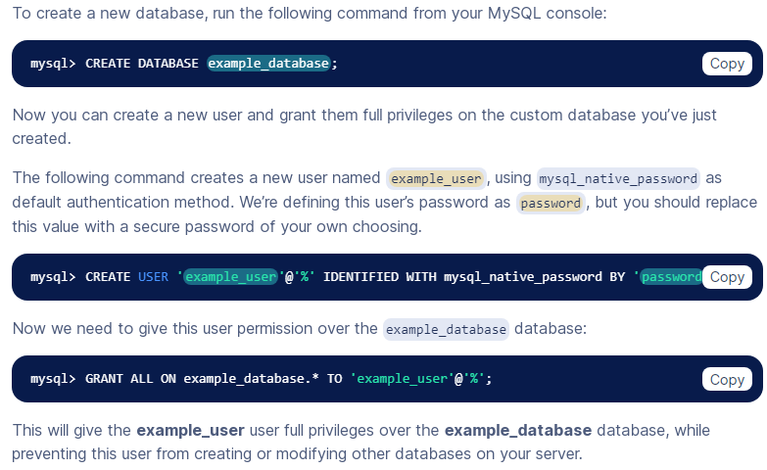

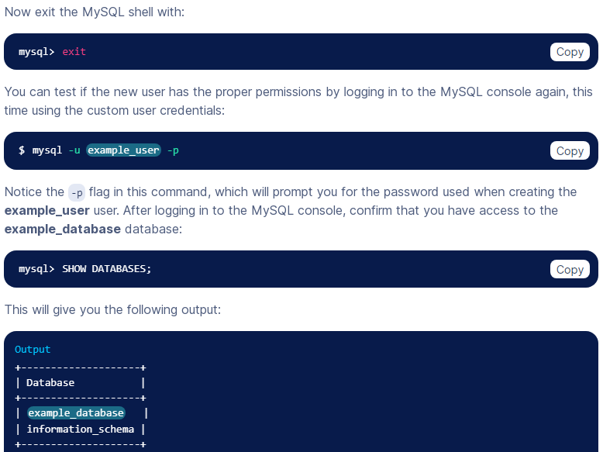

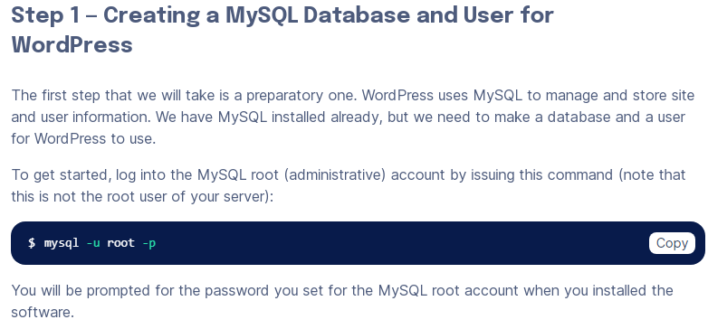 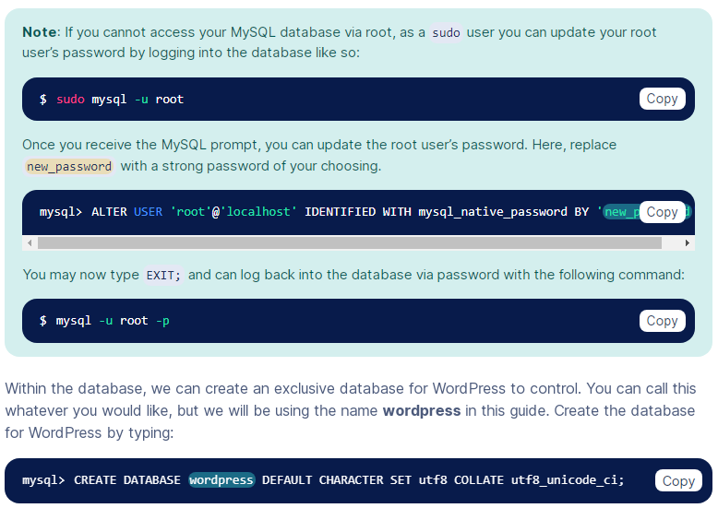

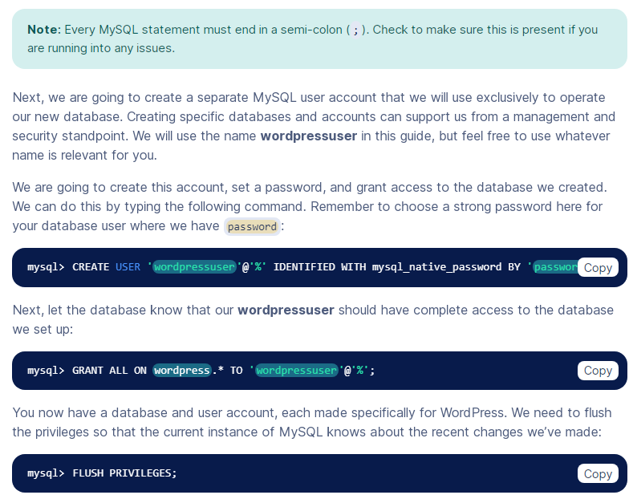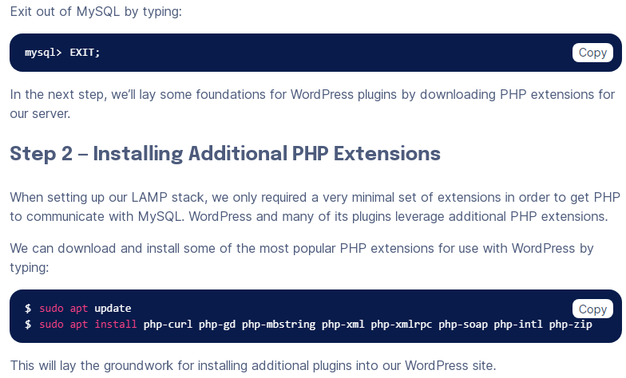

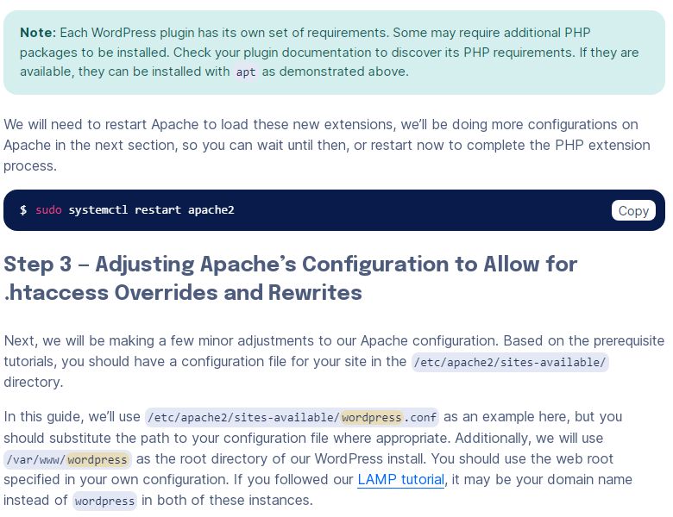 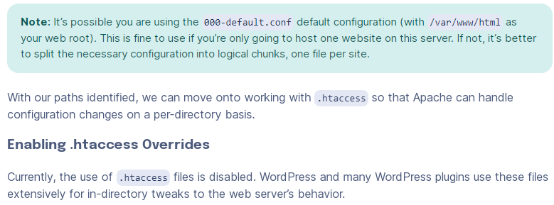

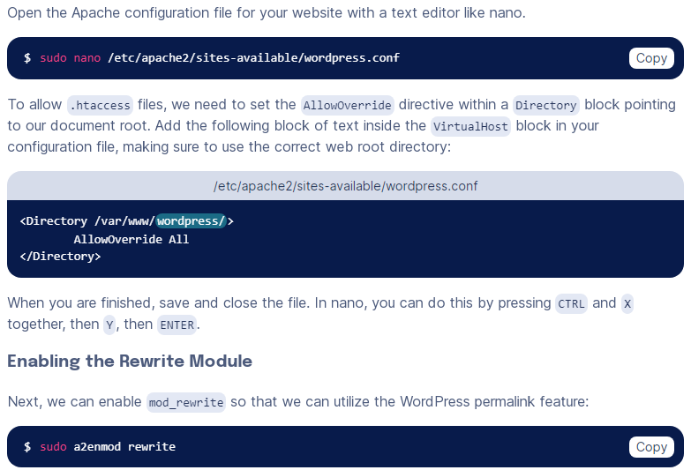 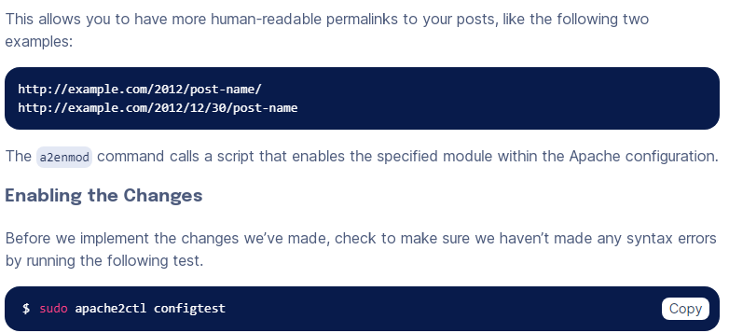

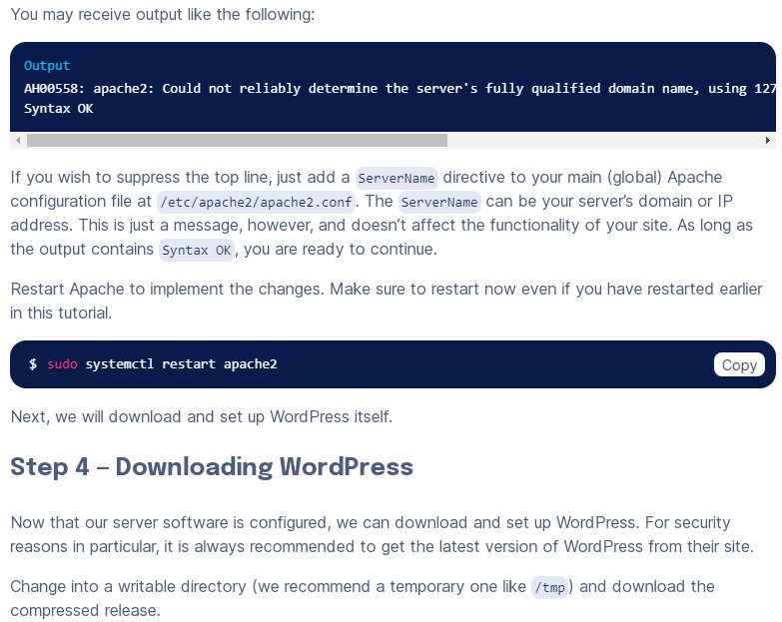 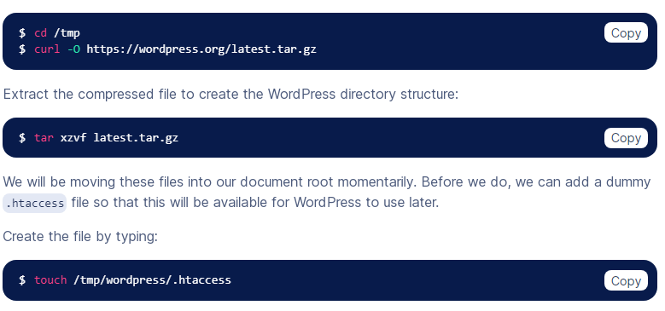

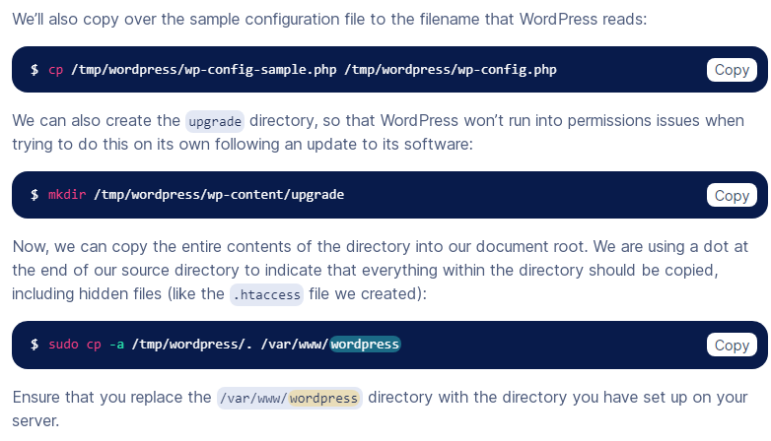 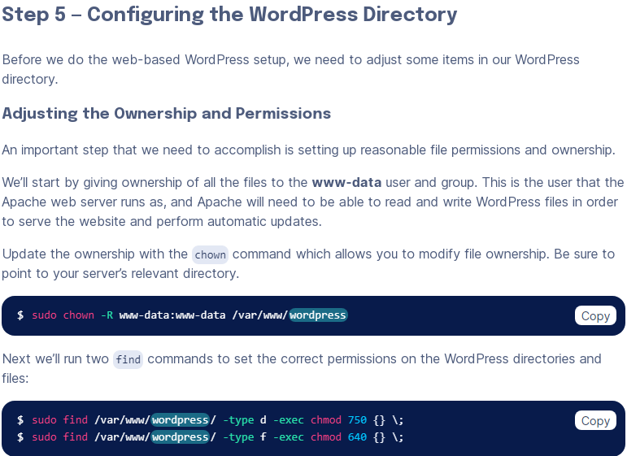

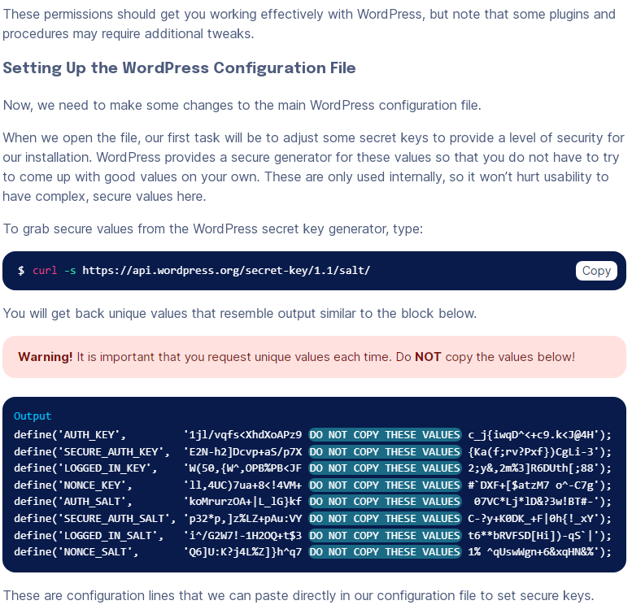 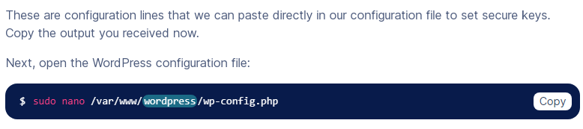

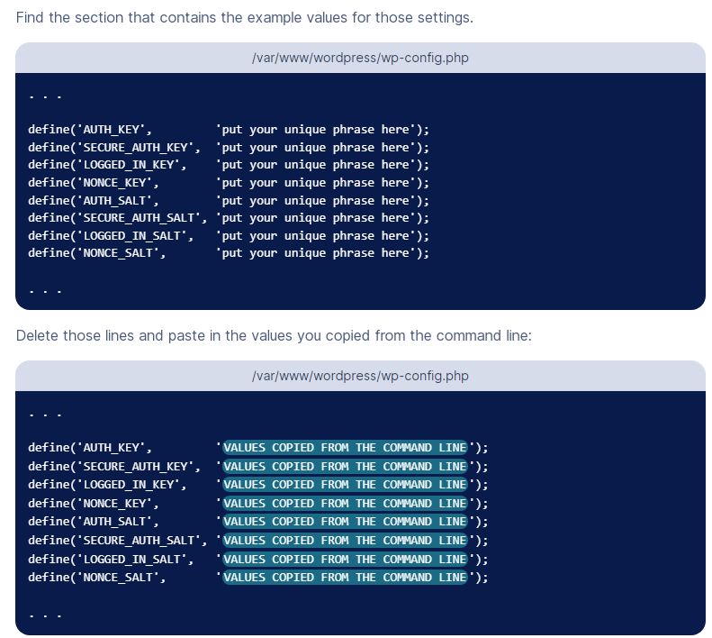 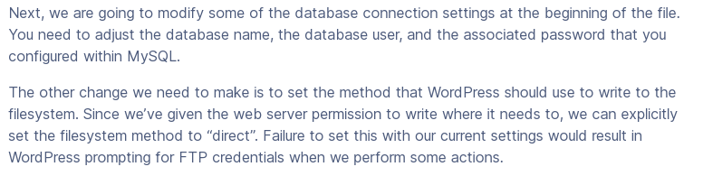 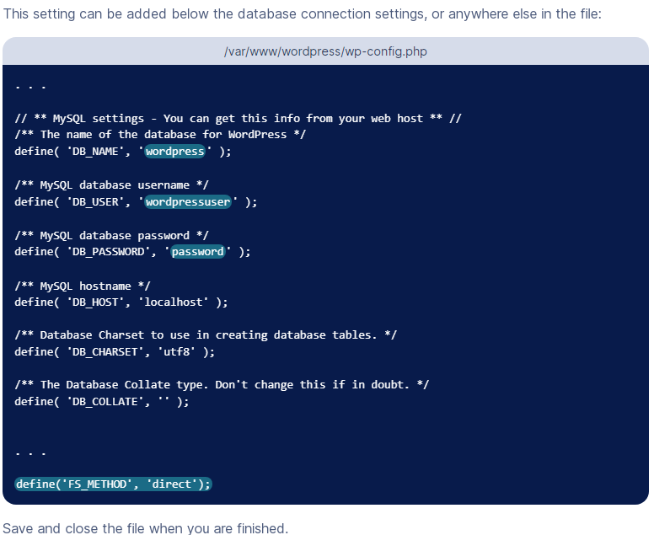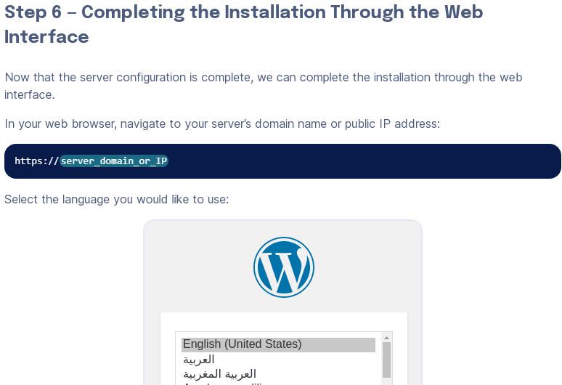

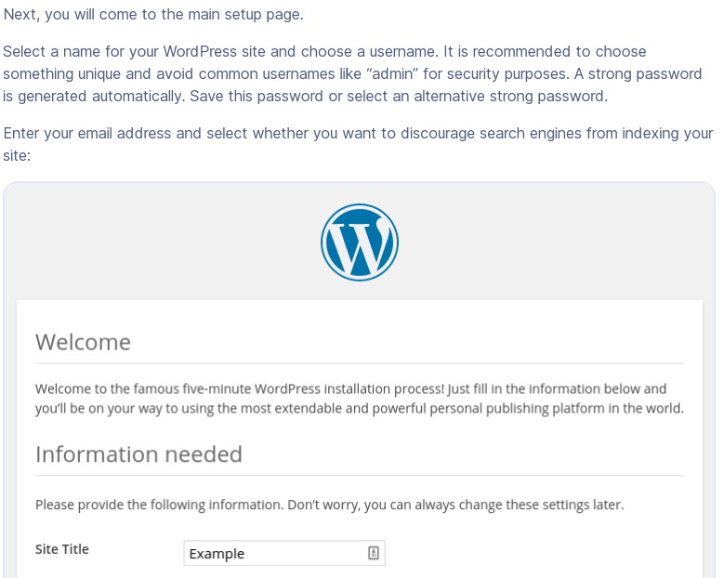 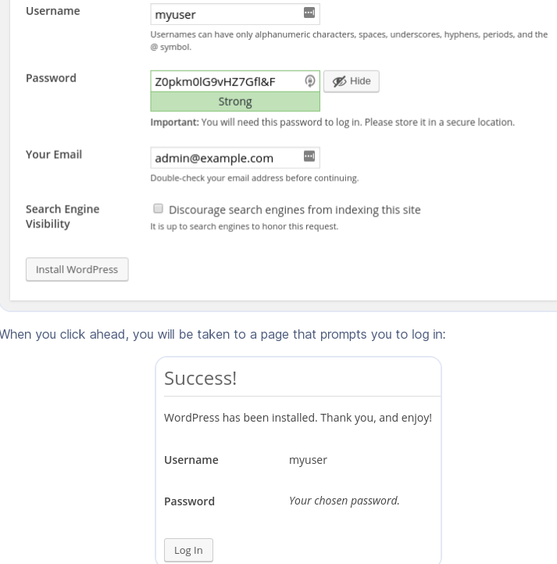 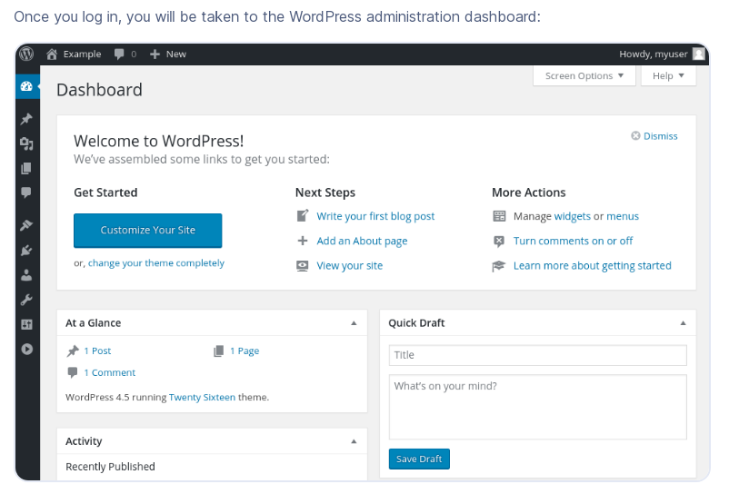

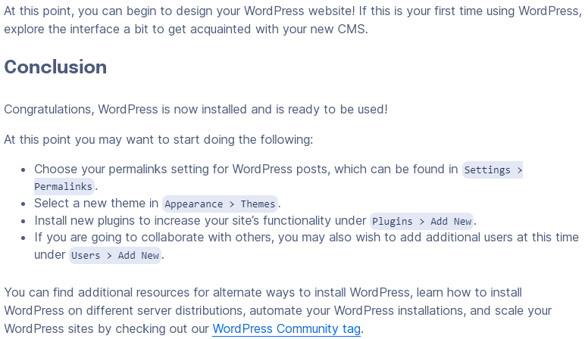

# Initial Server Setup with Ubuntu 20.04

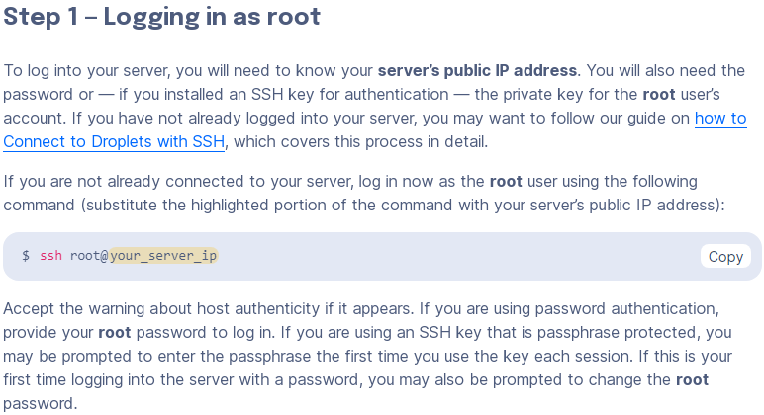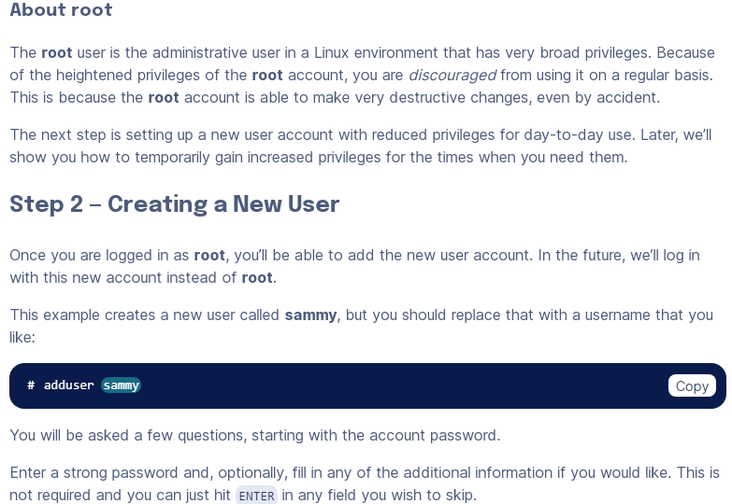

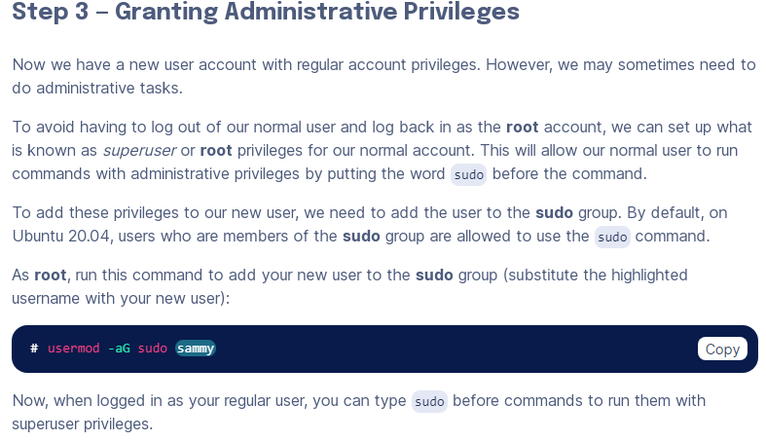 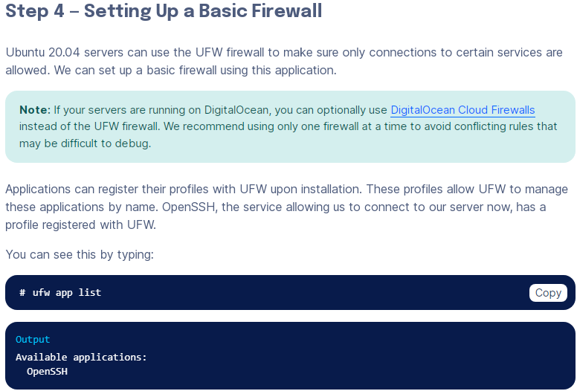 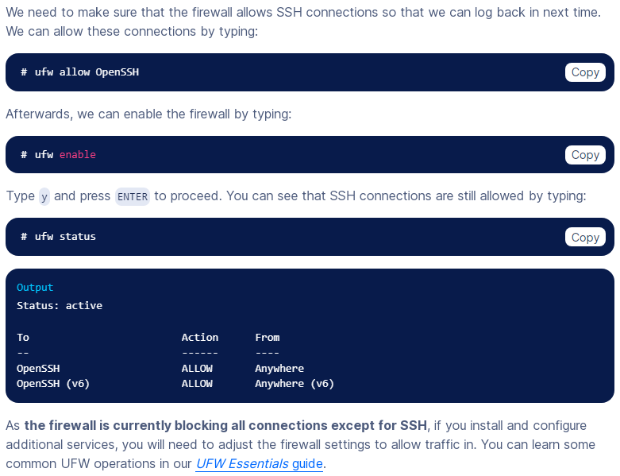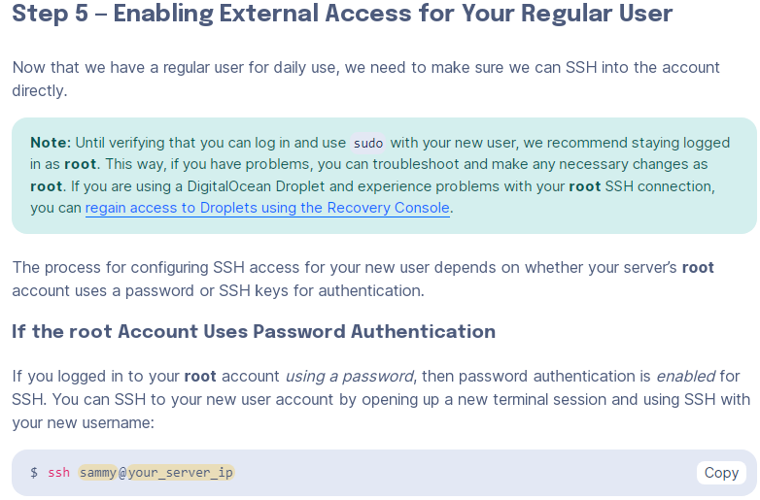

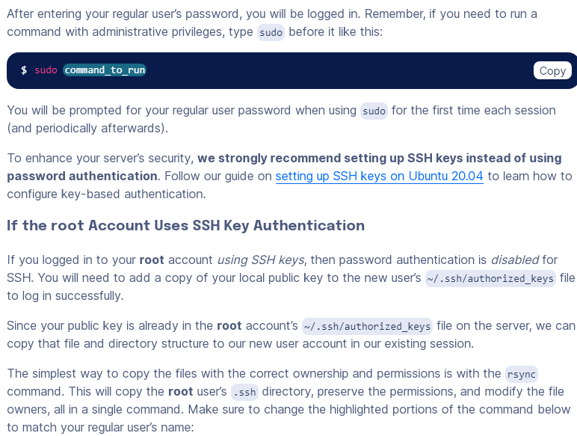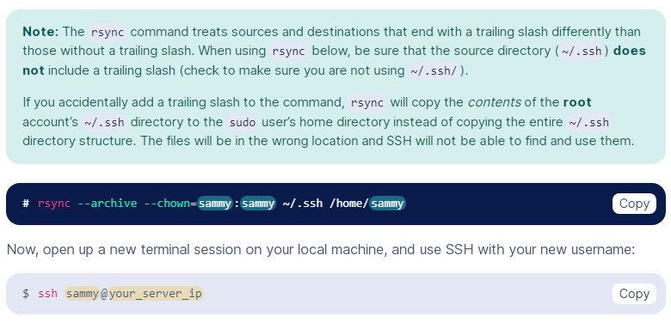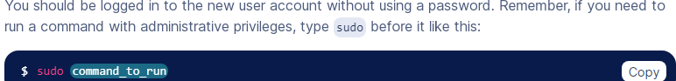

**Install wordpress on windaw iis server**

**Step 1: Download WordPress**

1. Go to the official WordPress website (<https://wordpress.org/download/>) and download the latest version of WordPress in ZIP format.

**Step 2: Extract the WordPress Files**

1. Extract the contents of the ZIP file you downloaded to a directory on your Windows server where you want to host your WordPress site. This will be your website's root directory (e.g., **C:\inetpub\wwwroot\mywordpress**).

**Step 3: Create a MySQL Database**

1. You'll need a MySQL database to store WordPress data. Install MySQL on your Windows server if you haven't already.
2. Create a new MySQL database for WordPress. You can use a MySQL client like phpMyAdmin or the MySQL command line to create the database.
3. Create a MySQL user and grant it privileges on the WordPress database. Note down the database name, username, and password for later use.

**Step 4: Configure PHP on IIS**

1. Install PHP on your Windows server. You can use a package like XAMPP or install PHP manually.
2. Configure PHP to work with IIS by adding PHP as a FastCGI module. You can use the "Internet Information Services (IIS) Manager" to configure this.

**Step 5: Configure WordPress**

1. Rename the **wp-config-sample.php** file in your WordPress directory to **wp-config.php**.
2. Open **wp-config.php** and configure the database settings by entering the database name, username, and password you created earlier:

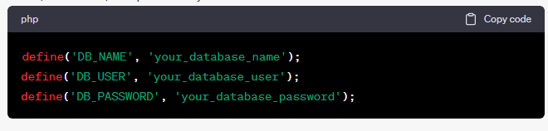

1. You may also want to define other constants like the authentication keys and salts. You can generate these keys by visiting the WordPress.org secret key generator (<https://api.wordpress.org/secret-key/1.1/salt/>).
2. Save your **wp-config.php** file.

**Step 6: Configure IIS for WordPress**

1. Open the "Internet Information Services (IIS) Manager."
2. In the Connections pane on the left, expand your server node and click on "Sites."
3. Right-click on "Default Web Site" or create a new site if needed, and select "Add Application."
4. Set an alias for your WordPress site (e.g., "mywordpress") and browse for the physical path where you extracted the WordPress files.
5. In the "Edit Application" dialog, go to the "Modules" section, and ensure that the "FastCgiModule" is installed and enabled.

**Step 7: Access Your WordPress Site**

1. Open a web browser and enter the URL to your WordPress site (e.g., **http://localhost/mywordpress**). Follow the WordPress installation instructions.
2. Complete the installation by providing your site title, username, password, and email address.
3. Once the installation is complete, you can log in to the WordPress admin dashboard and start customizing your site.

That's it! You've successfully installed WordPress on your Windows IIS server. You can now start building and managing your website using the WordPress platform.

**WP-CLI**

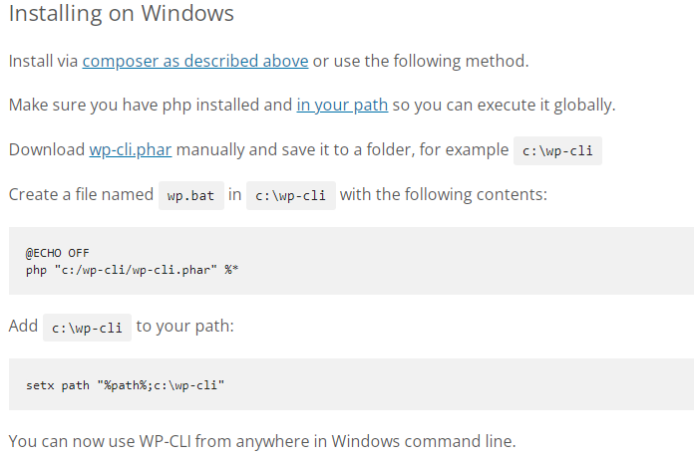

**Environment variable path setting example:**

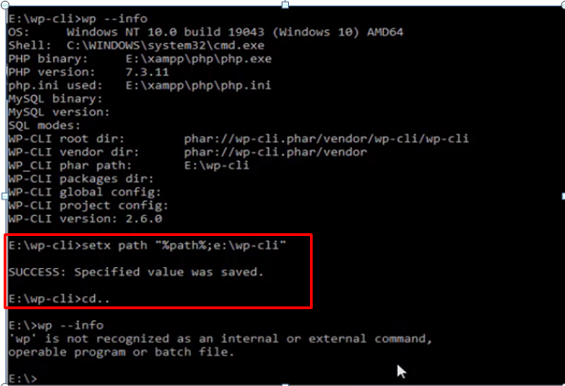

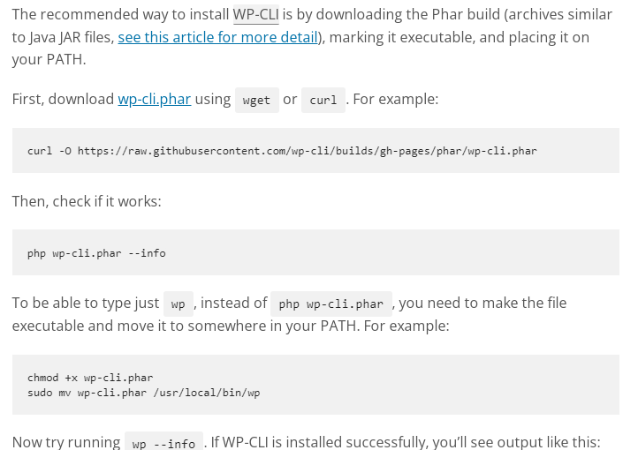

**wp+ enter key (wp help command) for showing all command**

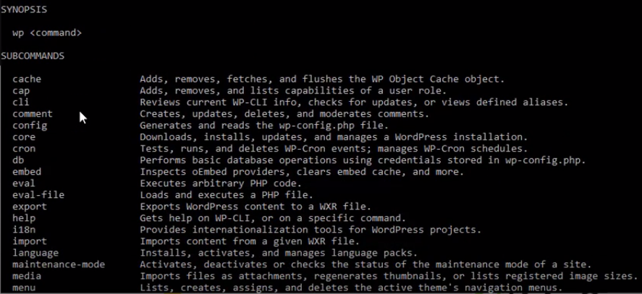

**Sub command**

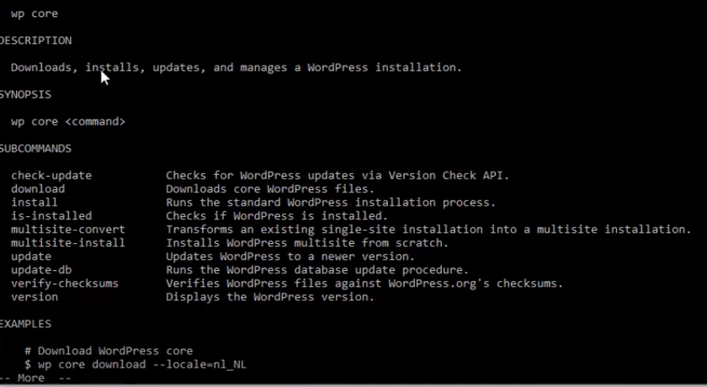

**a**

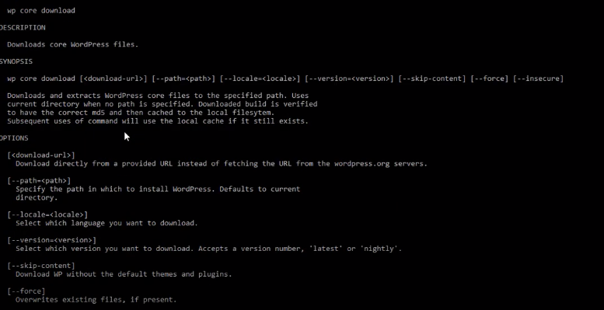

**Downloading example**

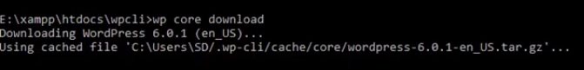

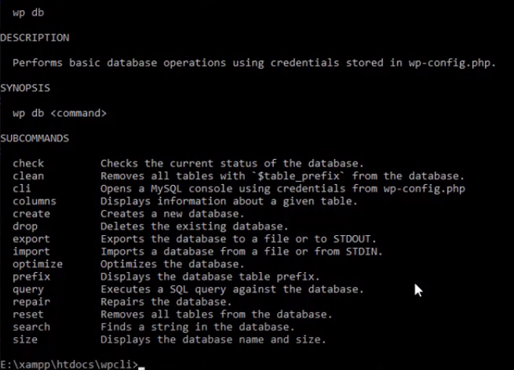

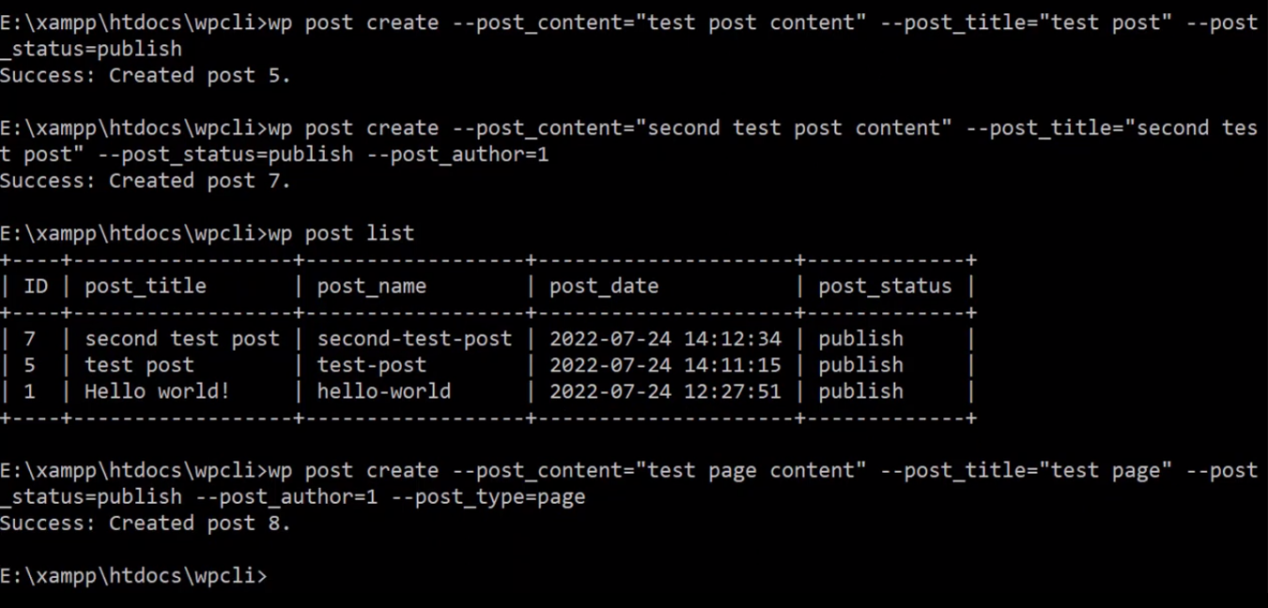

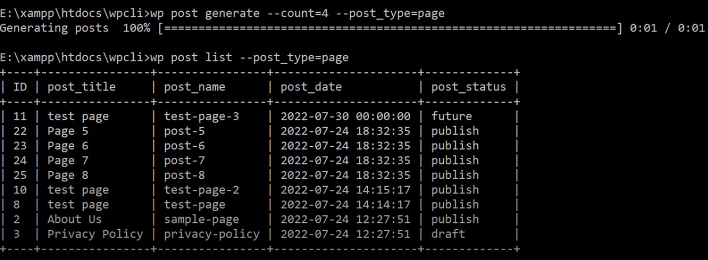

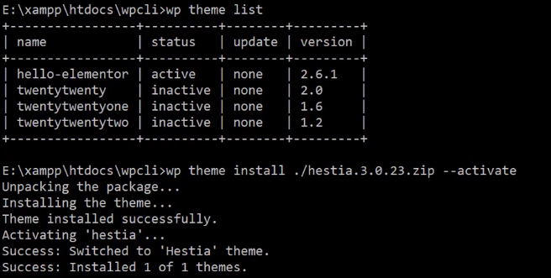

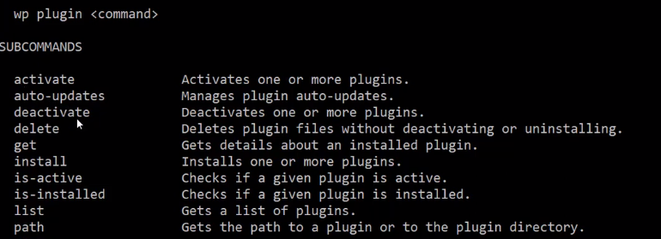

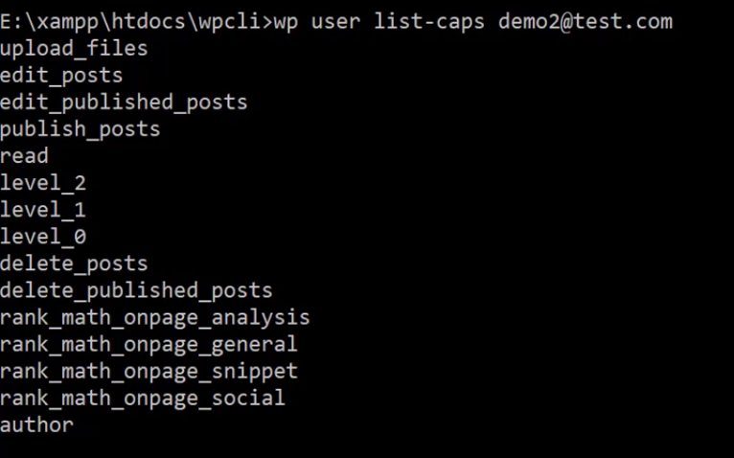

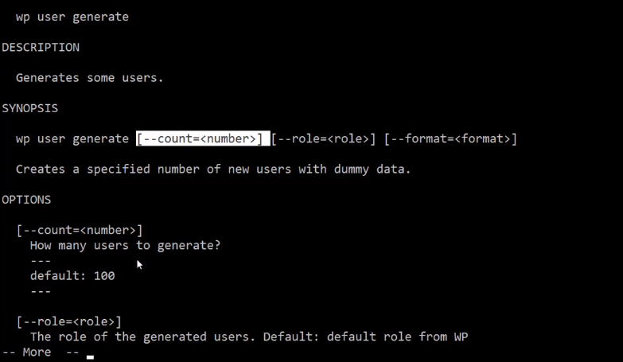

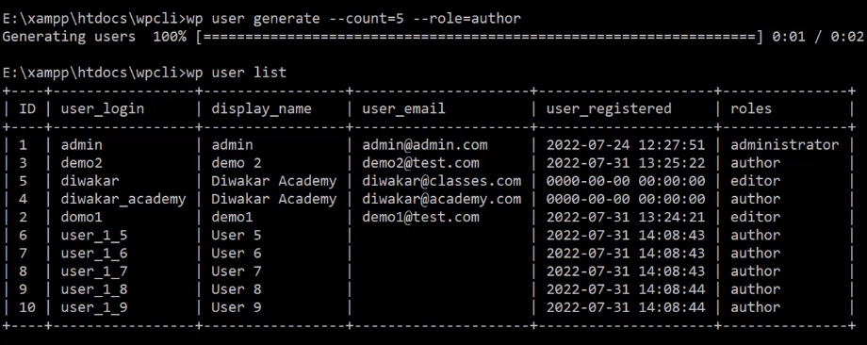

**WP CLI several benefits for developers, site administrators, and anyone who works with WordPress:**

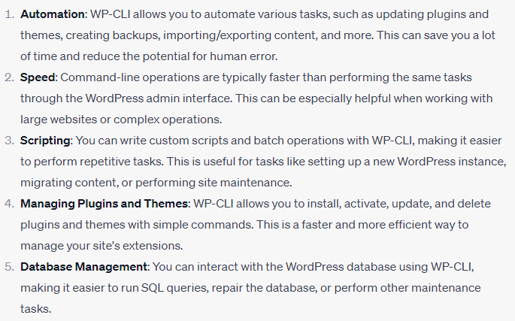

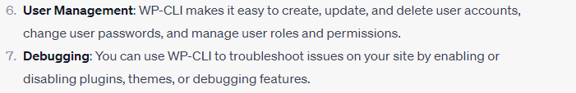

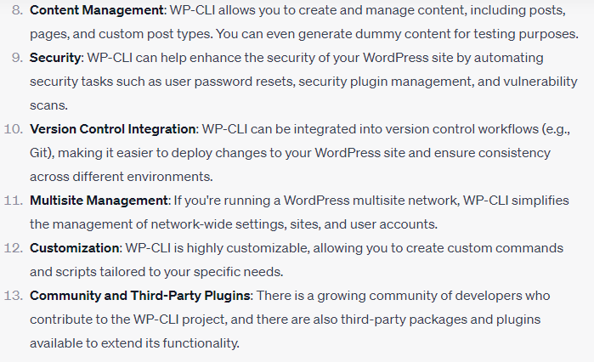

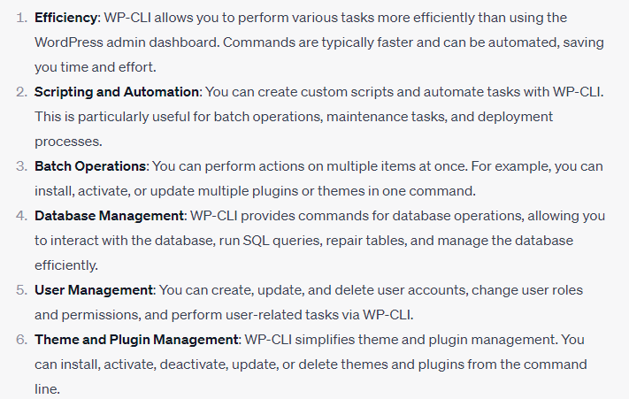

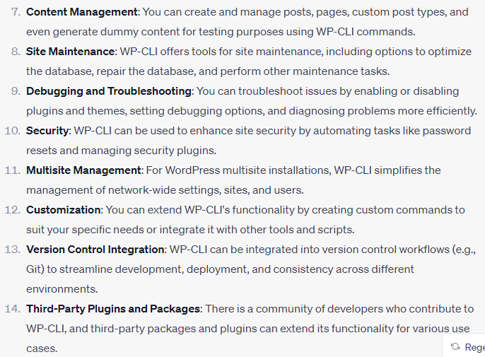

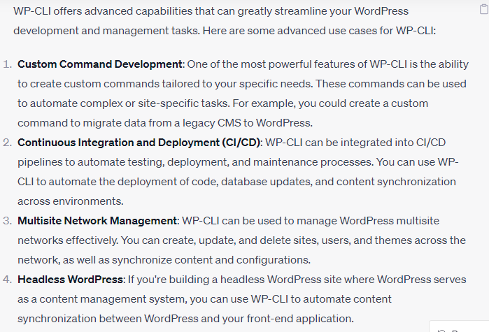

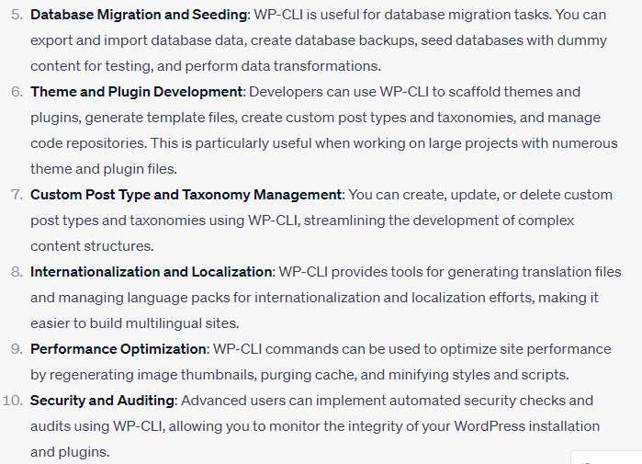

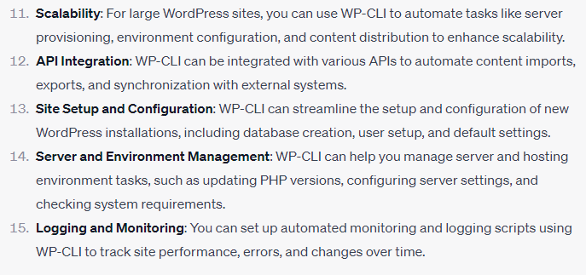

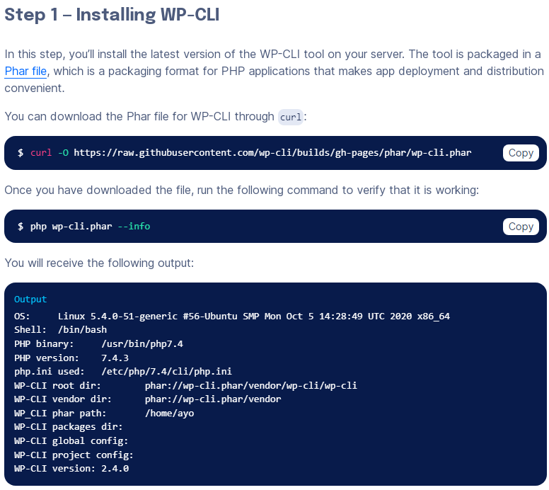

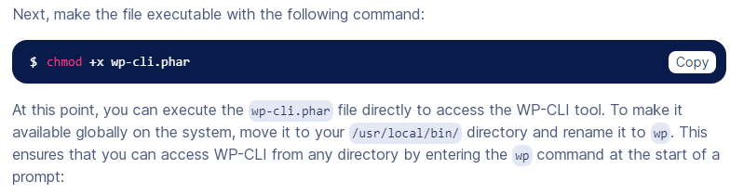

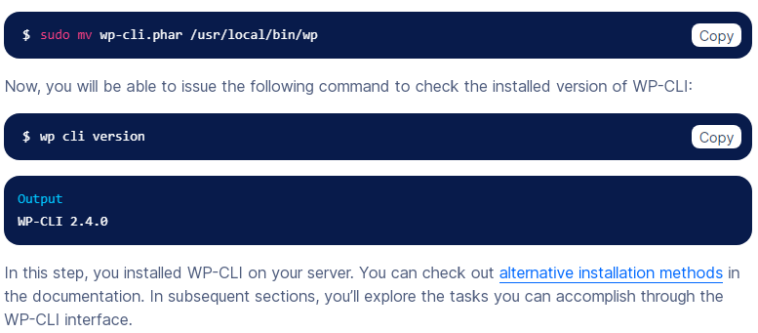

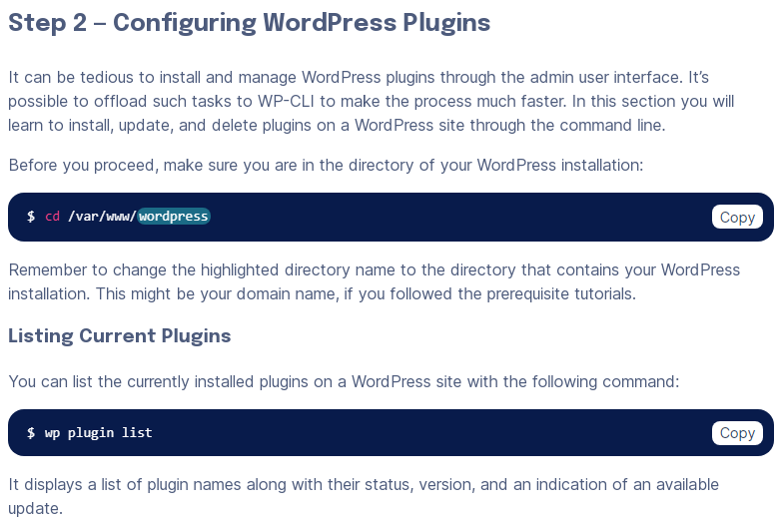

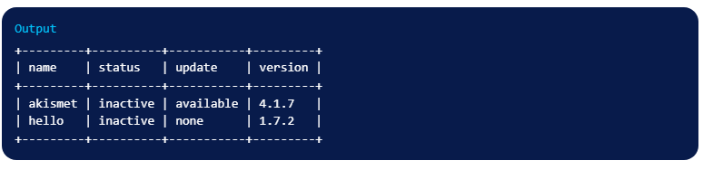

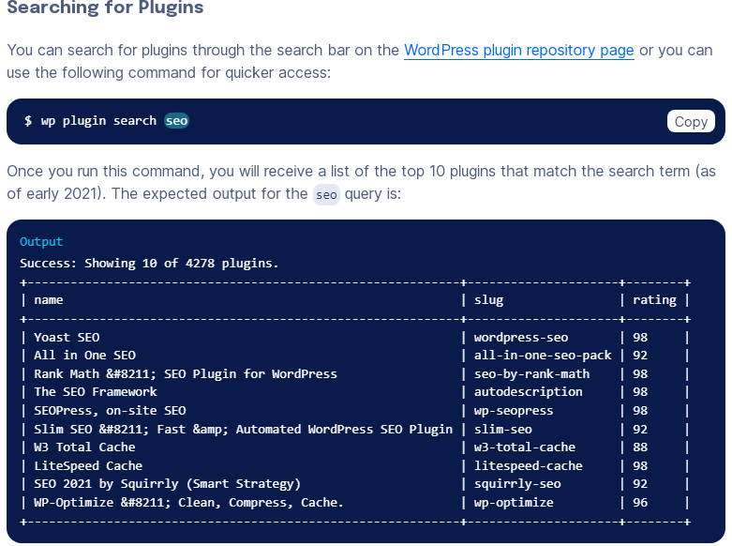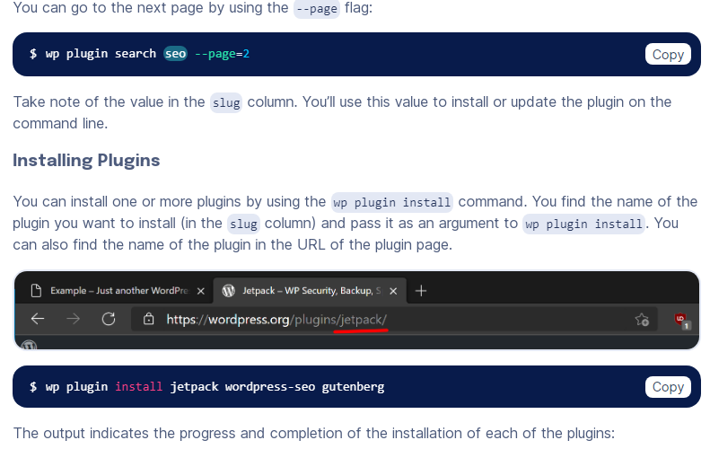

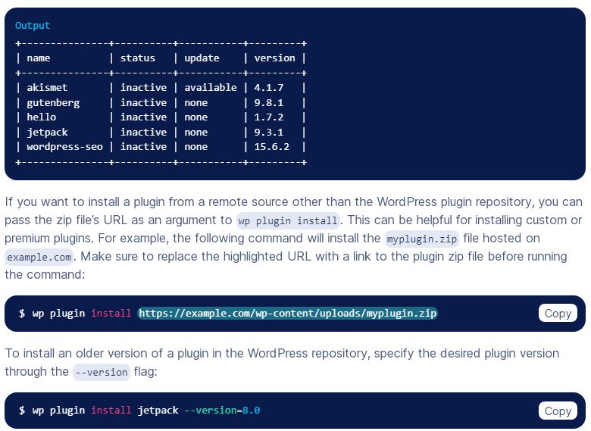 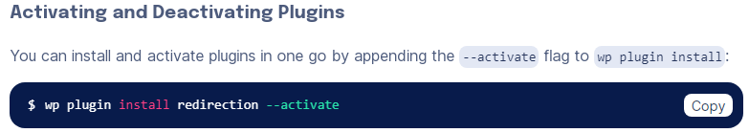 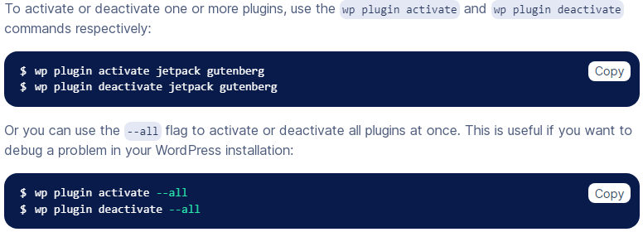

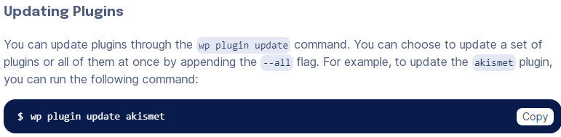 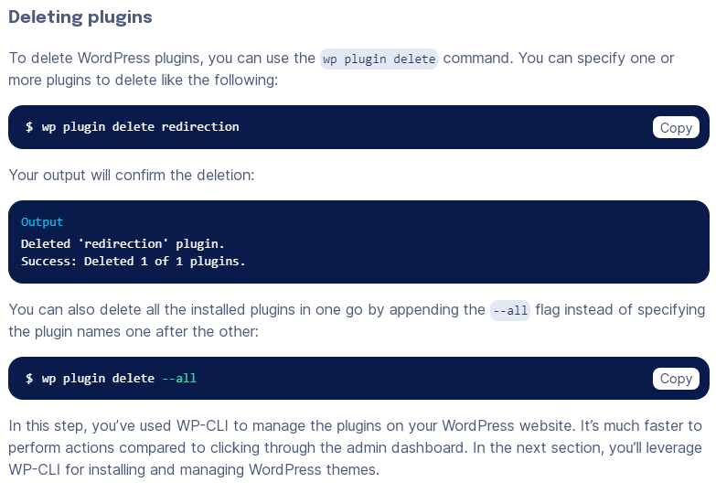 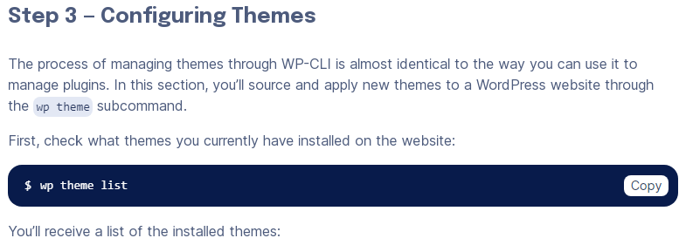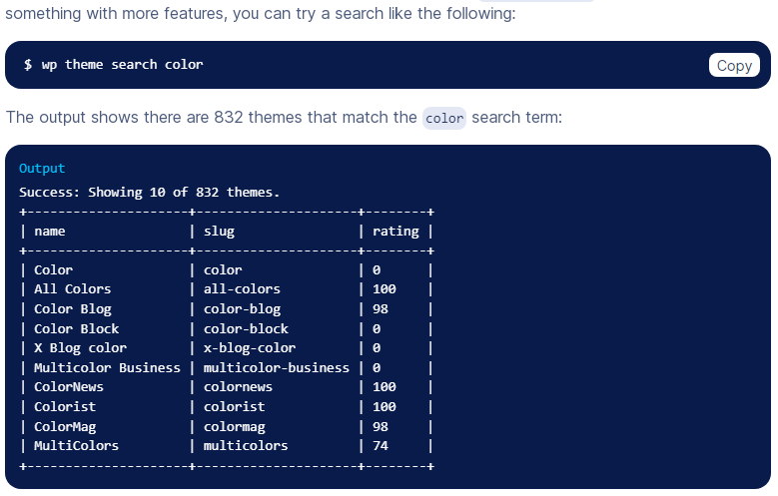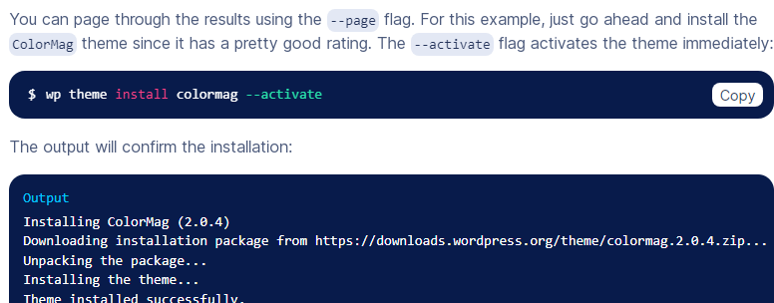



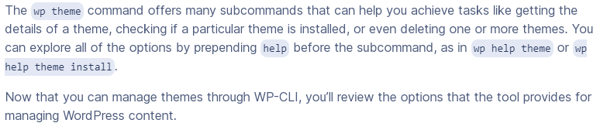

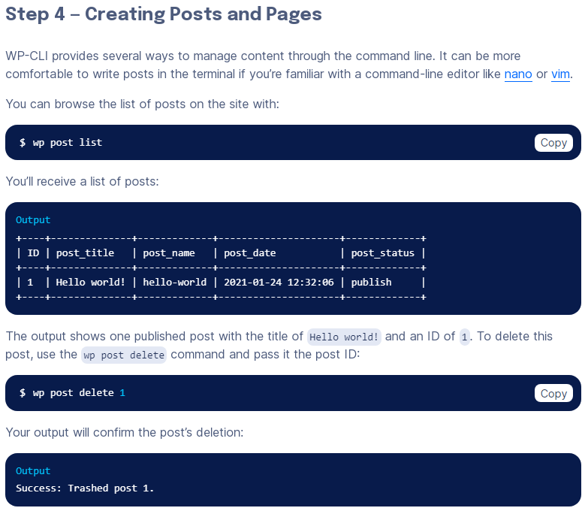 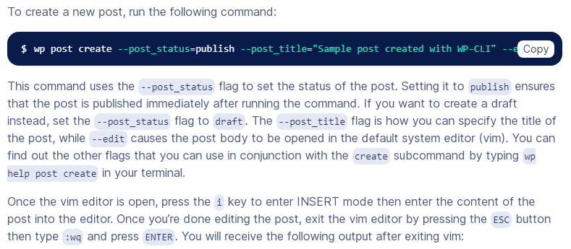 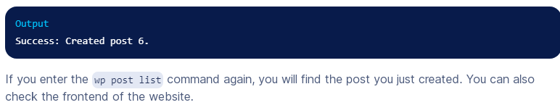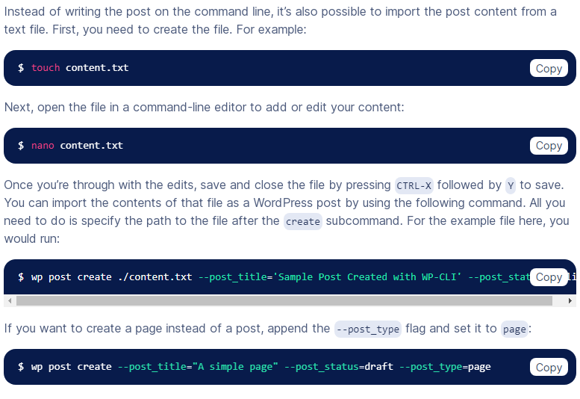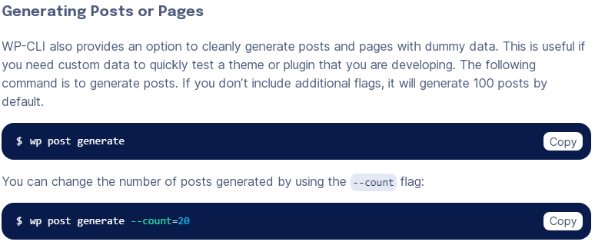

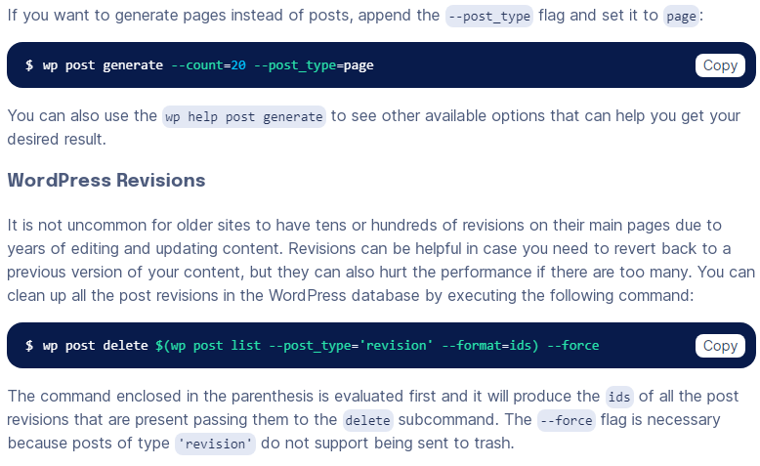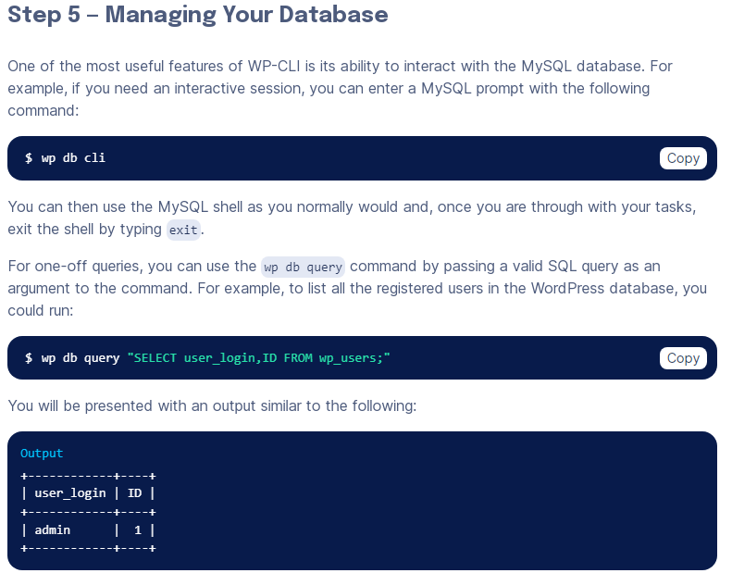



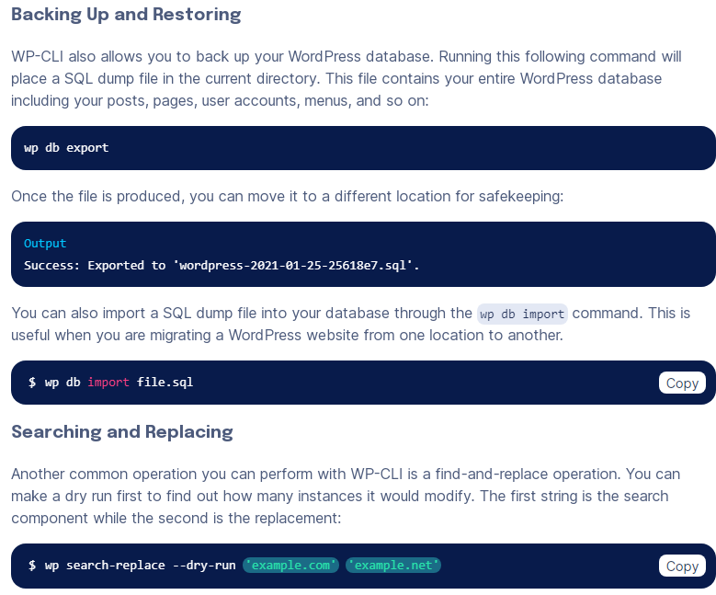

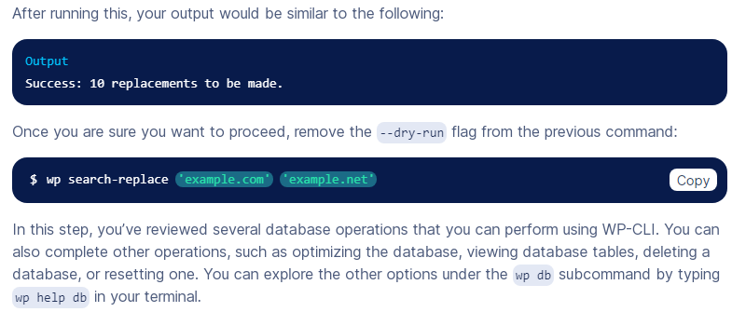

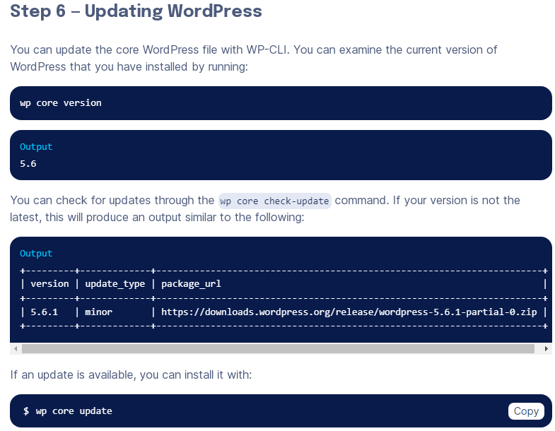

**Git Command**

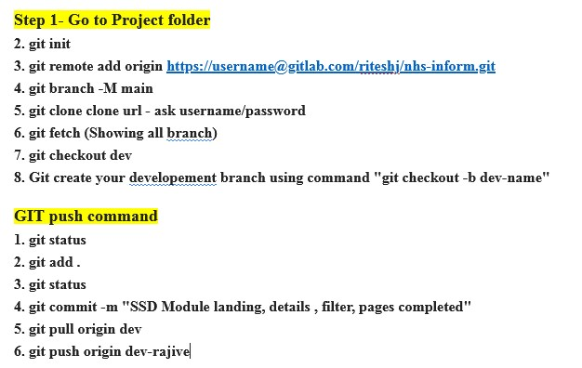

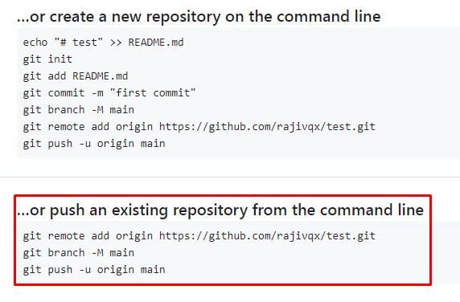

**Git Comman Command**

**Git is a powerful version control system used for tracking changes in source code during software developmentInitialization:**

* + **git init**: Initialize a new Git repository in the current directory.

1. **Cloning:**
   * **git clone <repository_url>**: Clone a remote repository to your local machine.
2. **Configuration:**
   * **git config --global user.name "Your Name"**: Set your global username.
   * **git config --global user.email "youremail@example.com"**: Set your global email address.
3. **Basic Workflow:**
   * **git status**: Check the status of your working directory and see which files have changed.
   * **git add <file>**: Stage changes for commit.
   * **git commit -m "Commit message"**: Commit staged changes with a message.
   * **git diff**: Show the differences between the working directory and the last commit.
4. **Branching and Merging:**
   * **git branch**: List all branches in the repository.
   * **git branch <branch_name>**: Create a new branch.
   * **git checkout <branch_name>**: Switch to a different branch.
   * **git merge <branch_name>**: Merge changes from one branch into another.
   * **git branch -d <branch_name>**: Delete a branch (use **-D** for a force delete).
5. **Remote Repositories:**
   * **git remote**: List remote repositories.
   * **git remote -v**: List remote repositories with URLs.
   * **git push <remote_name> <branch_name>**: Push your changes to a remote repository.
   * **git pull <remote_name> <branch_name>**: Pull changes from a remote repository.
6. **Tagging:**
   * **git tag**: List all tags in the repository.
   * **git tag <tag_name>**: Create a new tag at the current commit.
   * **git tag -a <tag_name> -m "Tag message"**: Create an annotated tag with a message.
7. **History:**
   * **git log**: View commit history.
   * **git log --oneline**: View a concise commit history.
   * **git blame <file>**: See who last modified each line of a file.
8. **Undoing Changes:**
   * **git reset <commit>**: Unstage changes but keep modifications.
   * **git reset --hard <commit>**: Discard changes and move the branch to a specific commit.
   * **git revert <commit>**: Create a new commit that undoes the changes introduced by a specific commit.
   * **git checkout -- <file>**: Discard changes in a specific file.
9. **Stashing:**
   * **git stash**: Temporarily save changes that are not ready to be committed.
   * **git stash pop**: Apply the most recent stash and remove it from the stash list.
10. **Advanced Topics:**
    * **git submodule**: Manage Git submodules within your repository.
    * **git rebase**: Reorganize and rewrite commit history.
    * **git cherry-pick**: Apply specific commits to your current branch.

**git help <command> or git <command> --help to access the official Git documentation.**

**Linex Comman Command**

1. **File and Directory Operations:**
   * **ls**: List files and directories.
   * **pwd**: Print the current working directory.
   * **cd**: Change the current directory.
   * **touch**: Create an empty file.
   * **mkdir**: Create a new directory.
   * **rmdir**: Remove a directory.
   * **rm**: Remove files or directories.
   * **cp**: Copy files or directories.
   * **mv**: Move or rename files or directories.
2. **File Viewing and Editing:**
   * **cat**: Concatenate and display file content.
   * **more** or **less**: View text files page by page.
   * **head** and **tail**: Display the beginning or end of a file.
   * **nano** or **vim** (or **vi**): Text editors for creating and editing files.
   * **grep**: Search for text patterns in files.
   * **find**: Search for files and directories.
3. **File Permissions:**
   * **chmod**: Change file permissions.
   * **chown**: Change file ownership.
   * **chgrp**: Change group ownership.
4. **System Information:**
   * **top**: Display real-time system information and processes.
   * **df**: Display disk space usage.
   * **free**: Display RAM usage.
   * **uname**: Display system information.
   * **lscpu**: Display CPU information.
5. **Package Management:**
   * **apt** (Debian/Ubuntu): Package management tool for installing, updating, and removing software packages.
   * **yum** (RHEL/CentOS): Package manager for Red Hat-based distributions.
   * **dnf** (Fedora): Package manager for Fedora.
6. **Network Utilities:**
   * **ping**: Send ICMP echo requests to a host.
   * **ifconfig** or **ip**: Network configuration and information.
   * **netstat**: Network statistics and routing tables.
   * **ssh**: Secure Shell for remote login.
   * **scp**: Securely copy files between hosts.
7. **Process Management:**
   * **ps**: Display information about running processes.
   * **kill**: Terminate processes.
   * **top**: Monitor and manage running processes interactively.
8. **Archiving and Compression:**
   * **tar**: Create or extract tar archives.
   * **zip** and **unzip**: Create and extract zip archives.
   * **gzip**, **gunzip**, **bzip2**, **bunzip2**: Compress and decompress files.
9. **User and Group Management:**
   * **useradd** and **userdel**: Add and delete user accounts.
   * **passwd**: Change user passwords.
   * **groupadd** and **groupdel**: Add and delete groups.
   * **su** and **sudo**: Switch users or execute commands as superuser.
10. **File System Navigation:**
    * **cd**: Change directory.
    * **ls**: List files and directories.
    * **pwd**: Print working directory.
    * **tree**: Display directory structure as a tree.

